September 2015 service@ncfe.org.uk 0191 239 8000 1

Online Assessment User Guide - Invigilation

Table of Contents
Introduction 3
Logging into assessments 3
Invigilation screen 6
Keycodes and reports 6
Controlling Assessments 9
Unlocking Assessments 10
Pausing Assessments 10
Uploading Assessments 11
Loss of internet connection during assessments 12
Troubleshooting 13

Introduction

This manual is for centre staff who are responsible for invigilating electronic assessments, including both online and remote assessments.

The online administration site for NCFE Online Assessment, where you can invigilate and administer candidate assessments, is called Surpass.

The secure software that candidates use to take assessments is called SecureClient.

If any assistance is needed please contact your NCFE Centre Support Assistant (CSA). If you don’t have their details you can speak to the Centre Support Team using the details at the bottom of this page.

You should be supplied login details for Surpass by a member of your centre staff, the link to Surpass is;

https://ncfe.surpass.com

SecureClient should already be installed on the PC’s or Laptops you’re using to run the assessments, or on the data keys you’ve been provided.

Logging into Assessments

To start SecureClient click on the NCFE Online Assessment shortcut icon on the computer desktop.

Each time you start it SecureClient will check that it’s the most up to date version, and will download and update itself if needed, this will take a few seconds.
SecureClient will then perform a diagnostic check, to compare the specification of the computer to the specification required for the software to run correctly.

If the test discovers anything that doesn’t meet the requirements you will see this message;
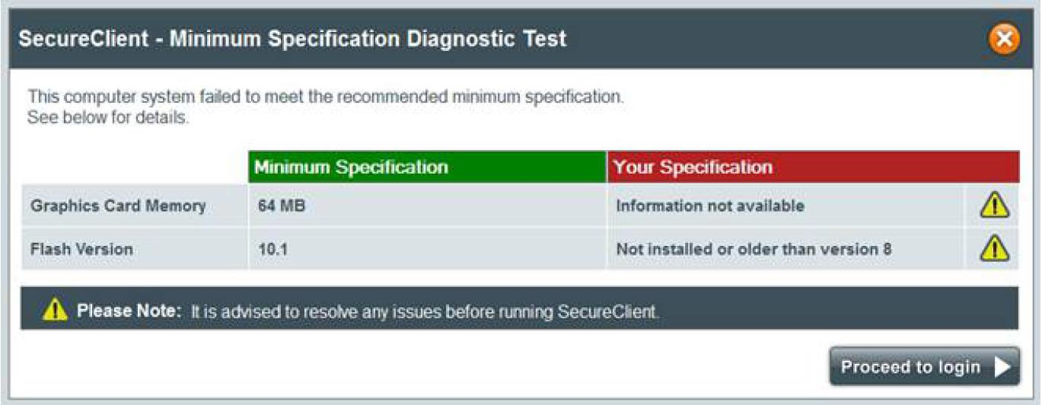

It’s advised that any issues highlighted are resolved before trying to run assessments to avoid any impact on the candidates’ experience. If you wish to proceed to login without taking any action you can click “Proceed to login”.

Tests that have been run through SecureClient will record the specifications of the computer used to sit the assessment, to assist in any diagnostics that are required in the event of technical problems.

Once the diagnostic check is complete you’ll see this screen;
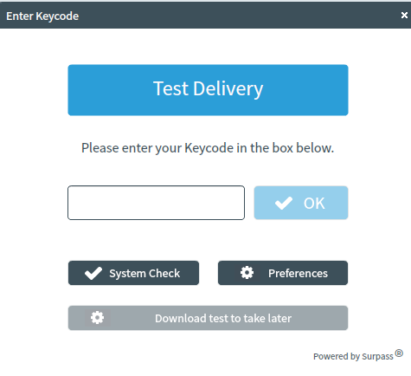
- The Preferences button allows you to change the colours that the assessment will display in, which may be useful for candidates with visual or reading difficulties.
- To login to an assessment, you’ll need to enter the unique candidate keycode for the correct assessment.
- Select OK and you’ll then see a confirmation screen. Once you confirm the candidate details the system will recognise that the candidate has begun the assessment.
- The first page of the assessment will always be an information screen and includes a tutorial that the candidate can view to learn how to navigate the assessment.
- The exam timer will start as soon as the candidate selects Start Test from the information screen.

Invigilation screen

The Invigilation screen of Surpass allows you to access candidate’s keycodes, both onscreen and on print-outs. It also allows you to monitor and control the progress of candidates’ assessments in real time.

Keycodes and reports

You’ll be able to access your candidates’ unique keycodes from the Invigilation screen. Each line on the screen is an individual candidate assessment.
You can provide a candidate with their Keycode directly from the screen or print an invigilation pack, which includes a Keycode slip which you can give to the candidate.

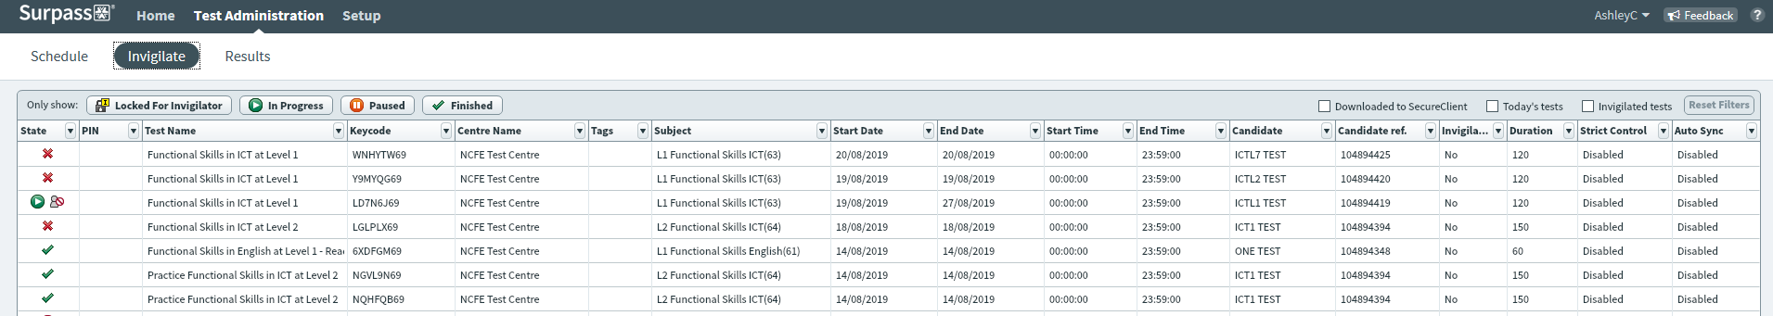

You can print off an invigilation pack by highlighting the relevant assessment and choosing Print Invigilation Pack from the bottom right of the screen. Once selected you’ll be given the option to Create Invigilation Pack using selected tests. If you want to print invigilation packs for large numbers of assessments you may find it easier to use the second option, Create Invigilation pack using the wizard. Otherwise, select Create Invigilation Pack using selected tests.
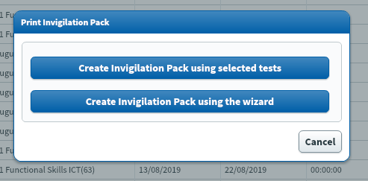

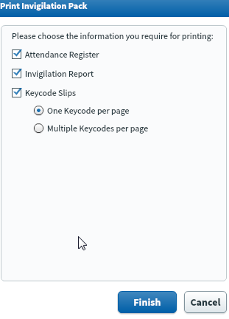
- Once this has been selected you’ll be shown the following screen. This screen will give the option to print invigilation packs for an individual assessment.
- You’ll be given the option of choosing to print Candidate Assessment Keycodes, Invigilation Report and Attendance Register
- Attendance Register – this is an optional report to confirm the learner attended.
- Invigilation Report - this is an optional report for your internal invigilation records. This doesn’t need to be returned to NCFE.
- Keycode Slips – these are the individual slips to give to candidates with their Keycodes which they’ll need to login to their assessment; you can select either one or multiple Keycodes per page.
- Once the options you need have been selected, choose Finish and the relevant files will open in a printable screen

To print invigilation packs using the wizard, select Print Invigilation pack from the bottom of the Schedules screen.

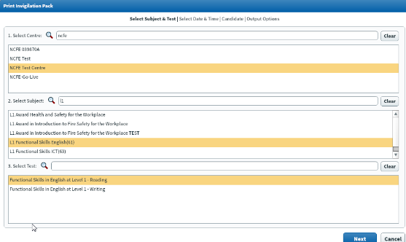
  - Once selected you’ll be given another pop up screen where you’ll be given various options.
  - Select the correct centre, qualification and the assessment and choose Next
Another series of pop up boxes will allow you to select the time/date of assessment as well as the candidate(s).

Controlling Assessments

The Invigilation screen allows you to monitor the progress of your candidates’ assessments in real time for any assessments that are being run with a live internet connection. The screen will show when assessments have been downloaded for remote assessment and can be used to track answers being uploaded following those assessments being completed.
Each assessment will be in one of the following states;

Icon | State
 | The assessment has been locked and will need to be unlocked by the invigilator before it starts, or the candidate will need to enter the PIN number the invigilator has set
 | The assessment is ready to start and the candidate can log in using their Keycode
 | The assessment is in progress now, an additional icon will show if the internet connection has been lost whilst the assessment was in progress
 | The assessment window has closed and the system is expecting candidates results to be uploaded
 | The assessment is finished and the candidate results have been received
 | The assessment has been voided and is not available to log in to, the candidate can be rescheduled to a new assessment
 | The assessment has been downloaded
 | The assessment has been paused

Unlocking Assessments

When an assessment is scheduled you have the option to set additional invigilation options if you require extra levels of security above the unique candidate keycode. If the schedule for invigilate option has been selected during the assessment schedule there are 2 ways you can unlock an assessment.
- You can select the assessment on the Invigilation screen and press the Unlock button, the candidate’s assessment will then start.
- You can select the assessment on the Invigilation screen and press the Set PIN button, when the candidate enters their keycode the SecureClient will prompt them to enter the PIN which we’d normally expect the invigilator to do.

Pausing Assessments

If something happens during the assessment session, such as a fire drill, and you wish to pause the assessment you can do this with the Pause button. You would then restart the assessment using the Resume button.
This will stop the timer and the candidate will see a message on-screen to tell them the assessment has been paused.

Uploading Assessments

If a candidate’s assessment has been downloaded and sat offline, or if the internet connection dropped during an online assessment and was not restored before the assessment was completed, the candidates answers will need to be uploaded. In these cases the Invigilation screen will show the Awaiting Upload symbol next to the assessment.
- Open the SecureClient software on the computer the assessment was sat on, any results on the laptop will be submitted automatically
- This will take anywhere between a few seconds and a few minutes depending on the number of results to upload and the speed of your internet connection
- Close the SecureClient software and check the assessment on the Surpass Invigilation screen, if the results have been uploaded you’ll see a green tick to show it’s finished
- If the assessment was a multiple choice exam you’ll also see the provisional results in the Surpass Results screen.

Loss of internet connection during assessments

NCFE Online Assessment has a function which means that if a PC crashes while candidates are sitting an assessment, they can log back in and continue from where they left off. Also if there’s an interruption to your internet connection during an assessment the candidate will be able to continue as if nothing had happened. As long as the internet connection is restored before the end of the assessment the results will be uploaded automatically to NCFE as normal.

If the internet connection is still offline when the candidate completes their assessment, the candidate will see their provisional result on screen, but the results won’t have been uploaded to the NCFE Online Assessment system. The results will be stored on the PC used to sit the assessment.

As the candidate software has an auto upload function built into it, once internet connection is restored, simply re-launch the candidate software on the PC the candidate was using and the software auto uploads any results that haven’t been uploaded yet. This should be done as soon as
the internet connection is restored.

Problem | Cause | Solution
Error '801' is shown when entering a test keycode or when logging into Administration screen. | Your file permissions or security settings may be preventing you from installing the MSI. | Delete the installation directory and reinstall as an Administrator.
Error '801' is shown when entering a test keycode or when logging into Administration screen. | Caused by issues with the installation of SQL compact (either an old & incompatible version was already installed, or the installation did not complete successfully). | Resolved by installing SQL Compact Service Pack 2 from the Microsoft website
Error '827' is shown when validating the test keycode. | The keycode may have been inputted incorrectly.  Caused by SecureClient running offline and the test not downloading. This can be due to a variety of reasons, but the most common cause is due to the internet access being blocked by a proxy server or firewall. | Check the keycode and try again.  Resolved by entering proxy details in the proxy form or the proxy.xml file or by allowing access to the central server URLs through the proxy.
SecureClient has updates that are invalid | Caused by insufficient permissions on the SecureClient folder or because a lower level user account is being used.  Caused by a proxy server blocking access to an update's URL. | Resolved by granting read/write permissions on the SecureClient folder or by logging in with a user with higher permissions.
SecureClient failed to load (no error message) | Caused by standards and format settings being non-UK. Specifically the character used to mark a decimal place is a comma (,) rather than full stop (.) | Resolved by changing the Standards and Formats settings to United Kingdom

Troubleshooting

Problem | Cause | Solution
Error '821' - Secure Client Core - There was an error trying to decrypt an item for the current question. | Caused by an on-access virus scan preventing the SecureClient from reading/writing files | Delete the installation directory and reinstall as an Administrator.
Tests appear as 'In progress/User disconnected' in the Invigilation screen, although the tests have actually been completed. | Caused by a lost or slow internet connection when the exam was submitted by the candidate. | Check there is an internet connection available and relaunch the SecureClient on the computer used by the candidate. The result should then be uploaded, you can check if this is successful by viewing the Invigilation screen.

