September 2017 service@ncfe.org.uk 0191 239 8000 1

Online Assessment User Guide - Installation

Table of Contents
Introduction 3
Installing SecureClient 3, 4, 5
- Individual Installation 3, 4, 5
- Network Installation 6

Proxy Servers 7
Antivirus 8
Default Programs 8
SecureClient Diagnostic 9
Practice Assessment 10

Introduction

This manual is for users who are responsible for installing the candidate software for NCFE Online Assessment, this software is referred to as SecureClient.

The online administration site where users can schedule and administer candidate assessments is called Surpass.

The instructions are written for users familiar with installing software or managing IT infrastructure, if any assistance is needed please contact NCFE Customer Support using the details at the bottom of this page.

Installing SecureClient

Individual Installation

This is the process to install SecureClient onto a single computer to run NCFE Online Assessment, this will install the software to a public directory so it’s available to all users on the computer.

If you want SecureClient to only be available to a specific user, you will be able to install the software to a specific user directory.

- Download the installation file from this link:
https://ncfe.surpass.com/launchtest
Click the link above; when the page loads, click the ‘Secure Delivery’ tab, then select ‘Download SecureClient (MSI)’.

2. Select ‘Run’ when presented with the security warning.

3. After clicking ‘Run’, you’ll be presented with the screen below;

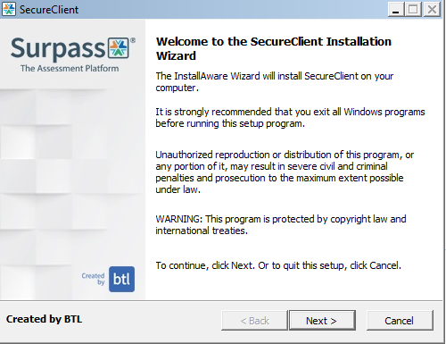

Click “Next”

4. You will then see this screen which lets you set the location to install the software;

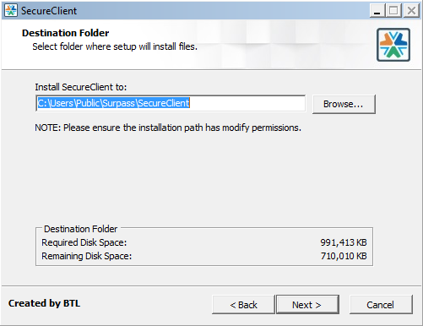

- If you want to install the software to a specific user profile, you can change the installation folder on this screen.

- Once you’ve selected your preferred destination (We recommend installing to your desktop), click ‘Next’.

SecureClient will check for updates each time it’s opened. You should open the software once you’ve installed it to let it do this for the first time.

Network Installation

If you need to install the software across multiple computers on the same network at the same time, you can do this using a batch file. To create a batch file follow these steps;

- Create a new text document with filename secureclient, the document should contain this line of text;

msiexec.exe /i C:\SecureClientInstaller.msi CMDLINE=/DEFAULT_INSTALL_DIR=”C:\TEST” /qn

- C:\SecureClientInstaller.msi is the location that the SecureClient installer file is saved
- C:\TEST is the directory SecureClient will be installed to.

- Save the file and rename the file extension from .txt to .bat to create the batch file

- The batch file can then be used to install the software to multiple computers on a network using Microsoft Group Policy or similar network management application.

Proxy Servers

It’s important that SecureClient can communicate directly with the central servers that hold assessment and candidate data, without interruption from a Proxy Server. If you use a Proxy Server you’ll need to add exceptions to bypass it for the following addresses;

https://ncfe.surpass.co.uk/surpass/InvigilateService.asmx https://ncfe.surpass.co.uk/surpass/AssessmentService.asmx https://ncfe.surpass.co.uk/surpass/Surpass.html https://ncfe.surpass.co.uk/surpass/MembershipService.asmx https://ncfe.surpass.co.uk/surpass/connectionTest.html https://ncfe.surpass.co.uk/surpass/UpdateService.asmx
You should also remove any setting blocking HTTPS traffic on port 443.

If you need to add your proxy server details to the SecureClient installation this can be found here;

C:\Users\Public\Surpass Central - SecureClient NCFE\Surpass Central - SecureClient NCFE\configfiles Open the file in notepad and enter the proxy details in the format below:
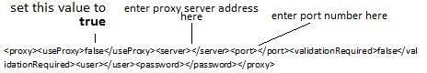

Antivirus

Antivirus or anti malware software can prevent the SecureClient recording candidate responses or opening question material and in some cases cause the exam to freeze. On access scan for example is something that can be particularly problematic.

Please ensure that “On Access Scanning” is disabled for the SecureClient folder and all subfolders. To do this you should add an exception to your Antivirus software, following the manufacturer’s instruction, for the SecureClient folder and subfolders. We also recommend that you consider disabling any virus scanning whilst candidate assessments are taking place.

If you require support with this we ask that you refer to the help files of your Antivirus software or contact the manufacturer.

Default Programs

Some assessments require the learner to open a document from the exam, these documents will open in Microsoft Office suite programs. This is currently required for Functional Skills ICT assessments but may also be required for other assessments in future.

To ensure the learner can properly open the document without interruption you should set the correct default program for the following file types.

File Type | Microsoft Office Program
.doc .docx | Microsoft Word
.xls .xlsx | Microsoft Excel
.ppt .pptx .pps .ppsx | Microsoft PowerPoint

You can make these settings in the “Control Panel > Default Programs > Associate a file type or protocol with a program” menu in Microsoft Windows.

You should also check that the Trust Centre in each of Microsoft Word, Excel and PowerPoint is not set to block or restrict any of these file types.

These file types may also open in other Office software programs, please note these are not supported by NCFE and not covered by the technical requirements for SecureClient.

SecureClient Diagnostic

Each time you open SecureClient it will perform a diagnostic check to compare the specification of the computer to the required specification for the software to run correctly.

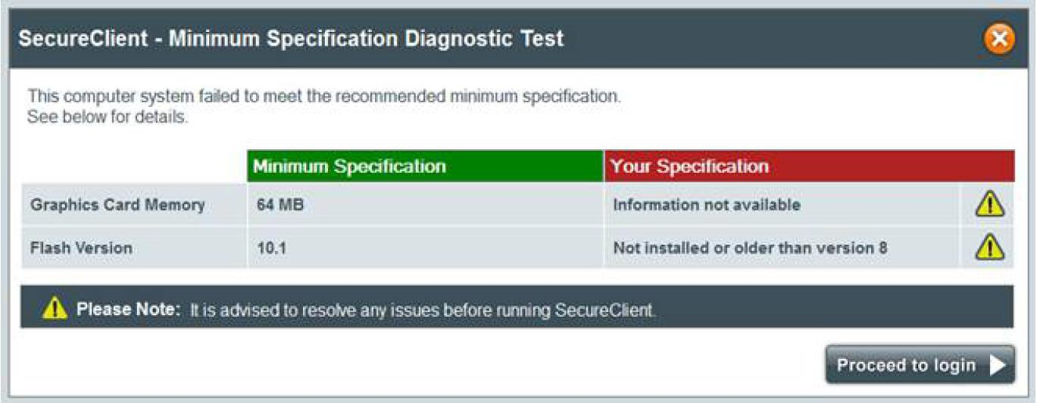
If the test discovers anything that doesn’t meet the requirements you will see this message;

It’s advised that any issues highlighted are resolved before trying to run assessments, to avoid any impact on the candidates’ experience. If you wish to proceed to login without taking any action you can click “Proceed to login”.

Tests that have been run through SecureClient will record the specifications of the computer used to sit the assessment, to assist in any diagnostics that are required in the event of technical problems.

Practice Assessment

We ask that you run practice assessments once you’ve installed the software to ensure that everything is working correctly.

You can create a practice assessment via Surpass. Please refer to the Online Assessment Administration Guide for reference.

- Log in to the candidate assessment and confirm the candidate details, this will result in the assessment being downloaded ready for the candidate to sit.
- Move through the questions and submit responses, you should answer at least some of the questions.
- Press finish to end the assessment, this should result in the assessment showing as completed in the Invigilation screen of Surpass.

Customer Support will be on hand to support with this process and if any problems arise they will help you to resolve the issue.

