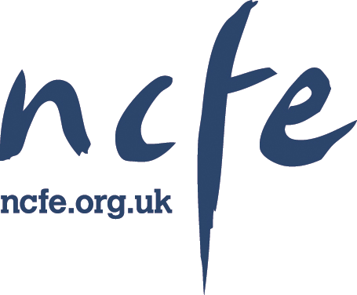

Entry Level Award in Creative Craft (Entry 2) (600/4943/1)

Learner’s Evidence Tracking Log
(LETL)

Issue 1, June 2012


Learner name:
Centre number:
Centre name:

Signatures
Learner: Date:
Tutor/Assessor: Date:
Internal Moderator*: Date:
External Moderator*: Date:
* for completion if part, or all, of the evidence has been sampled by the Internal and/or External Moderator


Contents
Section 1 - Overview 3
What you need to cover 3
Tracking your evidence 4
How your evidence is checked 4
How to get your certificate 5
Opportunities for further education and training 5
Section 2 – Planning and tracking your assessment 6
Completing your Learner’s Evidence Tracking Log (LETL) 6
Example unit 7
Section 3 – Mandatory unit 8
Unit 01 Create a piece of craft or design 8
Section 4 –Additional information 9
Additional support 9
About NCFE …10

Section 1 - Overview

Thank you for choosing an NCFE qualification. This Learner Evidence Tracking Log (LETL) is yours to keep and is a place to record your progress.

The NCFE Entry Level Award in Creative Craft (Entry 2) has been accredited by the regulators for England, Wales and Northern Ireland and is part of the Qualifications and Credit Framework (QCF). Its Qualification Accreditation Number is 600/4943/1.

This qualification has been supported by Creative and Cultural Skills, the Sector Skills Council for the creative sector.

What you need to cover

This qualification is made up of a set of learning outcomes and assessment criteria that describe what you need to be able to do, and the things you need to know, to achieve your qualification.

The qualification consists of the following mandatory unit:

Unit 01 Create a piece of craft or design

To achieve the NCFE Entry Level Award in Creative Craft (Entry 2) you must achieve the mandatory unit. You must provide evidence to show that you meet all the learning outcomes and assessment criteria defined in the unit.

Section 1 - Overview

Tracking your evidence

During your course your Tutor/Assessor will ask you to carry out work either in the classroom, in your workplace or at home, which you’ll keep as evidence of your learning.

The work you produce (evidence) will be assessed by your Tutor/Assessor to make sure you’ve covered everything in sufficient detail. Your evidence could be made up of a combination of:

- written work or class notes
- products or samples of practical work
- case studies
- simulated activities or role play
- work placement diaries
- learning logs
- video or audio recordings
- other appropriate formats suggested by your Tutor/Assessor.

When all your evidence is gathered together in a file or folder, this becomes your portfolio.

Your centre and Assessor may have systems that they use to plan and monitor your assessment. These may be computer-based (eg using ‘e-portfolio’ software) or paper-based (using forms or checklists). These systems are designed to show how each piece of evidence meets which learning outcomes and assessment criteria.

How your evidence is checked

After your Tutor/Assessor has assessed your work, another member of staff – the Internal Moderator – will review it. An External Moderator from NCFE will visit your centre. The External Moderator’s role is to make sure your work has been assessed to NCFE’s requirements. They’ll do this by checking a sample of candidates’ portfolios – which may include yours. They may also wish to talk to you about the content of the course and the work you’re doing.

Section 1 - Overview
Section 1 - Overview

How you get your certificate

Once you’ve built up your portfolio of evidence and your Tutor/Assessor and the Internal and External Moderators are satisfied it meets the standards, you’ll be awarded the NCFE Entry Level Award in Creative Craft (Entry 2).

Your centre will send us a signed certificate claim form when they and the External Moderator have signed off your completed portfolio. We will send your certificate to your centre within 10 working days of receiving the claim form. Your centre will either forward the certificate to your home address, or tell you that it’s available for you to collect.

Opportunities for further education and training

After successfully completing this qualification, you may like to go on to further study in the same or a similar subject. This might include:

- NCFE Level 1 Award in Creative Craft
- NCFE Level 1 Award in Performance Skills
- NCFE Level 1 Award in Interactive Media
- NCFE Level 1 Certificate in Photography
- NCFE Level 1 Award or Certificate in Music Technology

Section 2 – Planning and tracking your assessment

Completing your Learner’s Evidence Tracking Log (LETL)

This section of the log will help you keep track of the work you’ve done and the work you still need to do to finish your portfolio.

It will also help your Tutor/Assessor and Internal and External Moderators find their way around your portfolio so they can assess it or check it. Your Tutor/Assessor will make sure you’re completing your log correctly.

Overleaf is a sample page similar to the mandatory units you’ll find in the rest of this log. Use the columns to write down what evidence you’ve put in your portfolio and to show your Tutor/Assessor and the Internal and External Moderators where it’s located.

You and your Tutor/Assessor and/or an independent witness must sign and date the individual pieces of work in your portfolio. Once you’ve completed your portfolio, your Tutor/Assessor will sign the front of the log, to show that they’re satisfied you’ve completed it correctly.

Section 2 – Planning and tracking your assessment

Example unit
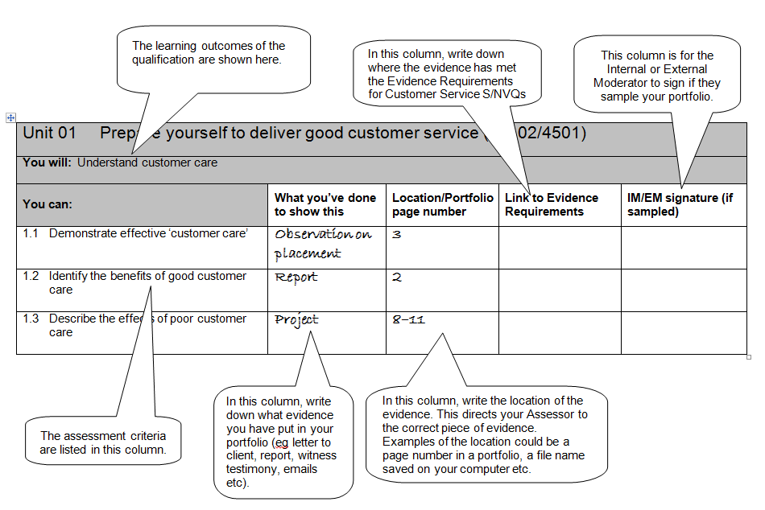

Unit 01 Create a piece of craft or design (J/503/4346)

You will: Understand how a craft or design project is made

You can: | What you’ve done to show this | Location/Portfolio page number | Link to Evidence Requirements | IM/EM signature (if sampled)
1.1 Demonstrate awareness of the combination of materials/methods to create crafted items or designs
You will: Be able to create a crafted item or design
You can: | What you’ve done to show this | Location/Portfolio page number | Link to Evidence Requirements | IM/EM signature (if sampled)
2.1 Select from given materials to create crafted item or design

Section 4 – Additional information

NCFE is a leading provider of nationally recognised qualifications and is committed to delivering exceptional customer service. We’re based in Newcastle upon Tyne. If you’d like to know more about us, please visit our website www.ncfe.org.uk.

Additional support requirements
NCFE recognises that you might require additional support in order to achieve your qualification. This might be if you’ve a permanent or temporary disability, medical condition or specific learning need.

Your Tutor/Assessor will discuss the most appropriate method of support to meet your needs and may need to notify NCFE of the support they’re going to give you. This could be facilities to support reading or writing needs, hearing, visual or physical impairment; facilities to support a medical condition or temporary injury; or facilities to support you if your first language isn’t English.

For more information your Tutor/Assessor will be able to provide you with a full copy of NCFE’s Reasonable Adjustments and Special Considerations Policy, or you can download it from www.ncfe.org.uk.

Appeals or complaints
If you’ve any queries or problems with your qualification you should first talk to your Tutor/Assessor, the Internal Moderator or another member of staff at your centre. If you’ve got a complaint about the way your work has been assessed, or the support you’ve been given, use your centre’s own appeals or grievance policy (ask your Tutor/Assessor for a copy).

For more information your Tutor/Assessor will be able to provide you with a full copy of NCFE’s Appeals and Enquiries about Results Policy, or you can download it from www.ncfe.org.uk.

Malpractice
‘Malpractice’ is used to describe something a person does when they intentionally mislead somebody – for example, if they copy somebody else’s work and pass it off as their own. It we’re notified about a suspected case of malpractice, we’ll work with the centre to find out if and why it’s happened and what we can do to sort it out.

If your centre suspects you’ve been involved in malpractice, we won’t be able to issue your certificate during the investigation. If we prove that malpractice has happened, you may have part of your assessment disallowed or, in serious cases, your final results may be void. This means you won’t receive a certificate or, if we’ve already issued you one, we’ll ask that you return it straight away.

For more information your Tutor/Assessor will be able to provide you with a full copy of NCFE’s Malpractice Policy, or you can
download it from www.ncfe.org.uk.

Section 4 – Additional information

Enquiries
Any enquiries relating to this qualification should be addressed to:

NCFE
Citygate
St James Boulevard
Newcastle upon Tyne
NE1 4JE

Tel: 0191 239 8000
Fax: 0191 239 8001
E-mail: artsmediandpublishing@ncfe.org.uk
Website: www.ncfe.org.uk

Equal opportunities
NCFE fully supports the principle of equal opportunities and opposes all unlawful or unfair discrimination on the grounds of ability, age, colour, culture, disability, domestic circumstances, employment status, gender, marital status, nationality, political orientation, racial origin, religious beliefs, sexual orientation and social background.

NCFE aims to ensure that equality of opportunity is promoted and that unlawful or unfair discrimination, whether direct or indirect, is eliminated both in its own employment practices and in access to its qualifications.

You can download a copy of NCFE’s Equal Opportunities Policy from www.ncfe.org.uk.

Data protection
NCFE is registered under the Data Protection Act and is committed to maintaining the highest possible standards when handling personal information.

NCFE is a registered charity (Registered Charity No. 1034808) and a company limited by guarantee (Company No. 2896700).
All the material in this publication is copyright.
All information contained in this publication is correct at the time of printing.

The qualifications regulators (‘regulators’) are Ofqual in England, the Welsh government and CCEA in Northern Ireland.

