To be completed by the examiner | Mark
Section A
Section B
Part A
Part B
Part C

NCFE Level 1 in Essential Digital Skills
603/7118/3
Topic: Buying a dog
Sample assessment material
Part D
TOTAL MARK

Mark Scheme

Marking guidelines

General guidelines
You must apply the following marking guidelines to all marking undertaken throughout the marking period. This is to ensure fairness to all learners, who must receive the same treatment. You must mark the first learner in exactly the same way as you mark the last.
- The mark scheme must be referred to throughout the marking period and applied consistently.
- Reward learners positively, giving credit for what they have shown rather than penalising them for what they might have omitted.
- Utilise the whole mark range and always award full marks when the response merits them.
- Be prepared to award zero marks if the learner’s response has no creditworthy material.
- Do not credit irrelevant material that does not answer the question, no matter how impressive the response might be.
- The marks awarded for each response should be clearly and legibly recorded in the grid on the front of the question paper.

Assessment objectives
This assessment requires learners to:
AO1 | Knowledge  Learners should be able to:  - Recall  - Select  - Identify
AO2 | Skills  Learners should be able to:  - Apply  - Demonstrate  - Use

Section A
Q1 | Which of the following file sizes is the smallest?  Answer B: 23 KB | 2.2.1.1.4.1  [1 mark]
Q2 | Which one of the following describes an advantage of backing up to the cloud?  Answer C It safeguards data from damage or loss | 1.1.3.1.2  [1 mark]
Q3 | Which one of the following describes the use of multi-factor authentication to gain access to a website?  Answer C Presenting two or more pieces of evidence to verify the user’s identity | 1.1.1.1.1  [1 mark]
Q4 | Jack is using social media.  Someone on social media keeps posting opinions that Jack does not agree with. To stop seeing these posts, what should Jack do?  Answer D: Use the app settings to block them | 1.2.1.1.2  [1 mark]
Q5 | Which one of the following protects a computer from trojans and worms?  Answer D: Installing malware protection software | 1.1.4.1  [1 mark]
Q6 | Which one of the following is a reason for an account being removed from a social media platform?  Answer A: Not following the company’s policy | 1.2.1.1.6  [1 mark]
Q7 | Charlie has been advised that overuse of his computer is affecting his sleep patterns. Which one of the following should Charlie do?  Answer A: Avoid using his computer right before going to bed | 1.3.2.1.4  [1 mark]
Q8 | Tanveer wants to buy a book called Looking After Your Dog by someone called Curtis. Tanveer also wants to support shops in his local town of Westmouth but he does not know any local bookshops.  Which one of the following search terms would return the most accurate results?  Answer C: “Looking After Your Dog’ Curtis ‘Westmouth bookshop’” | 2.1.1.2.1  [1 mark]
Q9 | Ayesha wants to chat to her friend in Canada about her upcoming visit. Which one of the following is a private way for Ayesha to contact her friend?  Answer D: Text message | 4.1.2.1.3  [1 mark]
Q10 | Eileen wants to uninstall some applications that she does not use from her personal computer. She has gone into Settings, then Apps & Features. Look at the image below and choose what Eileen should do next.  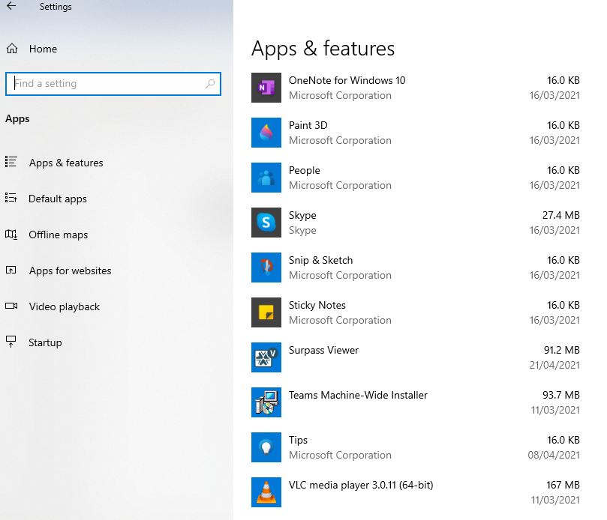  Answer D: Select the app and select uninstall from the pop-up window | 2.3.1.1.4  [1 mark]
Q11 | Natalia has forgotten her password for her social media account.  When resetting her login credentials, which piece of personal information would Natalia be asked to confirm?  Answer B: Email address | 2.3.1.1.1  [1 mark]
Q12 | When buying online which one of the following would indicate that the website is secure?  Answer B: There is a padlock symbol in the address bar | 5.2.3.1.1  [1 mark]
Q13 | Zi Chung needs to have a face-to-face discussion with four colleagues who live in different parts of the country.  Which one of the following would be the best way for Zi Chung to hold an online meeting?  Answer D: Using a video collaboration tool | 4.1.2.1.6  [1 mark]
Q14 | Li has bought a printer and wants to share a positive review about the product to inform other customers. Which one of the following would do this effectively?  Answer B: Posting the details on the company’s social media platform | 4.1.1.1.3  [1 mark]
Q15 | Juan wants to order a laptop to have in time for a new college course he starts next week. He has identified two possible choices.  Which one of the following comparison options would help Juan decide?  Answer A: Delivery time | 5.2.2.1.3.2  [1 mark]
Q16 | Which one of the following cannot be done by adjusting email account settings?  Answer D: Increasing storage space | 5.1.3.1  [1 mark]
Q17 | Mia views a website and decides it is secure. She has also decided what she wants to buy.  What is the first action Mia should take during her online shop?  Answer A: Add her choice to the basket | 5.1.1.1.1  [1 mark]

Section B
Tasks | Assessment Criteria
Part A  - Hierarchical folder structure created and named correctly. Main folder named ‘Fundraising’ and sub-folders named ‘websites’ and ‘social media.’ [1 mark] Evidenced by Learner Observation Record.  - Suitable search terms used, eg animals + fundraising.  - Suitable search terms used, eg animals [1 mark] + fundraising [1 mark]. URL demonstrating security of each website.  - Both websites must include https or padlock to achieve mark. [1 mark]  - Award mark if platform found is fundraising only (eg Just Giving) or specific animal care fundraising organisation (eg an animal rescue site).  - Fundraising websites document saved to the websites folder. [1 mark]  Evidenced by screenshot.  - Email created to manager with appropriate subject line and content. [1 mark]. Fundraising Websites research document attached to email. [1 mark]  Evidenced by screenshot.  - Social media post written that is no longer than 280 characters and includes the hashtag ‘fundraising’ [1 mark]  promoting upcoming fundraising activity within an appropriate work context. [1 mark] | 2.2.1.1.2.2  2.1.1.2.1  2.1.1.2.1  2.1.2.1.1  2.2.1.1.3  4.1.2.1.1  2.2.1.1.5.1  4.1.2.1.4  4.1.1.1.2
Part B  - All information must be present and within a table with two columns and fourteen rows [2 marks]. Within two columns but wrong number of rows [1 mark]. Award no marks if wrong number of columns or information not within a table.  - Both images are positioned correctly replacing the headings, one in each column. [2 marks]  If one image is positioned correctly. [1 mark]  - Picture is cropped to exclude the dog walker. [1 mark]  - The image contrast [1 mark] and brightness [1 mark] is adjusted to 0% or middle.  - The learner has applied a filter to the image. Mark to be awarded if filter applies to whole image or edges only. [1 mark]  - The image is resized to 19 cm in height. [1 mark]  - A border has been added to the whole document. [1 mark]  - Confirmation that the file is saved and backed-up to another location.  [1 mark] | 3.1.1.1  3.1.1.1.1  3.2.1.1.4  3.2.1.1.1  3.2.1.1.6  3.2.1.1.7  3.2.1.1.5  3.1.1.1.5  1.1.3.2
Part C  a. AutoSum used to calculate totals for each column containing numerical  values. [2 marks]  - Award both marks for =SUM(B4:B17) and =SUM(E4:E6)  - Only one column totalled - 1 mark only  - No mark awarded for =SUM(B3,B4,B5 … B17) - 0 marks  b. There is an appropriate formula for total costs for the first year. [1 mark] Accept any variation of simple formula that results in the correct answer.  c. Initial set-up items are sorted in ascending alphabetical order. [1 mark]  d. All values are formatted as currency to two decimal places. Currency symbols must be shown. Any currency accepted. [1 mark]  e. Solid, black borders have been applied to all cells containing text and numeric data only. [1 mark]  f. All cells containing numerical data have been right aligned. [1 mark]  g. The bar chart has been edited to include axis labels. [1 mark], chart title [1 mark] and numeric data labels. [1 mark]  h. Pie chart has been created. [1 mark] that includes a legend  - The learner is required to select the appropriate data range D4:E6 for the legend to be generated.  - It must contain data labels for each section must include correct values of £28.00 £240.00, £200.00. [1 mark]  - and the chart title “Yearly costs of owning a dog”. [1 mark]  - Evidence that the learner has saved the file locally and backed-up to a cloud space. [1 mark] | 3.3.3.1.1  3.3.3.1.4  3.3.3.1.3  3.3.1.1.9.3  3.3.1.1.8  3.3.1.1.3  3.3.2.1.5  3.3.2.1.4  3.3.2.1.6  3.3.2.1.2  3.3.2.1.7  1.1.3.2
Part D  a. Screenshots must show appropriate search terms used (eg dry+dog+food). [1 mark]  Dog food product found based on dog profile information is fit for purpose. [1 mark] Product MUST be chicken flavoured, and suitable for adult life stage.  Evidence of products sorted by price (lowest to highest). [1 mark] Evidenced by screenshots. Screenshots must show that chicken flavour adult food was selected and sorted by price (lowest to highest). No marks awarded if these filters were not applied.  b. Evidence of additional search for the same product from another relevant website. [1 mark]  URL, product names and prices of both sites copied into the Bruno Dog Profile document. Must match the product and price selected from task a. No mark awarded if the wrong website is stated.  c. Price of cheaper item evidenced in the Bruno Dog Profile document is entered in Surpass. [1 mark]  d. Visa debit card option selected and used as payment option. [1 mark]  e. Payment details entered into the online payment system correctly. [1 mark] Name on card, card number, expiry date  f. Form submitted. [1 mark] | 2.1.1.2.1  5.2.2.1.5  2.1.1.2.3  5.2.1.1.3  5.2.2.1.2  5.1.3.1.6  5.1.3.1.6  5.1.2.1.6

Assessment objective grid
Question | AO1 | AO2 | Total
Section A
1 | 1 |  | 1
2 | 1 |  | 1
3 | 1 |  | 1
4 | 1 |  | 1
5 | 1 |  | 1
6 | 1 |  | 1
7 | 1 |  | 1
8 | 1 |  | 1
9 | 1 |  | 1
10 | 1 |  | 1
11 | 1 |  | 1
12 | 1 |  | 1
13 | 1 |  | 1
14 | 1 |  | 1
15 | 1 |  | 1
16 | 1 |  | 1
17 | 1 |  | 1
Section B
Part A |  | 9 | 9
Part B |  | 11 | 11
Part C |  | 14 | 14
Part D |  | 8 | 8
Total | 17 | 42 | 59
% | 29 | 71 | 100

Document information
Owner: Joanna Fairless, Head of Assessment Design

Change History Record
Version | Description of change | Approval | Date of Issue
v0.1 | First draft |  | November 2019
v0.2 | Feedback incorporated |  | September 2020
v0.3 | Reformatted with new document style |  | December 2020

