NCFE Level 3 Certificate in
Mathematics for Everyday Life (603/3437/X)
Practice
Engineering and Manufacturing

DATE

Paper 2: P00XXXX

Mark Scheme
v1.0

This mark scheme has been written by the Assessment Writer and refined, alongside the relevant questions, by a panel of subject experts through the external assessment writing process and at standardisation meetings.

The purpose of this mark scheme is to give you:
- examples and criteria of the types of response expected from a learner
- information on how individual marks are to be awarded
- the allocated assessment objective(s) and total mark for each question.

Marking guidelines

General guidelines

You must apply the following marking guidelines to all marking undertaken throughout the marking period. This is to ensure fairness to all learners, who must receive the same treatment. You must mark the first learner in exactly the same way as you mark the last.

- The mark scheme must be referred to throughout the marking period and applied consistently. Do not change your approach to marking once you have been standardised.
- Reward learners positively giving credit for what they have shown, rather than what they might have omitted.
- Be prepared to award zero marks if the learner’s response has no creditworthy material.
- Do not credit irrelevant material that does not answer the question, no matter how impressive the response might be.
- The marks awarded for each response should be clearly and legibly recorded in the grid on the front of the question paper.
- If you are in any doubt about the application of the mark scheme, you must consult with your Team Leader or the Chief Examiner.

Guidelines for using the marking grid

Marks in the mark scheme are explicitly referenced against the following:

M | Method Marks: Marks available for the correct or suitable method used.
A | Accuracy Marks: Marks available for an accurate answer where the correct or suitable method has also been used. Unless otherwise stated with CAO.
B | Independent of other marks available used to award for a single correct answer.
G | Graph marks: marks available for completing a graph or diagram accurately.
E | Explanation: Marks available for an accurate explanation
CAO | Correct Answer only: Marks available for the correct answer - no method required.
FT | Follow through.

Assessment objectives

This unit requires learners to:

AO1 | Deepen competence in the selection and use of mathematical methods and techniques.
AO2 | Develop confidence in representing and analysing authentic situations mathematically and in applying mathematics to address related questions and issues.
AO3 | Build skills in mathematical thinking, reasoning and communication.

The weightings of each assessment objective can be found in the qualification specification.

Section 1 | Total for this section: 26 marks

Q1a(i) |  |  | AO1 | AO2 | AO3
 |  |  | 2
Marks | Process and Answer |  | Additional or Alternative Evidence  (with guidance) |  |  |  | SC
1 | 1 x 10 + 2 x 11 + 2 x 12 + 10 x 13 + 5 x 14) ÷ 20 | M1 | OE |  |  |  | C3
1 | 12.8 (mins) | A1 | CAO |  |  |  | C3
Q1a(ii) |  |  | AO1 | AO2 | AO3
Marks | Process and Answer |  | Additional or Alternative Evidence  (with guidance) |  |  |  | SC
1 | Any comment that concludes appointment times should be longer than 10 minutes | B1 |  |  |  |  | C3
1 | Two types of mathematical reasoning:  Eg  - The mean of 12.8 is higher than 10 mins  - 95% have appointments lasting more than 10 mins  - Median time is 13 mins  75% of the appointments lasted for at least 13 mins | B1 | FT their mean  OE |  |  |  | C3

Q1b(i) |  |  |  |  |  | AO1 | AO2 |  | AO3
 |  |  |  |  |  |  | 2
Marks |  | Process and Answer |  |  |  | Additional or Alternative Evidence  (with guidance) |  |  |  |  |  | SC
1 |  | See below |  | M1 |  | Correct random number allocation ranges |  |  |  |  |  | B4
1 |  |  |  | A1 |  | Appointment length times  FT their random number allocations |  |  |  |  |  | B4
Additional guidance

Random numbers | 00-04 | 05-14 | 15-39 | 40-49 | 50-99
Appointment length (mins) | 10 | 11 | 12 | 13 | 14

Q1b(ii) |  |  |  |  |  | AO1 | AO2 |  | AO3
 |  |  |  |  |  |  | 2
Marks |  | Process and Answer |  |  |  | Additional or Alternative Evidence  (with guidance) |  |  |  |  |  | SC
1 |  | See below |  | M1 |  | Random number allocation ranges |  |  |  |  |  | B4
1 |  |  |  | A1 |  | All ETAs correct  FT their random number allocation ranges  [96 – 99 can be disregarded for both marks] |  |  |  |  |  | B4
Additional guidance

Random numbers | 00 - 23 | 24 - 39 | 40 - 55 | 56 - 63 | 64 - 71 | 72 – 91 | 92 -95 | 96 - 99
Early arrival time (mins) | 5 | 6 | 7 | 8 | 9 | 10 | DNA | ignore

Q1c(i) |  |  |  |  | AO1 |  | AO2 | AO3
 |  |  |  |  |  |  | 2
Marks | Process and Answer |  |  |  | Additional or Alternative Evidence  (with guidance) |  |  |  |  |  |  | SC
1 | See below |  | M1 |  | Random number allocation ranges |  |  |  |  |  |  | B4
1 |  |  | A1 |  | All ETAs correct  FT their random number allocation ranges  [96 – 99 can be disregarded for both marks] |  |  |  |  |  |  | B4
Additional guidance

Random numbers | 00 - 23 | 24 - 39 | 40 - 55 | 56 - 63 | 64 - 71 | 72 – 91 | 92 -95 | 96 - 99
Early arrival time (mins) | 5 | 6 | 7 | 8 | 9 | 10 | DNA | ignore

Q1c(ii) |  |  | AO1 | AO2 | AO3
 |  |  |  |  | 4
Marks | Process and Answer |  | Additional or Alternative Evidence  (with guidance) |  |  |  | SC
1 | See below | M1 | Row one complete |  |  |  | B4
1 |  | M1 | Next 3 rows complete  FT their values for 1st mark – allow 2 errors |  |  |  | B4
1 |  | M1 | Next 3 rows complete  FT their values for 2nd mark – allow 2 errors |  |  |  | B4
1 |  | A1 | Fully correct table  Award 4 marks if seen |  |  |  | B4
Additional guidance

Appointment time | Arrival time | Appointment start time | Appointment End Time | Time spent in the waiting area
8.00am | 7.55 | 8.00 | 8.10 | 5 minutes
8.10am | 8.01 | 8.10 | 8.24 | 9 minutes
8.20am | 8.15 | 8.24 | 8.37 | 9 minutes
8.30am | 8:23 | 8.37 | 8.48 | 14 minutes
8.40am | DNA | 8.48 | 8.48 | DNA
8.50am | 8.43 | 8.48 | 9.01 | 5 minutes
9.00am | 8.55 | 9.01 | 9.14 | 6 minutes
9.10am | 9.04 | 9.14 | 9.26 | 6 minutes
9.20am | 9.10 | 9.26 | 9.39 | 16 minutes
9.30am | 9.20 | 9.39 | 9.53 | 19 minutes

Q1c(iii) |  |  | AO1 | AO2 | AO3
 |  |  |  |  | 1
Marks | Process and Answer |  | Additional or Alternative Evidence  (with guidance) |  |  |  | SC
1 | Any comment that states the waiting times will get longer as the day progresses | B1 | OE comments |  |  |  | B4
Q1c(iv) |  |  | AO1 | AO2 | AO3
 |  |  |  |  | 1
Marks | Process and Answer |  | Additional or Alternative Evidence  (with guidance) |  |  |  | SC
1 | DNA shortens the waiting time for the patients who do arrive | B1 | OE comments |  |  |  | B4

Q1d(i) |  |  | AO1 | AO2 | AO3
 |  |  | 1 | 1
Marks | Process and Answer |  | Additional or Alternative Evidence  (with guidance) |  |  |  | SC
1 | Completed diagram  See below | G1 | Left hand set of branches correct  OE |  |  |  | C1
1 |  | G1 | Right hand set of branches correct  OE |  |  |  | C1
Additional guidance

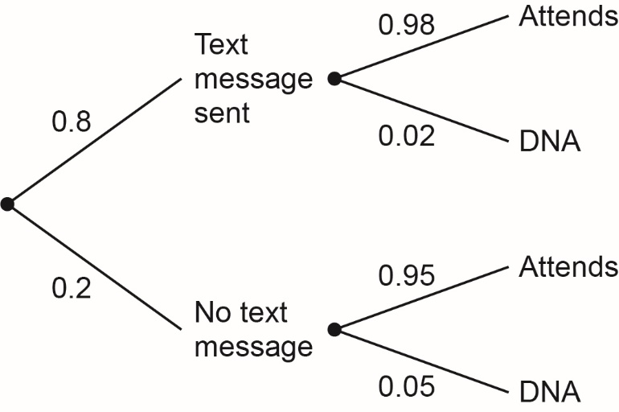

Q1d(ii) |  |  | AO1 | AO2 | AO3
 |  |  |  | 2
Marks | Process and Answer |  | Additional or Alternative Evidence  (with guidance) |  |  |  | SC
1 | 0.8 x 0.02 + 0.2 x 0.05  Or  or 0.016 + 0.01 | M1 | Two correct pairs added  OE |  |  |  | C1
1 | 0.026 or 2.6% OE | A1 | CAO |  |  |  | C1
Q1d(iii) |  |  | AO1 | AO2 | AO3
Marks | Process and Answer |  | Additional or Alternative Evidence  (with guidance) |  |  |  | SC
1
Q1d(iv) |  |  | AO1 | AO2 | AO3
Marks | Process and Answer |  | Additional or Alternative Evidence  (with guidance) |  |  |  | SC
1

Section 2 | Total for this section: 19 marks

Q2a(i) |  |  | AO1 | AO2 | AO3
 |  |  |  | 2
Marks | Process and Answer |  | Additional or Alternative Evidence  (with guidance) |  |  |  | SC
1 | 8.21 x 37 + 9.5 x 3.5 or 337.02 | M1 |  |  |  |  | A2
1 | £1460.42 | A1 | FT their £337.02 × 52 ÷ 12 |  |  |  | A2
Q2a(ii) |  |  | AO1 | AO2 | AO3
 |  |  |  | 3
Marks | Process and Answer |  | Additional or Alternative Evidence  (with guidance) |  |  |  | SC
1 | 0.2 x (1460.42 – 1042) or 83.68 or 1376.74 | B1 | FT their 1460.42 from Q2ai |  |  |  | A2
1 | 0.12 x (1640.42 - 719) or 88.97 | B1 | FT their 1460.42 from Q2ai |  |  |  | A2
1 | (£)1287.77 | A1 | CAO |  |  |  | A2
Q2a(iii) |  |  | AO1 | AO2 | AO3
 |  |  |  | 3
Marks | Process and Answer |  | Additional or Alternative Evidence  (with guidance) |  |  |  | SC
1 | Their 1460.42 x 0.05 or 73.02 or their 1460.42 x 0.95 or 1387.40 | M1 | FT from Q2ai  Accept 1387.399 |  |  |  | A2
1 | Their (1387.40 – 1042) x 0.2 or 69.08 and  (their 1387.40 – 719) x 0.12 or 80.21 | M1 | FT |  |  |  | A2
1 | (£) 1238.11 | A1 |  |  |  |  | A2
Q2a(iv) |  |  | AO1 | AO2 | AO3
 |  |  |  |  | 2
Marks | Process and Answer |  | Additional or Alternative Evidence  (with guidance) |  |  |  | SC
1 | 15000 ÷ (1354 × 0.1) or 110.78.. | B1 |  |  |  |  | A1
1 | 9 years and 3 months | A1 | CAO |  |  |  | A1

Q2b(i) |  |  | AO1 | AO2 | AO3
 |  |  | 1
Marks | Process and Answer |  | Additional or Alternative Evidence  (with guidance) |  |  |  | SC
1 | Positive skew | B1 |  |  |  |  | D2
Q2b(ii) |  |  | AO1 | AO2 | AO3
 |  |  |  | 2
Marks | Process and Answer |  | Additional or Alternative Evidence  (with guidance) |  |  |  | SC
1 | 220 + 30 or 270 – 20 | M1 | OE |  |  |  | D2
1 | 250 | A1 | CAO |  |  |  | D2
Q2b(iii) |  |  | AO1 | AO2 | AO3
 |  |  |  | 2 | 1
Marks | Process and Answer |  | Additional or Alternative Evidence  (with guidance) |  |  |  | SC
1 | 0.6 x 110 or 66 or 0.8 x 90 or 72 | M1 | OE method to find a frequency |  |  |  | D2
1 | 0.6 x 110 or 66 and 0.8 x 90 or 72 | M1 | OE method to find a frequency |  |  |  | D2
1 | 138 | A1 | CAO |  |  |  | D2
Q2b(iv) |  |  | AO1 | AO2 | AO3
 |  |  |  |  | 3
Marks | Process and Answer |  | Additional or Alternative Evidence  (with guidance) |  |  |  | SC
1 | Median is 150th term or £30000 to £35000 | M1 | Allow 151st term or between 150 & 152 |  |  |  | D2
1 | 20/90 x 5000 or 1111.11 | A1 | OE |  |  |  | D2
1 | £3111.11 | A1 | CAO |  |  |  | D2

Section 3 | Total for this section: 19 marks

Q3a |  |  | AO1 | AO2 | AO3
 |  |  |  | 4
Marks | Process and Answer |  | Additional or Alternative Evidence  (with guidance) |  |  |  | SC
1 | x + y ≤ 120 | B1 |  |  |  |  | B3
1 | x ≥ 40 | B1 |  |  |  |  | B3
1 | y ≥ 30 | B1 |  |  |  |  | B3
1 | x > y | B1 |  |  |  |  | B3

Q3b(i) |  |  |  |  |  | AO1 |  | AO2 |  | AO3
 |  |  |  |  |  |  |  |  |  | 4
Marks |  | Process and Answer |  |  |  | Additional or Alternative Evidence  (with guidance) |  |  |  |  |  | SC
1 |  | x = 40 drawn |  | B1 |  | See Q3bii for graph |  |  |  |  |  | B3
1 |  | y = x drawn |  | B1 |  | See Q3bii for graph |  |  |  |  |  | B3
1 |  | y = 30 drawn |  | B1 |  | See Q3bii for graph |  |  |  |  |  | B3
1 |  | x + y = 120 drawn |  | B1 |  | See Q3bii for graph |  |  |  |  |  | B3
Q3b(ii) |  |  |  |  |  | AO1 |  | AO2 |  | AO3
 |  |  |  |  |  |  |  | 1
Marks |  | Process and Answer |  |  |  | Additional or Alternative Evidence  (with guidance) |  |  |  |  |  | SC
1 |  | Region shaded correctly  See below |  | B1 |  | FT their inequalities |  |  |  |  |  | B3
Additional guidance

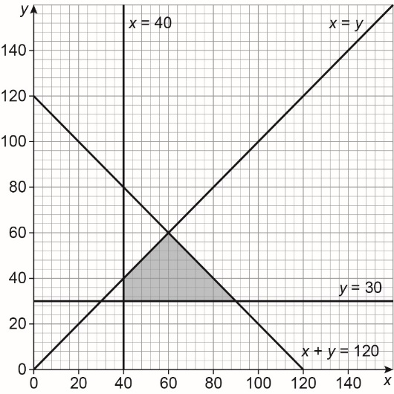
Q3c(i) |  |  |  |  | AO1 |  | AO2 |  | AO3
 |  |  |  |  |  |  | 4
Marks | Process and Answer |  |  |  | Additional or Alternative Evidence  (with guidance) |  |  |  |  |  |  | SC
1 | (40, 30), (40,40), (60,60) and (90,30) |  | G1 |  | Accept coordinates without brackets  May be indicated on graph  FT their shaded region  [Award mark region is triangular and 3 vertices given or indicated] |  |  |  |  |  |  | B3
1 | 40 x 50 + 30 × 100 = £5000  40 x 50 + 40 × 1000 = £6000  60 x 50 + 60 × 100 = £9000  90 x 50 + 30 × 100 = £7500 |  | A1 |  | Award 1 mark for one correct stock value |  |  |  |  |  |  | B3
1 |  |  | A1 |  | Award 2 marks for two correct stock values |  |  |  |  |  |  | B3
1 |  |  | A1 |  | Award 3 marks for all correct stock values |  |  |  |  |  |  | B3
Q3c(ii) |  |  |  |  | AO1 |  | AO2 |  | AO3
 |  |  |  |  | 1
Marks | Process and Answer |  |  |  | Additional or Alternative Evidence  (with guidance) |  |  |  |  |  |  | SC
1 | (90,30) |  | B1 |  | Valid answer based on their graph  OE eg 90 TC and 30 GV  FT their vertices in 3ci if values sum to 120 |  |  |  |  |  |  | B3
Q3c(iii) |  |  |  |  | AO1 |  | AO2 |  | AO3
 |  |  |  |  | 1
Marks | Process and Answer |  |  |  | Additional or Alternative Evidence  (with guidance) |  |  |  |  |  |  | SC
1 | (60,60) |  | B1 |  | Valid answer based on their graph  OE eg 60 TC and 60 GV  FT their vertices in 3ci if values sum to 120 and x value greater than or equal to y value |  |  |  |  |  |  | B3

Q3d |  |  | AO1 | AO2 | AO3
 |  |  |  | 2
Marks | Process and Answer |  | Additional or Alternative Evidence  (with guidance) |  |  |  | SC
1 | See below | B1 | Award 1 mark for 2 correct |  |  |  | C3
1 |  | B1 | Award 2 marks for all 3 correct |  |  |  | C3
Additional guidance

Thermostatic cartridges | Gas valves | Hoses | Boiler fans | Circuit boards | Control panels | Boiler pumps | Pressure release safety valves
0.32 | 0.08 |  |  |  |  | 0.38

Q3e |  |  | AO1 | AO2 | AO3
 |  |  | 2
Marks | Process and Answer |  | Additional or Alternative Evidence  (with guidance) |  |  |  | SC
1 | 0.04 or 0.04³ | B1 | OE |  |  |  | C3
1 | 0.000064 | B1 | OE |  |  |  | C3

Section 4 | Total for this section: 26 marks

Q4a(i) |  |  | AO1 | AO2 | AO3
 |  |  | 2
Marks | Process and Answer |  | Additional or Alternative Evidence  (with guidance) |  |  |  | SC
1 | Normal distribution shaped curve | B1 |  |  |  |  | D4
1 | Centred on 162 cm | B1 |  |  |  |  | D4
Additional guidance

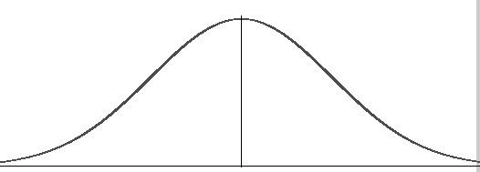
162
Q4a(ii) |  |  | AO1 | AO2 | AO3
 |  |  | 4
Marks | Process and Answer |  | Additional or Alternative Evidence  (with guidance) |  |  |  | SC
1 | Z = 2.326 | B1 |  |  |  |  | D4
1 | 2.326 = $\frac{x-162}{12.5}$ | B1 | OE  FT their 2.326 |  |  |  | D4
1 | x = (2.326 x 12.5) + 162 | B1 | OE  FT their 2.326 |  |  |  | D4
1 | 191(.075) cm | A1 | FT their 2.326 |  |  |  | D4

Q4b(i) |  |  | AO1 | AO2 | AO3
 |  |  |  |  | 1
Marks | Process and Answer |  | Additional or Alternative Evidence  (with guidance) |  |  |  | SC
1 | 68% | A1 |  |  |  |  | D4
Q4b(ii) |  |  | AO1 | AO2 | AO3
 |  |  |  |  | 1
Marks | Process and Answer |  | Additional or Alternative Evidence  (with guidance) |  |  |  | SC
1 | 237 and 293 (days) or 56 (days) | A1 |  |  |  |  | D4

Q4c(i) |  |  | AO1 | AO2 | AO3
 |  |  |  |  | 1
Marks | Process and Answer |  | Additional or Alternative Evidence  (with guidance) |  |  |  | SC
1 | Any answer that says no and suggests it is primary data | A1 |  |  |  |  | D1
Q4c(ii) |  |  | AO1 | AO2 | AO3
 |  |  |  |  | 1
Marks | Process and Answer |  | Additional or Alternative Evidence  (with guidance) |  |  |  | SC
1 | No and valid reason  Eg  - The data is biased because the Health and Safety Manager has surveyed one store only  - The employees may not be representative of the UK population | A1 |  |  |  |  | D1

Q4c(iii) |  |  | AO1 | AO2 | AO3
 |  |  | 2
Marks | Process and Answer |  | Additional or Alternative Evidence  (with guidance) |  |  |  | SC
1 | Advantages any one from:  - More representative of a population with different subgroups  - Cheaper than asking the whole population  - More time efficient than asking the whole population (conduction a census) | A1 |  |  |  |  | D1
1 | Disadvantages any one from  - Not easy when the population does not fit into specific subgroups  - More expensive than random sampling  - Members of a subgroup may not be available to respond | A1 |  |  |  |  | D1
Q4c(iv) |  |  | AO1 | AO2 | AO3
 |  |  | 4
Marks | Process and Answer |  | Additional or Alternative Evidence  (with guidance) |  |  |  | SC
1 | Manchester = 452 (do not accept unrounded final answer) | A1 |  |  |  |  | D1
1 | Birmingham = 68 | A1 |  |  |  |  | D1
1 | Stoke on Trent = 95 | A1 |  |  |  |  | D1
1 | Redditch = 91 | A1 |  |  |  |  | D1

Q4c(v) |  |  | AO1 | AO2 | AO3
 |  |  |  | 3
Marks | Process and Answer |  | Additional or Alternative Evidence  (with guidance) |  |  |  | SC
1 | Cumulative frequencies calculated | B1 | May be seen in graph |  |  |  | D2
Additional guidance

Plotted at | Cumulative frequency
140 | 11
150 | 60
160 | 249
170 | 551
180 | 685
190 | 703
200 | 706

1 | Points correctly plotted at the end of each class width and with their calculated CF values | M1 | May be seen in graph |  |  |  | D2
1 | Points correctly joined in a smooth curve | A1 | May be seen in graph |  |  |  | D2
Additional guidance

Q4c(vi) |  |  | AO1 | AO2 | AO3
 |  |  | 2 | 3
Marks | Process and Answer |  | Additional or Alternative Evidence  (with guidance) |  |  |  | SC
1 | Median 163 (cm) | B1 | FT their graph  Must use 353rd or 354th term |  |  |  | D3
1 | LQ 156 (cm) | B1 | FT their graph  Must use 176th or 177th term |  |  |  | D3
1 | UQ 169 (cm) | B1 | FT their graph  Must use 530th or 531st term |  |  |  | D3
1 | IQR: 169 – 156 = 13 | B1 | FT their UQ and LQ values |  |  |  | D3
1 |  | G1 |  |  |  |  | D3
Additional guidance

Due to scale of graph, accept any reasonable approximation.
Accept box plot with values calculated rather than using cumulative frequency graph
AWRT
Q4c(vii) |  |  | AO1 | AO2 | AO3
 |  |  |  |  | 2
Marks | Process and Answer |  | Additional or Alternative Evidence  (with guidance) |  |  |  | SC
1 | e.g. the date is roughly symmetrical or the data has a small negative skew | B1 | Comment on symmetry  FT their graph or box plot |  |  |  | D2
1 | e.g. this does not support the theory that the height data is normally distributed, as normally distributed data is symmetrical about the mean (and median) | B1 | Comment on theory  FT their graph or box plot |  |  |  | D2

Assessment Objective Grid
Section | AO1 | AO2 | AO3 | Total
1 | 5 | 9 | 12 | 26
2 | 1 | 12 | 6 | 19
3 | 6 | 9 | 4 | 19
4 | 14 | 6 | 6 | 26
Total | 26 | 36 | 28 | 90

