NCFE Level 3 Certificate in
Mathematics for Everyday Life (603/3437/X) PRACTICE

Paper 1

Paper number: P00XXXX

DATE

To be completed by the examiner | Mark
Section 1
Section 2
TOTAL MARK
Time allowed: 1 hour 30 minutes

Learner instructions
- Use black or blue ink.
- Answer all questions.
- Read each question carefully.
- Write your responses in the spaces provided.
- All of the work you submit must be your own.

Learner information
- The marks available for each question are shown in brackets.
- The maximum mark for this paper is 60.
- You may use a calculator.

Learner name
Centre name
Learner number |  |  | Centre number

Please complete the details below clearly and in BLOCK CAPITALS.

Do not turn over until the invigilator tells you to do so.

Section 1

This section has a possible 8 marks.

We recommend that you spend 15 minutes on this section.

Answer all questions in the spaces provided.

1 |  | Graham is 20 years old.  He needs to get insurance for his motorcycle.  Graham must pay 30% more than the normal cost of insurance because he is a young rider.  Graham pays £838.50 for his insurance.  How much is the normal cost of insurance?  [1 mark]
 |  | A | £251.55
 |  | B | £586.95
 |  | C | £645.00
 |  | D | £1090.05
 |  | Answer

2 |  | A new cable link is going to connect six towns in a region. This is shown by the network below.  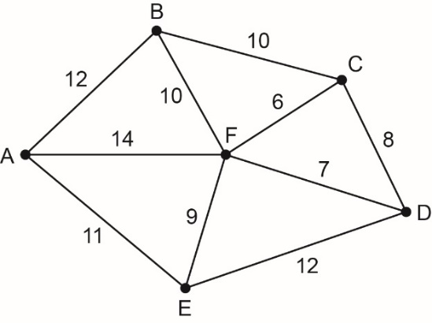  A consultant wants to find the minimum spanning tree. He uses Kruskal’s algorithm.  Which would be the third arc chosen?  [1 mark]
 |  | A | CB
 |  | B | CD
 |  | C | FD
 |  | D | FE
 |  | Answer

Please turn over
3 |  | There are 98 applicants for a job as a train driver.  All applicants are tested to see if they are colour blind.  The results are shown in the frequency tree diagram below.  M = Male, F = Female, C = Colour blind, N = Not colour blind.  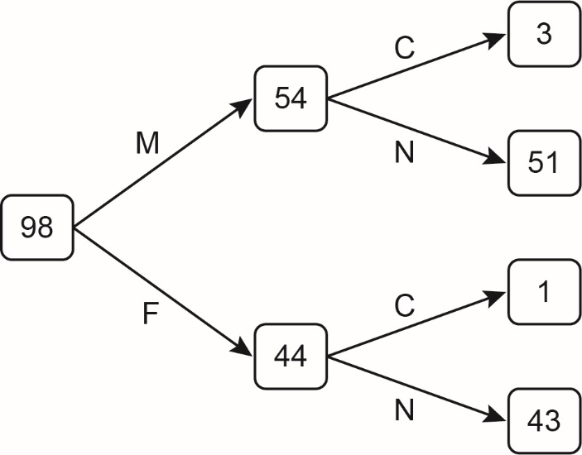  One of the applicants is chosen at random.  Given that this applicant is colour blind, what is the probability that they are female?  [1 mark]
 |  | A | $$\frac{1}{44}$$
 |  | B | $$\frac{4}{98}$$
 |  | C | $$\frac{3}{4}$$
 |  | D | $$\frac{1}{4}$$
 |  | Answer

4 |  | A college wants to form a student advisory group of 20 students.  The table shows the number of students in the college.  Department Male Female Totals  Business 58 56 114  Health 69 74 143  Engineering 82 65 147  The administrator decides to use stratified sampling to select the members of the advisory group.  How many female engineers should be included in the advisory group?  [1 mark]
 |  | A | 2
 |  | B | 3
 |  | C | 5
 |  | D | 10
 |  | Answer

5 |  | The balance of Ingrid’s credit card account is £245 on the last day of January.  Ingrid is charged 1.5% compound interest on the balance of the account on the last day of each month.  How much will Ingrid owe on the last day of April if she makes no payments to reduce the balance?  [1 mark]
 |  | A | £248.68
 |  | B | £252.41
 |  | C | £256.03
 |  | D | £256.19
 |  | Answer

Please turn over
6 |  | An activity network for building a shed is shown below.  The activity times are in hours.  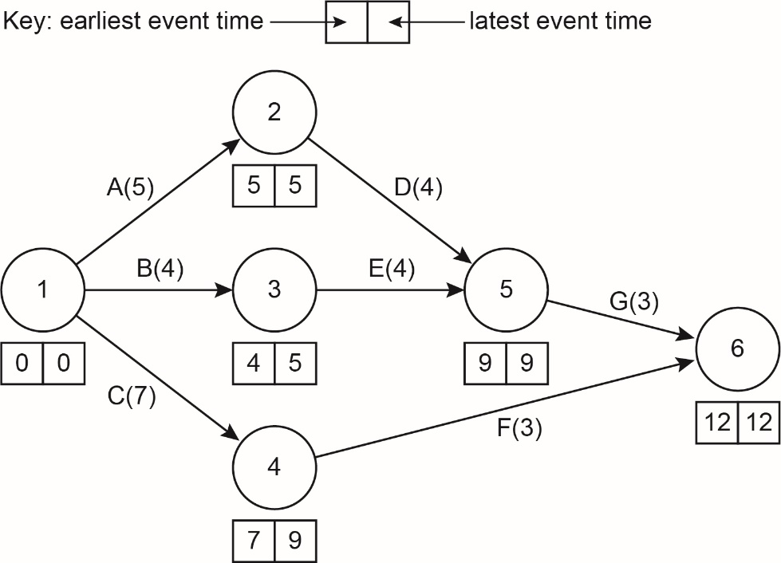  How many of these activities are non-critical?  [1 mark]
 |  | A | 2
 |  | B | 3
 |  | C | 4
 |  | D | 5
 |  | Answer

7 |  | A garage carries out car services, repairs and MOT tests.  The incomplete Venn diagram below represents the number of cars that the garage worked on last week.  Last week the garage worked on 125 cars.  5 cars had a service, MOT test and repairs.  10 cars had an MOT test only.  Repairs were done on 55 cars.  If one of the cars was picked at random, what is the probability that it had an MOT test and service only?  [1 mark]
 |  | A | 24%
 |  | B | 32%
 |  | C | 48%
 |  | D | 80%
 |  | Answer

Please turn over
8 |  | In a study about exercise, 80 runners ran on a treadmill for 6 minutes at a steady speed of 10km/h.  Their heart rates in beats per minute (bpm) were recorded at the end of the run.  The results showed that the heart rates were normally distributed with a mean of 120 bpm and standard deviation of 18 bpm.  This can be represented by the normal distribution X ~ N(120,18²).  Approximately how many runners had a heart rate above 138 bpm?  [1 mark]
 |  | A | 13
 |  | B | 18
 |  | C | 26
 |  | D | 38
 |  | Answer

Section 2

This section has a possible 52 marks.

We recommend that you spend 75 minutes on this section.

Answer all questions in the spaces provided.

9 | A band has 14 songs that they use in live performances.  The live performances are split into two sessions.
 | a) | For the first session the band has to select six songs.  Calculate the number of different selections that the band can make.
 |  |  | [2 marks]
 | b) | Once they have chosen six songs, they have to decide in which order they will perform them.  How many different ways can the band order the six songs?
 |  |  | [2 marks]

Please turn over
10 | This stem and leaf diagram shows the mass, in grams, of 25 male sparrowhawks.  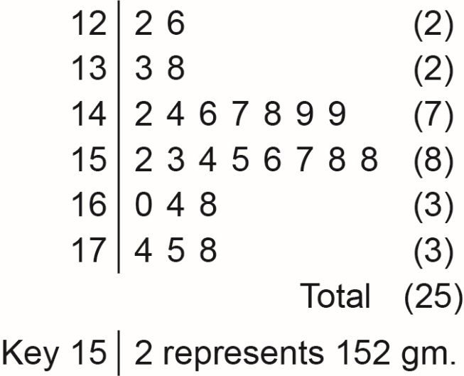  Find the median and interquartile range of the data.  Using your results, identify any outliers.  You must show your working.
 |  |  | [4 marks]

11 | A system of overhead pipes will connect six workstations in a large factory.  The table below shows the distances between the six workstations.  The distance between the stations is measured in metres.  Workstation A B C D E F  A - 62 - - 85 -  B 62 - 45 24 52 58  C - 45 - 71 32 62  D - 24 71 - 12 48  E 85 52 32 12 - 65  F - 58 62 48 65 -  Apply Prim’s algorithm to the table above to find the length of the minimum connector, starting at vertex A.  State the order in which you connected the vertices.  Draw the resulting connector and state the length.
 |  |  | [6 marks]

Please turn over
12 | Kiara owns a jewellery business.  She employs a salesperson in the shop and two outworkers who work from home.  The two outworkers are paid a fixed price for each set of necklaces and bracelets they produce.  Kiara is about to introduce a new range and wants to set a realistic pay rate for the work.  She asks both outworkers to make three identical sets of necklaces and bracelets from the new range.  Kiara records their times in minutes:  Set 1 Set 2 Set 3  Worker 1 55 51 50  Worker 2 60 53 51
 | a) | Give one reason why the time taken by the workers steadily decreased.  Why do you think the workers agreed with Kiara that 50 minutes was a fair time for the job?
 |  |  | [2 marks]

 | The salesperson works for 36 hours each week and is paid at the National Living Wage rate of £8.21 per hour (based on 2019-20 rates.)
 | b) | How much does the salesperson earn in a normal week?
 |  |  | [1 mark]
 | Kiara fixes the rate for the new range at £7 per set for outworkers.
 | c) | How many sets would an outworker have to make in a week to earn at least as much as the salesperson?
 |  |  | [1 mark]
 | d) | Give one reason why the salesperson might prefer his pay rate to the outworkers pay rate  and  give one reason why the outworkers might prefer their pay rate to the salesperson’s pay rate.
 |  | [2 marks]

Please turn over
13 | There are 20 cars entered for a motor race.  The number of cars likely to break down in a race can be modelled by a binomial distribution X ~ (20, 0.25)
 | a) | How many cars are expected to break down during a race?
 |  |  | [1 mark]
 | b) | What is the probability that no cars break down during a race?  Give your answer to four decimal places.
 |  |  | [2 marks]
 | c) | What is the probability that more than five cars break down during a race?  Give your answer to four decimal places.
 |  |  | [3 marks]

 | d) | What is the probability that in two successive races, more than five cars break down?  Give your answer to four decimal places.
 |  |  | [2 marks]
Please turn over for the next question.

14 | A road map of some of the main roads in Devon and Cornwall is shown below.  The distances shown are in miles.  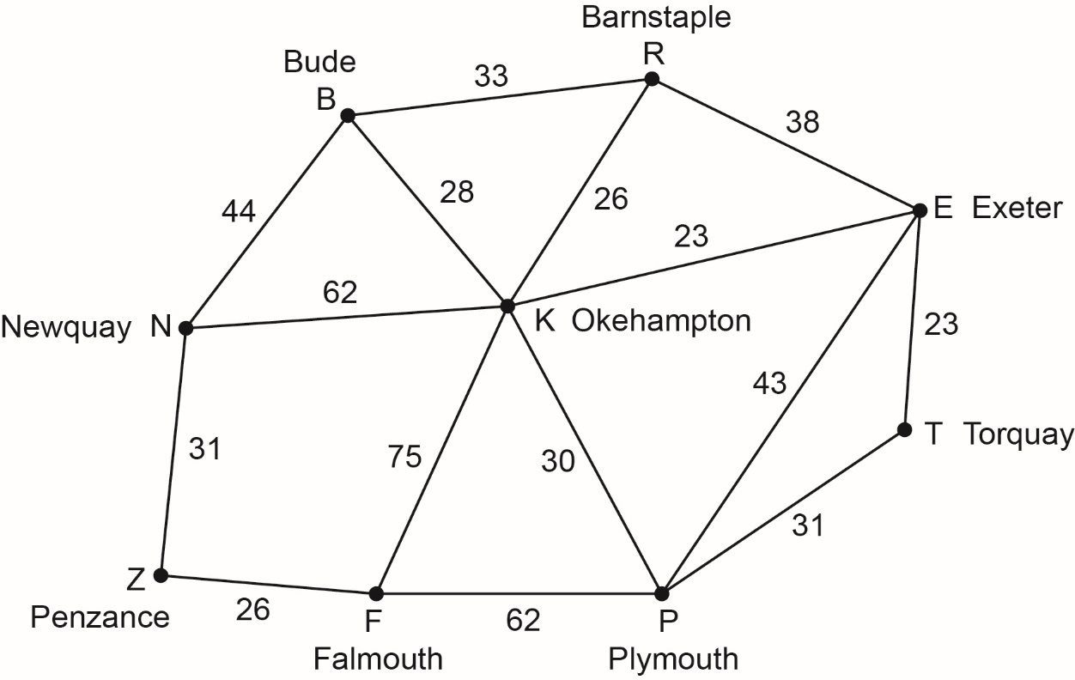

 | a) | The road from Okehampton to Exeter has been temporarily closed.  Find the shortest available distance from Penzance to Exeter using Dijkstra’s algorithm.  State clearly both the shortest route available and the length of this route.  You must use the diagram below and show all of your working.
 |  |  | [6 marks]
 |  |  | 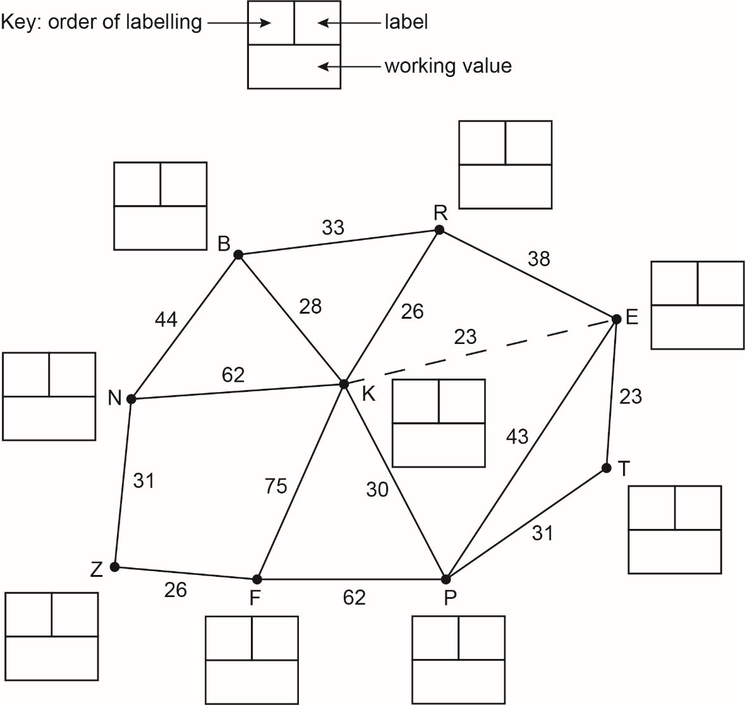
 | b) | The road between Okehampton and Exeter finally opens.  How much shorter is the distance now?
 |  |  | [2 marks]
Please turn over
15 | Alisha took out a personal loan from her bank of £3000  She was asked to pay off the loan in two equal payments of £1725  She had to make one payment at the end of the first year and one payment at the end of the second year.
 | a) | Show calculations to confirm that the annual percentage rate (APR) is approximately 9.85%
 |  |  | [3 marks]
Two years ago, James won £1200 for designing an app.

He invested the money into a savings account with an annual equivalent rate (AER) of 2.5%

James did not spend any of this money.

One year later, he invested a further £1000 into the same account.

James did not spend any of this money either.
 | b) | At the end of the two-year period, how much money does James have in his savings account?
 |  |  | [3 marks]

 | James bought a new estate car two years ago for his business. The value of the car depreciates by 20% each year.
 | c) | If the car is now worth £13 760, how much did James pay for the car originally?
 |  |  | [2 marks]

Please turn over for the next question.

16 | A recent study compared the body mass (in kilograms) and the brain mass (in grams) for a sample of mammals.  The results are shown in the table below:  Mammals A B C D E F G H I J  body mass (kg) 36.33 60.00 27.66 85.00 52.16 99.67 35.00 62.00 83.00 55.50  brain mass (g) 119.5 81.0 115.0 325.0 440.0 157.0 56.0 132.0 98.2 175.0  Lerato plotted these results on a scatter graph.  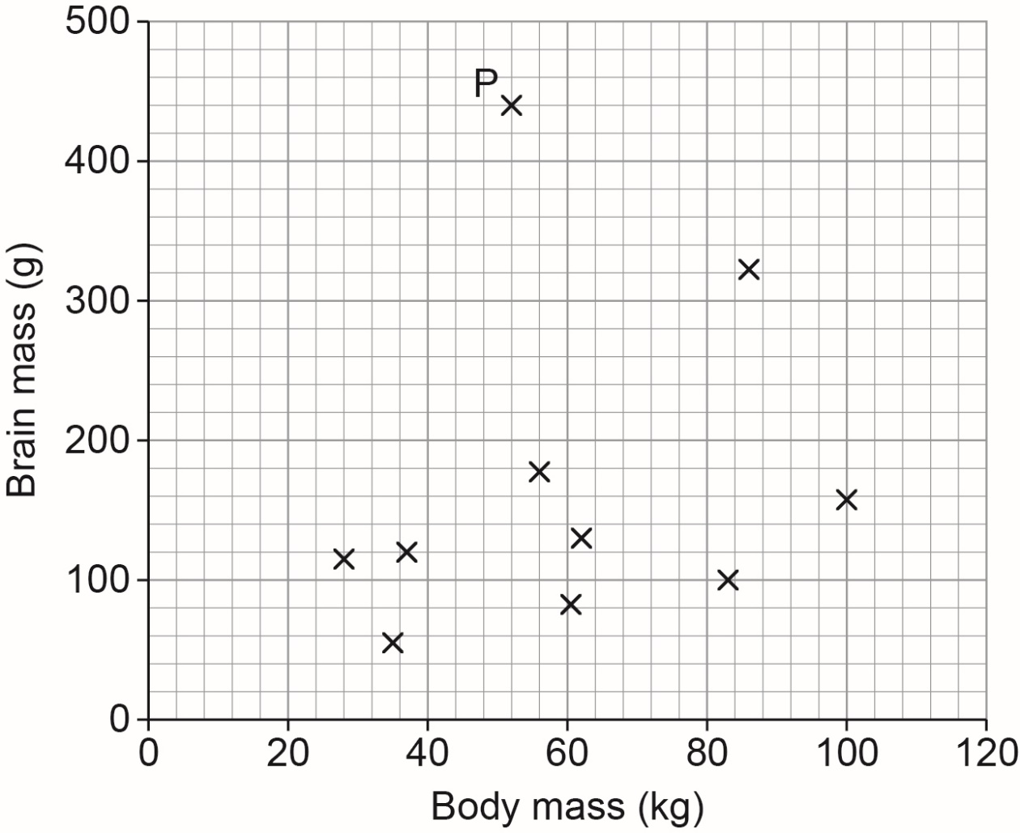  Lerato claims that heavier mammals will have heavier brains.
 | a) | Does the scatter graph support Lerato’s claim?  Give one reason for your answer.
 |  | [1 mark]

 | b) | Lerato suspects that P is an outlier.  Which mammal is represented by the point P and why does Lerato think that it might be an outlier?  Describe two actions Lerato should take if she suspects P is an outlier.
 |  | [4 marks]
 | c) | Calculate the product moment correlation coefficient (r) if all of the data is included.
 |  | [1 mark]

Please turn over
 | d) | If the point P is excluded, then the product moment correlation coefficient (r) is 0.483  Compare this with your result from 16(c).  Clearly state what the results show.
 |  | [2 marks]

This is the end of the external assessment.

This page is intentionally left blank

Assessment Objective Grid
Question | AO1 | AO2 | AO3 | Total
1 - 8
9
10
11
12
13
14
15
16
Total

