NCFE Level 3 Certificate in Mathematics for Everyday Life (603/3437/X)
Pre-release Material

To be issued to learners on XXXX in preparation for the below external assessment.

Learner information
- This pre-release material is for the below external assessment ONLY.
- You must not bring this pre-release material into the external assessment.
- You will be provided with a further copy of this pre-release material at the start of the external assessment.

DATE

Time allowed: 2 hours

Article A: Old age: Why 70 may be the new 65
In the UK, 65 years of age has traditionally been taken as the marker for the start of older age, most likely because it was the official retirement age for men and the age at which they could draw their State Pension.

In terms of working patterns, age 65 years as the start of older age is out of date. There is no longer an official retirement age, State Pension age is rising, and increasing numbers of people work past the age of 65 years.

People are also living longer, healthier lives. In 2018, a man aged 65 could expect to live for another 18.6 years, while a woman could expect to live for 21 more years. So, on average, at age 65 years, women still have a quarter of their lives left to live and men just over one fifth.

Furthermore, age 65 years is not directly comparable over time. Someone aged 65 years today has different characteristics than someone the same age a century ago. This is particularly marked in terms of their health and life expectancy.

So if the start of older age has shifted, what should be the new starting age? Should we just move the threshold on a few years – is age 70 really the new age 65? Or, might there be a better way of determining the start of older age?

What is population ageing?
At a population level, ageing is measured by an increase in the number and proportion of those aged 65 years and over, and an increase in median age (the age at which half the population is younger and half older).

On both of these measures, the population has aged and is projected to continue to age (Figure 1). In 2018, there were 11.9 million residents in Great Britain aged 65 years and over, representing 18% of the total population.

This compares with the year 1950 when there were 5.3 million people aged 65 years and over, representing 10.8% of the total population.

In 2050, there are projected to be 17.7 million people aged 65 years and over (24.8% of the population). The fastest-growing age group is aged 85 years and over. The population of this group is projected to double from 1.6 million in 2018 to 3.6 million by 2050 (5% of the population).

Please turn over

The balance of older and younger people in the population has also tipped more towards older people. The median age has risen from 34 years in 1950 to 40 years in 2018. By the middle of this century it is projected that median age will reach 43 years.

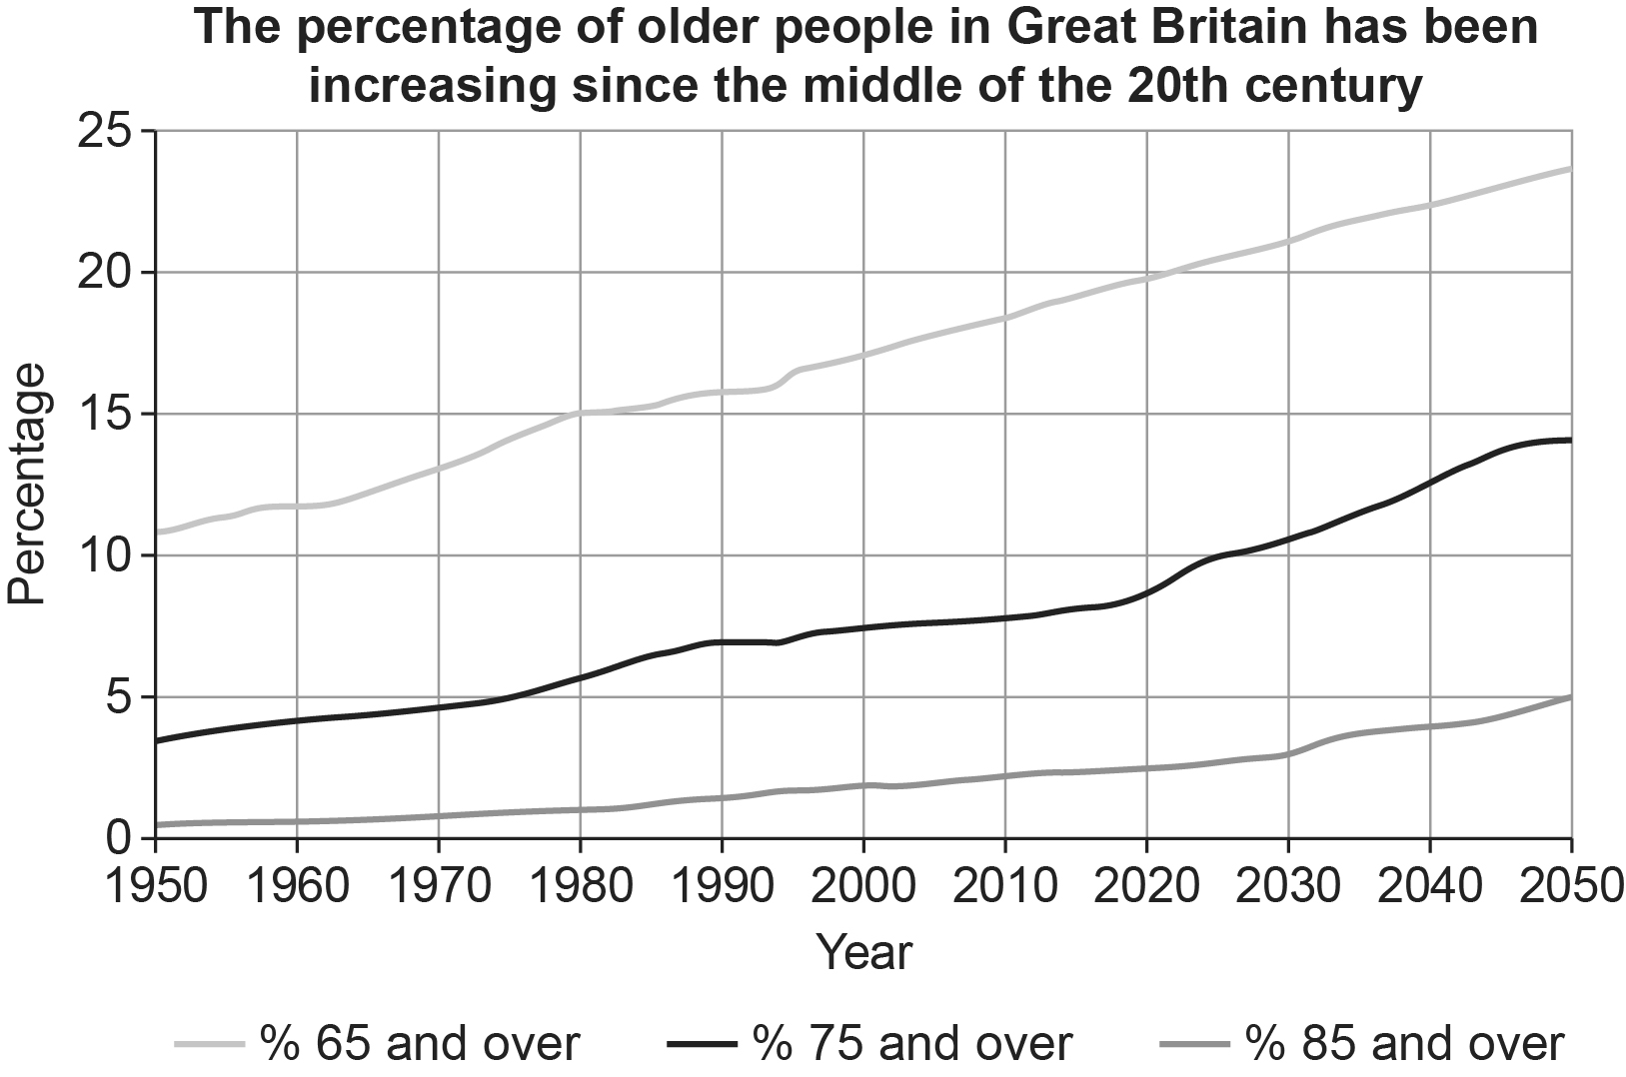

Why does this matter?
Measuring population ageing is important because it has multiple economic, public service and societal impacts. It brings challenges but also opportunities.

From an economic and societal point of view, longer lives mean people can continue to contribute for longer. They can have longer working lives, volunteer, and possibly provide care for family members, such as grandchildren. For individuals it might mean the opportunity to spend more time with family and friends and to pursue personal interests with more time for leisure activities.

The challenges of having more older people include increased demand for health and adult social services and increased public spending on State Pensions. If the balance is to shift from challenge towards opportunity, both at a societal level and at an individual level, then older people must be able to live healthy lives for as long as possible. The importance of health at older ages has been prioritised by the government in their Grand Challenge on Ageing.

Is there a better measure of population ageing?
Sergei Scherbov and Warren Sanderson have suggested that instead of taking a fixed chronological age as the start of older age, a better alternative would be to set the threshold at a fixed remaining life expectancy (RLE) of 15 years.
The age at which a person has an RLE of 15 years changes over time in line with changes in life expectancy and will also be different for men and women because of differences in their life expectancies.

Table 1: Age at which there is 15 years of remaining life expectancy.
 | 1911 | 2020 | 2066
Men | 57 | 70 | 75
Women | 60 | 72 | 77
Source: Office for National Statistics

In 2020, in Great Britain a man with RLE of 15 years was aged 70 and a woman was aged 72. In terms of RLE this is equivalent to a man aged 57 and a woman aged 60 in 1911. It is projected that by 2066, the equivalent ages will be 75 years for a man and 77 years for a woman (Table 1).
Unlike chronological age, age at RLE15 is a measure that changes over time in line with improvements in life expectancies. Instead of looking back over years lived (chronological age), this measure looks forward and marks the start of older age in terms of an average number of years left to live, that is, a prospective measure of ageing.
Source: https://www.ons.gov.uk/peoplepopulationandcommunity/birthsdeathsandmarriages/ageing/articles/livinglongerisage70thenewage65/2019-11-19

Please turn over
Article B: National Living Wage earners fall short of average family spending
From April 2020, the National Living Wage rose from £8.21 to £8.72 per hour from April 2020 – but how easy is it to live on?

Mums and dads working full-time on the new National Living Wage will earn £327 per week. Office for National Statistics (ONS) data suggests that this is less than the average amount spent by households with two adults and two children in the financial year ending 2020.

Two parents aged 25 and over each work 37.5 hours per week. They are paid at the new National Living Wage rate of £8.72 per hour. They will take home a total of £566 per week after Income Tax, National Insurance and pension contributions have been deducted.

In the financial year ending 2019, official data show a household with two adults and two children, where one or both parents work less than 37.5 hours per week. These parents spent an average of £769 per week on housing, bills, food, clothes, childcare, holidays and other living costs.

One-earner households
The gap between earnings and average household spending varies. The gap depends on household circumstances, including how many people live in a household.

Someone aged 25 and over who works 37.5 hours per week on the new NLW will earn £283 per week after Income Tax, National Insurance and pension contributions.

In the financial year ending 2019:
- households containing only one non-retired adult with no children spent an average of £347 per week.
- households with one adult and one child spent an average of £409 per week.
- households with one adult and two or more children spent an average of £421 per week.

Comparing earnings and spending
The figures given above compare 2020 National Living Wage earnings to household spending levels in the financial year ending 2019. Since 2019, household spending levels are likely to have risen because of price rises. The Consumer Prices Index, which included owner occupiers’ housing costs (CPIH), measured inflation at 1.3% in March 2020.

Earnings are not the only source of income. Tax credits, benefits and investments may help low-earners bring in more money. Also, low-income households tend to spend less than high-income ones, so in many households the gap between earnings and spending may be a lot smaller, or non-existent. However, people in the UK are borrowing more than they used to, and levels of household debt have gone up in recent years.

[The National Minimum wage will be recalculated in April 2021]

Article C: Income Tax and National Insurance 2020 – 2021
Income tax rates and taxable bands 2020 – 2021

PAYE tax rates and thresholds | 2020 - 2021
Personal allowance | £240 per week  £1042 per month  £12 500 per year
Basic rate | 20% on annual earnings above the PAYE tax threshold and up to £37 500.
Higher rate | 40% on annual earnings above the PAYE tax above £37 500 and up to £150 000
Additional rate | 45% on annual earnings over £150 000

To calculate your income tax if your annual income is £100,000 or less.

Find your taxable income by subtracting your personal tax allowance from your annual gross income.
You pay income tax at 20% on the first £37 500 of your taxable income.
You pay income tax at 40% on your taxable income over £37 500.

National Insurance (NI) 2020-21

You only make National Insurance deductions on earnings above the Lower Earning Limit (LEL).

Class 1 National Insurance thresholds

Lower Earning Limit (LEL) | £120 per week  £520 per month  £6240 per year
Primary Threshold (PT) | £183 per week  £792 per month  £9500 per year
Upper Earnings Limit (UEL) | £962 per week  £4167 per month  £50 000 per year

Class 1 National Insurance rates

Earnings at or above LEL up to and including PT | 0%
Earnings above PT and up to and including UEL | 12%
Balance of earnings above UEL | 2%

Examples
A person who had a weekly income of £375 pays 12% on the amount above £183.
A person who had a monthly income of £4250 pays 12% on the amount between £792 and £4167 plus 2% of the amount above £4,167.
Gross pay
Your gross pay is your wage or salary, before any deductions are made.
Net pay
Your net pay (or take-home pay) is the amount of money you receive after income tax, National Insurance and other deductions have been taken off your gross pay.

National Minimum Wage (NMW) from April 1st 2020

National Living Wage (25+) | £8.72 per hour
NMW (21 – 24) | £8.20 per hour
NMW (18 – 20) | £6.45 per hour
NMW (16 -17) | £4.55 per hour
Apprentices aged under 19 | £4.15 per hour
Apprentices aged 19 or over, but in their first year of their apprenticeship. | £4.15 per hour

Student Loans
The Student Loans Company (SLC) gives loans to students at university.
There are two types of repayment plan for student loans. If you started your course before 1 September 2012 you will be on repayment plan 1
If you started your course on or after 1 September 2012 you will be on repayment plan 2.
Repayment plan 1
You only start making repayments when your gross income is over the threshold of £19 380 a year (£1615 per month, £372 per week). You pay 9% of anything you earn over the threshold.

Please turn over.

Repayment plan 2
You only start making repayments when your gross income is over the threshold of £26 560 a year (£2214 per month, £511 per week). You pay 9% of anything you earn over the threshold.

For either plan you can also make additional voluntary repayments to SLC at any time which will reduce your balance earlier.
Personal pension contributions.

In most cases, your pension contributions are deducted from your salary before income tax is paid on them and so are effectively “tax free”.

This is the end of this document.

