NCFE Level 3 Certificate in
Mathematics for Everyday Life (603/3437/X)
Practice paper (May 2020)

Paper 2

Health and Science
Paper number: P00XXXX

DATE

To be completed by the examiner | Mark
Section 1
Section 2
Section 3
Section 4
TOTAL MARK
Time allowed: 2 hours

Learner instructions
- Use black or blue ink.
- Read each question carefully.
- Answer all questions.
- Write your responses in the spaces provided.
- Use the graph paper provided where instructed.
- All of the work you submit must be your own.

Learner information
- The marks available for each question are shown in brackets.
- The maximum mark for this paper is 90.
- You may use a calculator.

Learner name
Centre name
Learner number |  |  | Centre number

Please complete the details below clearly and in BLOCK CAPITALS.

Do not turn over until the invigilator tells you to do so.

Section 1

This section has a possible 26 marks.

We recommend that you spend 35 minutes on this section.

Answer all questions in the spaces provided.

1 | a) | In Article A the reporters suggest that 65 is no longer a suitable measure for the start of old age.
 |  | i. | Give two reasons why they suggest this.
 |  |  | [2 marks]
 |  | Article A suggests that the average age of the UK population is increasing over time.
 |  | ii. | According to the graph, approximately what percentage of people are predicted to reach at least the age of 75 by 2050?
 |  |  | [1 mark]

 |  | Population ageing is measured by the increase in the proportion of those aged 65 and older, leading to an increase in the median age.
 |  | iii. | Why is it sensible to use the median age rather than the mean age in this instance?
 |  |  | [1 mark]
 |  | The Government thinks it is important to measure population ageing as it has many implications for demographic planning.
 |  | iv. | Give one advantage and one disadvantage of people living longer.
 |  |  | [2 marks]
 |  | Scherbov and Sanderson suggest that an effective way to measure the ageing population is to look at Remaining Life Expectancy (RLE).
 |  | v. | Give two reasons why RLE could be an accurate measure of the population ageing.
 |  |  | [2 marks]

Please turn over
 | b) | Statisticians have used Article A to suggest that the life expectancy of people currently aged 60 could be modelled by a normal distribution X ~ N(85, 8²)  Using this model, calculate what percentage of people (to 1 decimal place) aged 60 in 2020:
 |  | i. | will live to at least 85?
 |  |  | [1 mark]
 |  | ii. | will die before they are 80?
 |  |  | [2 marks]

 |  | iii. | will live to be at least 100?
 |  |  | [3 marks]
 |  | iv. | will die between the ages of 80 and 89 inclusive?
 |  |  | [3 marks]

Please turn over
 | c) | As people are generally living longer, there is likely to be an increase in older drivers on the road.  Road safety experts want the Government to retest older drivers at regular intervals. This will make sure that the reaction times of older drivers are fast enough to cope with modern traffic demands.  A recent study carried out by a local university tested the reaction times of drivers of various ages, to a light changing from red to green.  The results are shown below:
Age (in years) | Reaction time (s) | Age (in years) | Reaction time (s)
18 | 0.15 | 49 | 0.39
20 | 0.27 | 56 | 0.48
25 | 0.11 | 64 | 0.72
32 | 0.50 | 68 | 0.76
38 | 0.72 | 73 | 0.45
42 | 0.52 | 80 | 0.77

 |  | These results are shown on this scatter graph:
 |  | 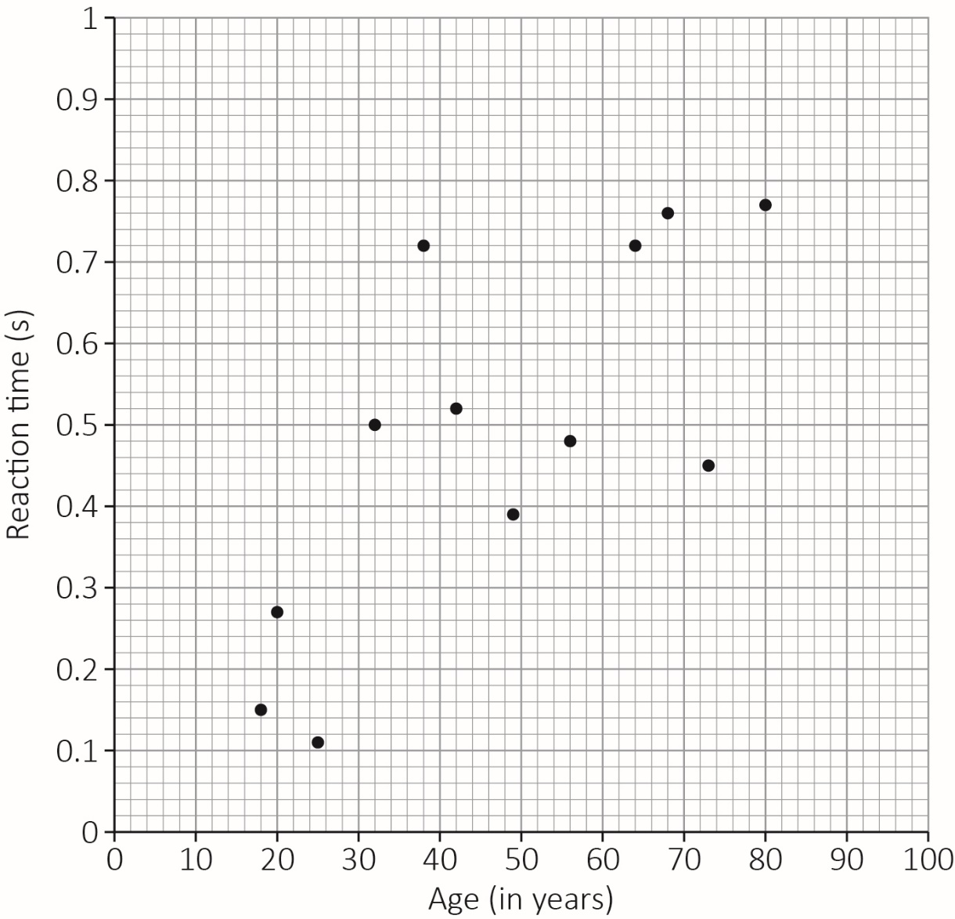
 |  | i. | Find:  - the double mean point  - the equation of the line of regression of time (t ) on age (x) and  the strength of correlation using the PMCC.
 |  |  | [3 marks]
 |  | ii. | Plot the regression line on the graph on page 6.
 |  |  | [2 marks]
 |  | iii. | Use this line to estimate the reaction time of a person aged 40.  Explain why this line should not be used to estimate the reaction time  of a person aged 90.
 |  |  | [2 marks]
Please turn over
 |  | iv. | These results support the view that people’s reactions slow down as they grow older. Give two reasons to support this statement.
 |  |  | [2 marks]

This page is intentionally left blank.
Please turn over for the next question.

Section 2

This section has a possible 19 marks.

We recommend that you spend 25 minutes on this section.

Answer all questions in the spaces provided.

2 | a) | Article B regarding the National Living Wage states that people on the National Living Wage earn less than the average family spends.  Article C gives the National Minimum Wage (NMW) for workers from the age  of 16 to 25.
 |  | i. | Explain how the National Minimum Wage differs from the National Living Wage.
 |  |  | [1 mark]
 |  | ii. | According to Article B, the National Living Wage rose from £8.21 per hour in April 2019 to £8.72 per hour in April 2020.  The Consumer Price Index measured the annual inflation rate at 1.3% over the same period.  How does the rise in the National Living Wage compare with inflation?
 |  |  | [2 marks]

 |  | iii. | Apprentice wage rates rose from £3.90 per hour in 2019 to £4.15 per hour in 2020.  Compare the percentage rise in the National Living Wage to the percentage rise in the apprentice wage rates. Explain your answer.
 |  |  | [2 marks]
 |  | iv. | Other than wages, name two different sources of income that people might receive.
 |  |  | [1 mark]

Please turn over
 | b) | Gareth is 19 years old and has just started a 2 year apprenticeship.  He works 35 hours per week and will be paid for annual leave.  After he completes his first year, he will be paid at the National Minimum Wage.  Article C gives the National Minimum Wage for workers from the age of 16 to 25.
 |  | i. | Calculate any tax and National Insurance Gareth may have to pay during his apprenticeship.  You must show calculations to support your answer.
 |  |  | [4 marks]

If Gareth successfully completes his apprenticeship, his company will offer him a
full-time job earning a gross annual salary of £28 000 per year.
 |  | ii. | Calculate Gareth’s net monthly salary once he has completed his apprenticeship.  Assume there is no change in the tax and National Insurance contributions.
 |  |  | [3 marks]

Please turn over
 | c) | A road system has been planned for six new villages.  Gareth is given the job of modifying the design of this road system. The planners have already proposed direct roads between the villages.  A direct road is one that links two villages without passing through another village.  The table below shows the lengths in kilometres of these direct roads.  Villages are labelled A-F.  A B C D E F  A - 11 6 - - -  B 11 - - 5 - 10  C 6 - - 3 4 -  D - 5 3 - 8 -  E - - 4 8 - 8  F - 10 - - 8 -  Gareth’s brief is to modify the design to minimise the number of roads.  Although there does not need to be a direct link, it must be possible to travel from village to village.
 |  | i. | Draw a network diagram of the original planned road system on the diagram below.  [1 mark]  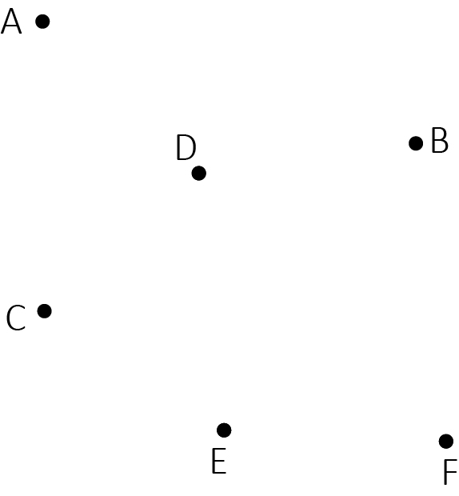
 |  | ii. | Use the tabular form of Prim’s algorithm starting at A, to find the minimum connector for the six villages.  You must state the order in which you connected the vertices.
 |  |  | [3 marks]
 | A | B | C | D | E | F
A | - | 11 | 6 | - | - | -
B | 11 | - | - | 5 | - | 10
C | 6 | - | - | 3 | 4 | -
D | - | 5 | 3 | - | 8 | -
E | - | - | 4 | 8 | - | 8
F | - | 10 | - | - | 8 | -

 |  | iii. | Draw the connector and give its total length.
 |  |  | [2 marks]

Please turn over
Section 3

This section has a possible 19 marks.

We recommend that you spend 25 minutes on this section.

Answer all questions in the spaces provided.

3 | Carla manages a health centre in Stamford Bridge.
 | a) | Carla calculated the number of packages arriving in a particular week.  Carla calculated that from Monday to Wednesday, the mean number of packages arriving was 59 each day.  On Thursday and Friday, the mean number of packages arriving was 84 each day.
 |  | i. | Calculate the mean number of packages arriving each day in that week.
 |  |  | [2 marks]

Carla uses two companies, Pharma (P) and Aspire (A), to supply the drugs needed in the pharmacy.

60% of her supplies come from Pharma and the remainder from Aspire.

The drugs are packed in boxes. Carla’s records below show that a small percentage of boxes are incorrectly (I) packed:

- 2% of packages from Pharma
- 4% of packages from Aspire.

 |  | ii. | Complete the frequency tree diagram below to show to show how many incorrectly packed boxes Carla can expect to receive in a week.  Assume she orders 250 boxes of drugs in a particular week.  Correctly packed boxes are represented by C on the diagram.
 |  |  | [2 marks]
 |  |  | 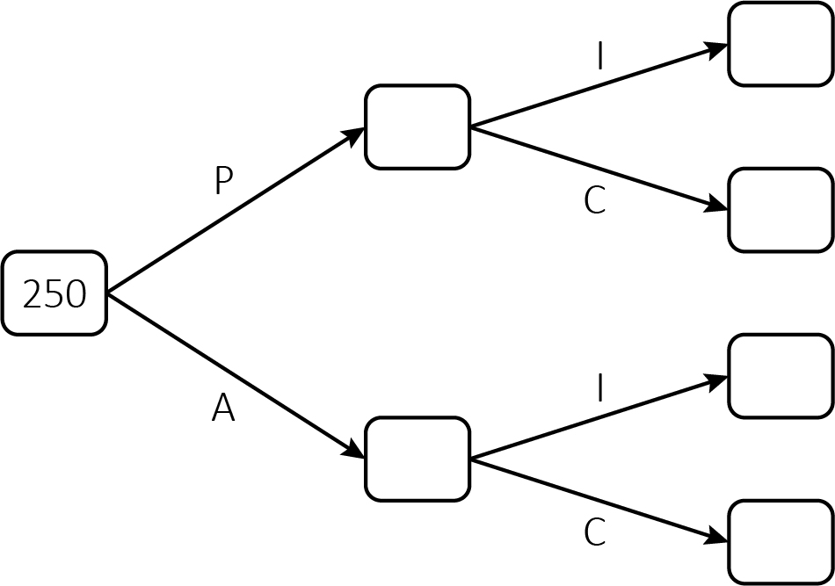
 |  | iii. | If a box is incorrectly packed, what is the probability that it came from Aspire?
 |  |  | [1 mark]
Please turn over
 | b) | Carla has installed water coolers in the waiting rooms at the health centre.  Carla analysed last summer’s data to find out the average daily consumption of water by patients at the centre.  Her results are shown in the table below.  Volume (v) in ml Frequency Frequency density  0 ≤ v < 300 60  300 ≤ v < 800 15  800 ≤ v < 1100 24  1100 ≤ v < 1500 40  1500 ≤ v < 1800 12
 |  | i. | Construct a histogram to represent this information.
 |  |  | [4 marks]

 |  | ii. | Use your histogram to estimate the number of people who drank up to 1200 ml of water.
 |  |  | [1 mark]
 |  | iii. | Estimate, to the nearest ml, the mean amount of water drank per person.
 |  |  | [2 marks]

Please turn over
 | c) | Carla currently lives and works in Stamford Bridge.  A new health centre has been opened in Withernsea and Carla has been asked to train the new manager.  Carla will now need to travel regularly between the two centres and wants to minimise her travelling time where possible.  The diagram below shows the time taken, in minutes, to drive between each of the towns.  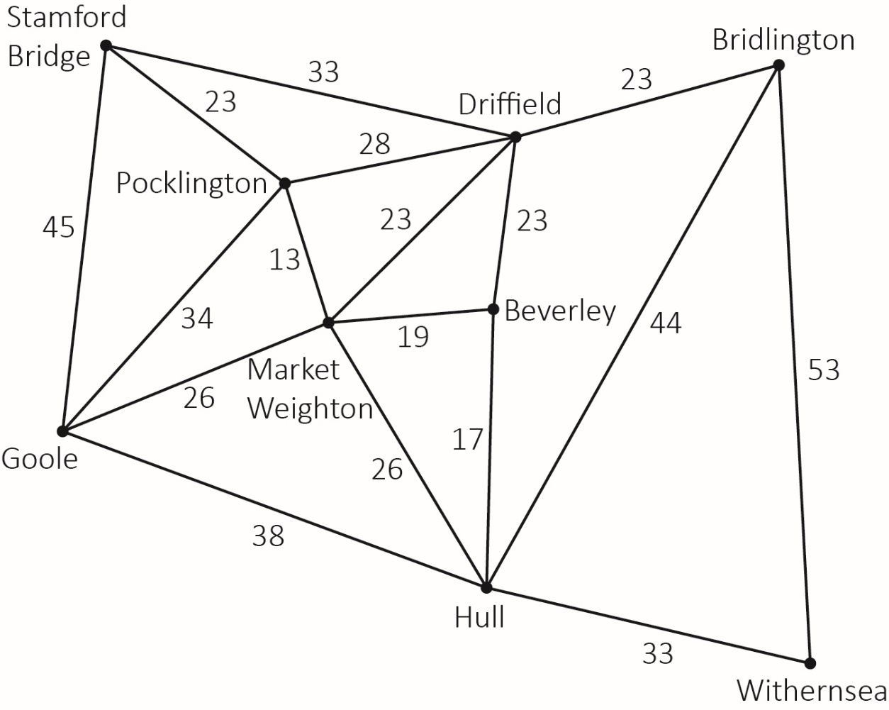

 |  | i. | Use Dijkstra’s algorithm on the diagram below to find the quickest route from CCarla’s home (S) to the new health centre at Withernsea (W).  What is the quickest route and how long will the journey take using this route?
 |  | [5 marks]
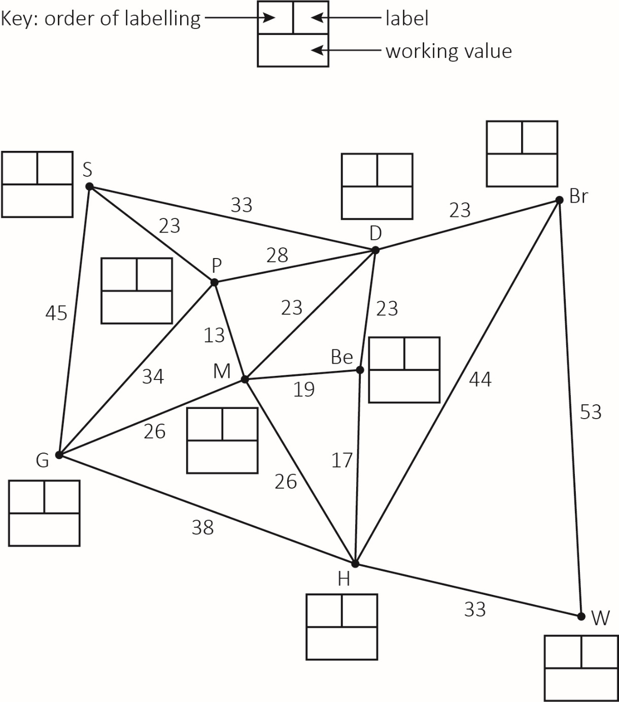

Please turn over
 |  | ii. | There are major roadworks planned in Market Weighton (M) for a month which will add extra time to Carla’s journey.  She decides to select the fastest route that avoids Market Weighton.  How many minutes will this route add to her journey?
 |  |  | [2 marks]

This page is intentionally left blank.
Please turn over for the next question.
Section 4

This section has a possible 26 marks.

We recommend that you spend 35 minutes on this section.

Answer all questions in the spaces provided.

4 | a) | Andy started a 3-year Health and Social Care Degree at university in September 2015  Each year Andy needed £9000 to cover his tuition fees and a further £4200 to cover his cost of living.  Andy borrowed this money from the Student Loan Company at the beginning of each year of his degree.  At the end of each year the Student Loan Company added interest to his loan at the rates outlined in the table below.  English and Welsh Student Loan  rates since 2015/16  Rate for those earning under £25,725  2015/16 3.9%  2016/17 4.6%  2017/18 6.1%  2018/19 6.3%
 |  | i. | Calculate Andy’s debt at the end of his first year.
 |  |  | [1 mark]

 |  | ii. | Calculate Andy’s debt at the end of the three years.
 |  |  | [3 marks]
Some months after leaving university, Andy started an administrative job at a local hospital.

He earns an annual salary of £32 000 which is paid to him monthly.

He was employed from the April after he graduated and began paying his student loan back when he received his first month’s salary.

 |  | iii. |  | Use the information in Article C to work out the cost of his first repayment.
 |  |  |  | [3 marks]
Please turn over
 | b) | Andy is responsible for the welfare of 290 employees.  Employees are classified in one of four categories.  These are shown in the table below.  Category Medical Auxiliaries Kitchen Administration  Number of employees 40 120 80 50  Andy wants to find out what the employees think about proposed changes to working conditions.  He decides to select 40 employees to take part in a review regarding these changes.
 |  | i. | Explain why it would be unsuitable to select a simple random sample from all staff.
 |  |  | [1 mark]
 |  | ii. | What are the advantages of stratified sampling in this instance?
 |  |  | [1 mark]

 |  | iii. | Use the table below to state the sample sizes in each category, if stratified sampling is used.  [2 marks]  Category Medical Auxiliaries Kitchen Administration  Number of employees 40 120 80 50  Calculated sample size  Sample size
Please turn over for the next question.

 | c) | A local minibus supplier is contracted to transport 75 student nurses from a local college to the hospital for a taster day.  The supplier has two types of minibuses:  - the Maxima which carries 17 passengers and  - the Minima which carries 15 passengers.  The supplier has three Maximas and four Minimas available for hire.  On the taster day the supplier only has six drivers available.
 |  | i. | If x represents the number of Maxima minibuses and y represents the number of Minima minibuses, construct four inequalities which must be satisfied by these two variables.
 |  |  | [4 marks]

 |  | ii. | Represent your inequalities on the graph below and clearly mark the feasible region.
 |  |  | [5 marks]
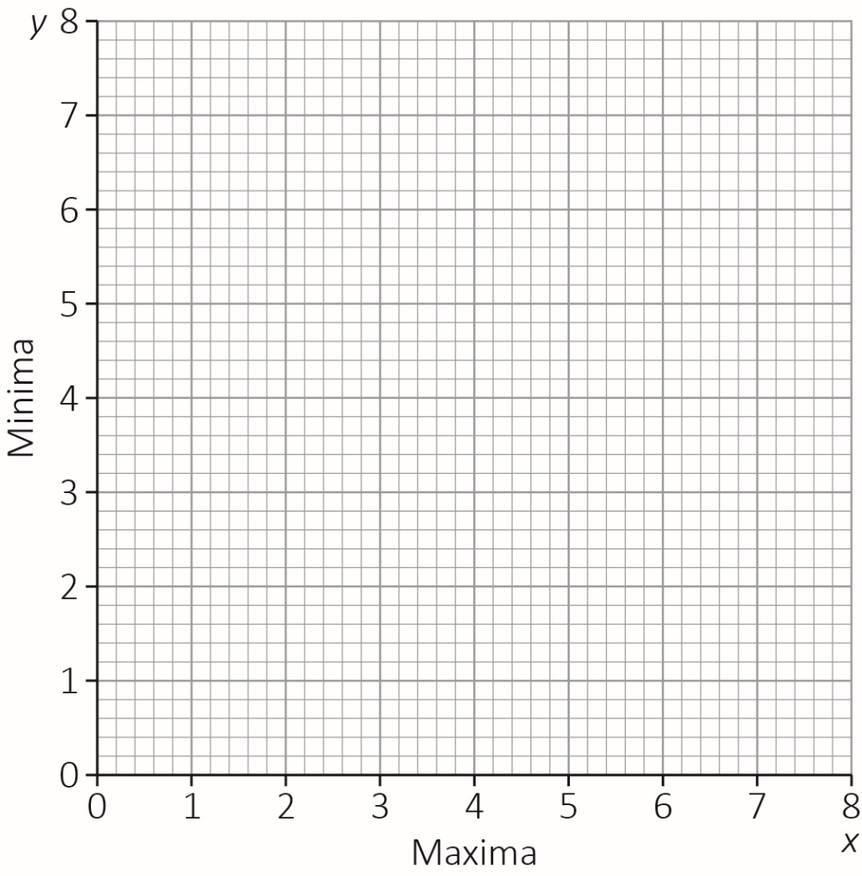

Please turn over
 |  | It costs £70 to hire a Maxima minibus and £50 to hire a Minima minibus per day.
 |  | iii. | Find the cheapest way to transport the 75 student nurses using Maxima and Minima minibuses.  Justify your decision by clearly showing your working.
 |  |  | [4 marks]

 |  | At the last minute, the college requests seats for five additional student nurses who now wish to attend the taster day.
 |  | iv. | Explain how this will alter the final arrangements and calculate how much extra this will cost.
 |  |  | [2 marks]

This is the end of the external assessment.

Assessment Objective Grid
Section | AO1 | AO2 | AO3 | Total
1
2
3
4
Total

