NCFE Level 3 Certificate in
Mathematics for Everyday Life (603/3437/X)
Practice paper (May 2020)
Business and Administration

DATE

Paper 2: P00XXXX

Mark Scheme
v1.0

This mark scheme has been written by the Assessment Writer and refined, alongside the relevant questions, by a panel of subject experts through the external assessment writing process and at standardisation meetings.

The purpose of this mark scheme is to give you:
- examples and criteria of the types of response expected from a learner
- information on how individual marks are to be awarded
- the allocated assessment objective(s) and total mark for each question.

Marking guidelines

General guidelines

You must apply the following marking guidelines to all marking undertaken throughout the marking period. This is to ensure fairness to all learners, who must receive the same treatment. You must mark the first learner in exactly the same way as you mark the last.

- The mark scheme must be referred to throughout the marking period and applied consistently. Do not change your approach to marking once you have been standardised.
- Reward learners positively giving credit for what they have shown, rather than what they might have omitted.
- Be prepared to award zero marks if the learner’s response has no creditworthy material.
- Do not credit irrelevant material that does not answer the question, no matter how impressive the response might be.
- The marks awarded for each response should be clearly and legibly recorded in the grid on the front of the question paper.
- If you are in any doubt about the application of the mark scheme, you must consult with your Team Leader or the Chief Examiner.

Guidelines for using the marking grid

Marks in the mark scheme are explicitly referenced against the following:

M | Method Marks: Marks available for the correct or suitable method used.
A | Accuracy Marks: Marks available for an accurate answer where the correct or suitable method has also been used. Unless otherwise stated with CAO.
B | Independent of other marks available used to award for a single correct answer.
G | Graph marks: marks available for completing a graph or diagram accurately.
E | Explanation: Marks available for an accurate explanation
CAO | Correct Answer only: Marks available for the correct answer - no method required.
FT | Follow through.

Assessment objectives

This unit requires learners to:

AO1 | Deepen competence in the selection and use of mathematical methods and techniques.
AO2 | Develop confidence in representing and analysing authentic situations mathematically and in applying mathematics to address related questions and issues.
AO3 | Build skills in mathematical thinking, reasoning and communication.

The weightings of each assessment objective can be found in the qualification specification.

Section 1 | Total for this section: 26 marks

Q1a(i) |  |  | AO1 | AO2 | AO3
 |  |  |  |  | 2
Marks | Process and Answer |  | Additional or Alternative Evidence  (with guidance) |  |  |  | SC
2 | Increasing number of people work past 65  The state pension age is rising  Life expectancy is increasing  A 65 year old now has different characteristics than someone of the same age some time ago | B2 | 1 mark for each  OE |  |  |  | D1
Q1a(ii) |  |  | AO1 | AO2 | AO3
 |  |  | 1
Marks | Process and Answer |  | Additional or Alternative Evidence  (with guidance) |  |  |  | SC
1 | Accept answers in the range 14-14.5% | A1 |  |  |  |  | D2
Q1a(iii) |  |  | AO1 | AO2 | AO3
 |  |  |  |  | 1
Marks | Process and Answer |  | Additional or Alternative Evidence  (with guidance) |  |  |  | SC
1 | Outliers can occur which may skew data when calculating the mean.  OE – such as anomalies can skew the data. | A1 |  |  |  |  | D3
Q1a(iv) |  |  | AO1 | AO2 | AO3
 |  |  | 2
Marks | Process and Answer |  | Additional or Alternative Evidence  (with guidance) |  |  |  | SC
1 | Advantages  Through longer working lives people can contribute more to the economy.  Voluntary work can be undertaken.  Care for family members/grandchildren can be provided | B1 | OE |  |  |  | D3
1 | Disadvantages  Higher demand for adult health and social care.  Increased public spending on State Pensions | B1 | OE |  |  |  | D3

Q1a(v) |  |  | AO1 | AO2 | AO3
 |  |  |  |  | 2
Marks | Process and Answer |  | Additional or Alternative Evidence  (with guidance) |  |  |  | SC
2 | Instead of looking at chronological age (years lived) the RLE changes over time.  Number of years left to live is a good marker of the start of old age.  Life expectancies differ for men and women.  It can be used as a measure to compare the characteristics and needs of individuals. | B2 | OE  1 mark for each |  |  |  | D3

Q1b(i) |  |  | AO1 | AO2 | AO3
 |  |  |  | 1
Marks | Process and Answer |  | Additional or Alternative Evidence  (with guidance) |  |  |  | SC
1 | 50% | A1 | CAO  No working needs to be shown |  |  |  | D4
Q1b(ii) |  |  | AO1 | AO2 | AO3
 |  |  |  | 2
Marks | Process and Answer |  | Additional or Alternative Evidence  (with guidance) |  |  |  | SC
1 | Z = -0.625 or  0.2660 or  0.7340 | M1 |  |  |  |  | D4
1 | 26.6% | A1 | CAO |  |  |  | D4
Q1b(iii) |  |  | AO1 | AO2 | AO3
 |  |  |  | 3
Marks | Process and Answer |  | Additional or Alternative Evidence  (with guidance) |  |  |  | SC
1 | z = 1.875 or 0.9696 | M1 |  |  |  |  | D4
1 | 1 – their 0.9696 | M1 |  |  |  |  | D4
1 | 3.0% | A1 | CAO |  |  |  | D4

Q1b(iv) |  |  | AO1 | AO2 | AO3
 |  |  |  | 3
Marks | Process and Answer |  | Additional or Alternative Evidence  (with guidance) |  |  |  | SC
1 | Z = 0.625  Or  0.7340  Or  0.266 | A1 |  |  |  |  | D4
1 | their 0.7340 – their 0.2660 or 0.468  or  (their 0.7340 – 0.5) x 2 | M1 | Their 0.2660 comes from Q1biii |  |  |  | D4
1 | 46.8% | A1 | CAO  If 89 used as the upper value (and get answer 42.5%) 2 marks only |  |  |  | D4

Q1c(i) |  |  | AO1 | AO2 | AO3
 |  |  | 3
Marks | Process and Answer |  | Additional or Alternative Evidence  (with guidance) |  |  |  | SC
1 | $(\overline{x}, \overline{t}$) = (47.08, 0.49) or (47.10, 0.49) | A1 | CAO  Allow answers without brackets |  |  |  | D5
1 | t = 0.11(4) + 0.008x or t = 0.008x + 0.11(4) | A1 | CAO  Allow any correct rounding as calculators give longer values |  |  |  | D5
1 | r = 0.73 | A1 | CAO  Allow any correct rounding as calculators give longer values |  |  |  | D6
Q1c(ii) |  |  | AO1 | AO2 | AO3
 |  |  |  | 2
Marks | Process and Answer |  | Additional or Alternative Evidence  (with guidance) |  |  |  | SC
2 | Drawn line goes through (0,0.11) and (47, 0.49) | M2 | Award 1 mark if goes through only one of these  FT from equation found in Q1ci |  |  |  | D5
Q1c(iii) |  |  | AO1 | AO2 | AO3
 |  |  |  | 2
Marks | Process and Answer |  | Additional or Alternative Evidence  (with guidance) |  |  |  | SC
1 | 0.43 | A1 | Allow reasonable approximation from their graph  FT their line  Accept answer from using equation |  |  |  | D5
1 | For a person aged 90, as no data was collected for people over 80, meaning the prediction would be unreliable | E1 | OE |  |  |  | D5

Q1c(iv) |  |  | AO1 | AO2 | AO3
 |  |  |  |  | 2
Marks | Process and Answer |  | Additional or Alternative Evidence  (with guidance) |  |  |  | SC
2 | The gradient of the regression line is positive 0.008, which suggests that each year on average a person’s reaction times would slow by 0.008 seconds.  Positive gradient of the regression line shows that the older a person gets the slower their reaction time. | B2 | OE  1 for each  Only award 1 mark if the correct interpretation of the gradient is stated but not translated in to context.  Note: for writing reasonable strong correlation ie 0.73. OE - one mark only as not put in to context.  For 2 marks their answer must be written in the context of the question. |  |  |  | D6

Section 2 | Total for this section: 19 marks

Q2a(i) |  |  | AO1 | AO2 | AO3
 |  |  | 1
Marks | Process and Answer |  | Additional or Alternative Evidence  (with guidance) |  |  |  | SC
1 | The National Minimum Wage is the amount workers between the ages of 16 to 24 are entitled to by law.  The National Living Wage is the minimum amount workers 25 and over are entitled to earn. | E1 |  |  |  |  | A2
Q2a(ii) |  |  | AO1 | AO2 | AO3
 |  |  |  |  | 2
Marks | Process and Answer |  | Additional or Alternative Evidence  (with guidance) |  |  |  | SC
1 | 6.211% | A1 | Accept 6.2% |  |  |  | A2
1 | The rise in pay is more than the rise in inflation. | E1 |  |  |  |  | A6
Q2a(iii) |  |  | AO1 | AO2 | AO3
 |  |  |  |  | 2
Marks | Process and Answer |  | Additional or Alternative Evidence  (with guidance) |  |  |  | SC
1 | 6.41% | A1 | Apprentice rise  Accept any correct rounding |  |  |  | A2
1 | Apprentice rates rose at a higher rate than NLW (comparing Apprentice 6.41% to NLW 6.21%) | E1 | FT their 6.21% from Q2aii |  |  |  | A6
Q2a(iv) |  |  | AO1 | AO2 | AO3
 |  |  | 1
Marks | Process and Answer |  | Additional or Alternative Evidence  (with guidance) |  |  |  | SC
1 | Tax credits, benefits, investments or any other sensible income source. Sources must be clearly different. For example, do not allow benefit and then child benefit. | A1 | For 2 sources of income |  |  |  | A2

Q2b(i) |  |  | AO1 | AO2 | AO3
 |  |  |  | 2 | 2
Marks | Process and Answer |  | Additional or Alternative Evidence  (with guidance) |  |  |  | SC
1 | £7,553 or  £629.42 or  £145.25 | E1 | Pay in Year 1 |  |  |  | A2
1 | £11,739 or  £978.24 or  £225.75 | E1 | Pay in Year 2 |  |  |  | A2
1 | No tax due | E1 | Stated or implied by calculations |  |  |  | A2
1 | £268.68 | A1 | CAO |  |  |  | A2
Q2b(ii) |  |  | AO1 | AO2 | AO3
 |  |  |  | 2 | 1
Marks | Process and Answer |  | Additional or Alternative Evidence  (with guidance) |  |  |  | SC
1 | £3100 or  £258.27 | M1 | Tax (yearly/monthly) |  |  |  | A2
1 | £2220 or  £184.96 | M1 | NI (yearly/monthly) |  |  |  | A2
1 | £1890.00 or  £1890.10 | A1 | CAO |  |  |  | A2

Q2c(i) |  |  | AO1 | AO2 | AO3
 |  |  |  |  | 1
Marks | Process and Answer |  | Additional or Alternative Evidence  (with guidance) |  |  |  | SC
1 | 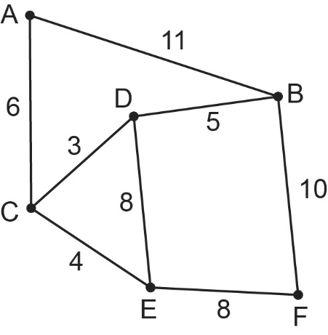 | G1 | Fully correct |  |  |  | B1
Q2(ii) |  |  | AO1 | AO2 | AO3
 |  |  |  | 3
Marks | Process and Answer |  | Additional or Alternative Evidence  (with guidance) |  |  |  | SC
3 | Evidence of using Prim’s algorithm in a table as below.  Correct order clearly stated or implied AC, CD, CE, DB, EF  Lengths AC = 6, CD = 3, CE = 4, DB = 5, EF = 8 | M3 | M3 if fully correct  M2 if 4 correct  M1 if 2 correct |  |  |  | B1
Additional guidance

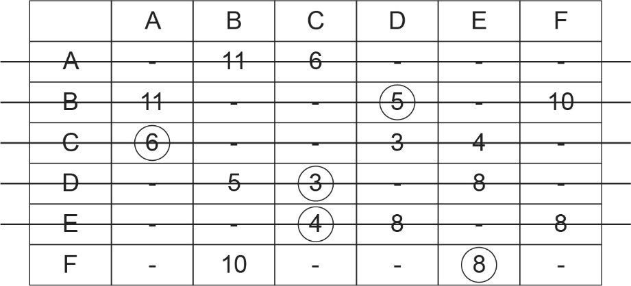

Q2c(iii) |  |  | AO1 | AO2 | AO3
 |  |  |  | 2
Marks | Process and Answer |  | Additional or Alternative Evidence  (with guidance) |  |  |  | SC
1 | 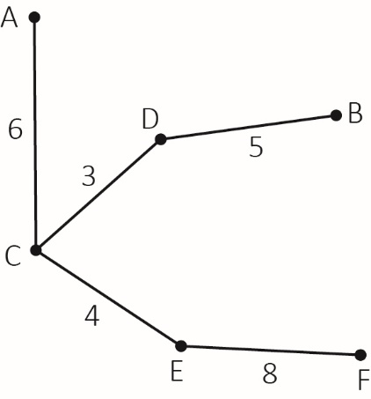 | M1 | Correct connections shown, labelled with correct lengths |  |  |  | B1
1 | 26 km | A1 |  |  |  |  | B1

Section 3 | Total for this section: 19 marks

Q3a(i) |  |  | AO1 | AO2 | AO3
 |  |  | 2
Marks | Process and Answer |  | Additional or Alternative Evidence  (with guidance) |  |  |  | SC
1 | 3 × 59 + 2 × 84 = 345 | M1 |  |  |  |  | D3
1 | 345 ÷ 5 = 69 boxes each day | A1 |  |  |  |  | D3
Q3a(ii) |  |  | AO1 | AO2 | AO3
 |  |  |  | 2
Marks | Process and Answer |  | Additional or Alternative Evidence  (with guidance) |  |  |  | SC
1 | 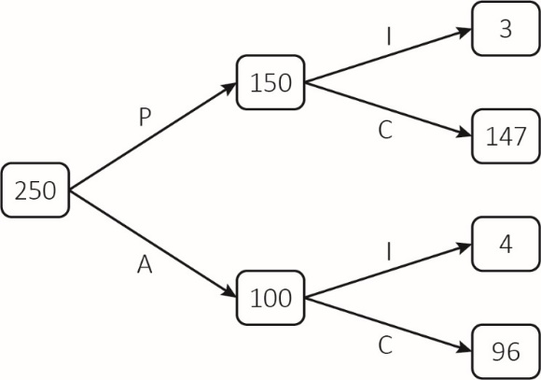 | G1 | First branch values correct |  |  |  | C1
1 |  | G1 | Second branches correct |  |  |  | C1
Q3a(iii) |  |  | AO1 | AO2 | AO3
 |  |  |  |  | 1
Marks | Process and Answer |  | Additional or Alternative Evidence  (with guidance) |  |  |  | SC
1 | Probability that a damaged package came from Albatross  $\frac{\text{4}}{\text{7}}$ or 0.571(..) or 57.1(..)% | A1 | FT |  |  |  | C1

Q3b(i) |  |  | AO1 | AO2 | AO3
 |  |  | 4
Marks | Process and Answer |  | Additional or Alternative Evidence  (with guidance) |  |  |  | SC
1 | Eg 60 ÷ 300 or 0.2 | M1 | Method or value for at least one frequency density seen |  |  |  | D2
1 | See below | A1 | All frequency density values correct |  |  |  | D2
Additional guidance

0 ≤ v < 300 | 60 | 0.2
300 ≤ v < 800 | 15 | 0.03
800 ≤ v < 1100 | 24 | 0.08
1100 ≤ v < 1500 | 40 | 0.1
1500 ≤ v < 1800 | 12 | 0.04

1 | Eg 0 to 0.2 | G1 | Appropriate consistent scale for frequency density  FT their frequency density values within the range [0.02, 0.4] |  |  |  | D2
1 | See below | G1 | Correct histogram drawn  FT their frequency density values within the range [0.03, 0.4] |  |  |  | D2
Additional guidance

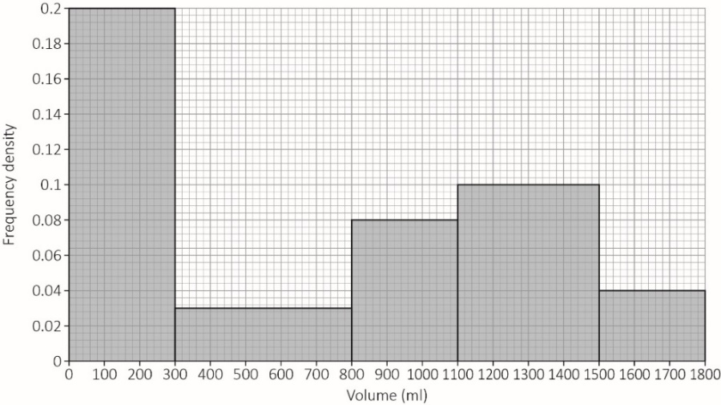

Q3b(ii) |  |  | AO1 | AO2 | AO3
 |  |  |  |  | 1
Marks | Process and Answer |  | Additional or Alternative Evidence  (with guidance) |  |  |  | SC
1 | 99 + 0.25 × 40 = 109 players | A1 | FT |  |  |  | D2

Q3b(iii) |  |  | AO1 | AO2 | AO3
 |  |  |  | 2
Marks | Process and Answer |  | Additional or Alternative Evidence  (with guidance) |  |  |  | SC
1 | 111 850 | A1 |  |  |  |  | D3
1 | 741 ml | A1 |  |  |  |  | D3

Q3c(i) |  |  | AO1 | AO2 | AO3
 |  |  |  | 5
Marks | Process and Answer |  | Additional or Alternative Evidence  (with guidance) |  |  |  | SC
1 | 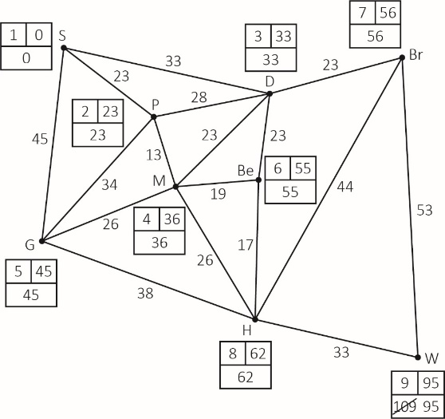 | B1 | Selecting the correct starting point (Stamford Bridge) |  |  |  | B1
1 |  | A1 | Ordering of labels |  |  |  | B1
1 |  | A1 | Working values |  |  |  | B1
1 |  | B1 | Quickest route is S, P, M, H, W |  |  |  | B1
1 |  | A1 | 95 minutes |  |  |  | B1
Q3c(ii) |  |  | AO1 | AO2 | AO3
 |  |  |  | 1 | 1
Marks | Process and Answer |  | Additional or Alternative Evidence  (with guidance) |  |  |  | SC
1 | New route S, D, Be, H, W | E1 |  |  |  |  | B1
1 | 11 minutes | E1 | FT Q3ci  106 – their 96 |  |  |  | B1

Section 4 | Total for this section: 26 marks

Q4a(i) |  |  | AO1 | AO2 | AO3
 |  |  | 1
Marks | Process and Answer |  | Additional or Alternative Evidence  (with guidance) |  |  |  | SC
1 | £13 714.80 | A1 |  |  |  |  | A4
Q4a(ii) |  |  | AO1 | AO2 | AO3
Marks | Process and Answer |  | Additional or Alternative Evidence  (with guidance) |  |  |  | SC
1 | (13714.80 + 13200) x 1.046 | M1 |  |  |  |  | A4
1 | £28 152.88 | A1 | FT from Q4ai |  |  |  | A4
1 | £43 875.41 | A1 | CAO |  |  |  | A4
Q4a(iii) |  |  | AO1 | AO2 | AO3
Marks | Process and Answer |  | Additional or Alternative Evidence  (with guidance) |  |  |  | SC
1 | £6275 or  £2666.67 | M1 |  |  |  |  | A4
1 | £564.75 or  £522.92 | M1 |  |  |  |  | A4
1 | £47.06 | A1 | CAO |  |  |  | A4

Q4b(i) |  |  | AO1 | AO2 | AO3
 |  |  |  |  | 1
Marks | Process and Answer |  | Additional or Alternative Evidence  (with guidance) |  |  |  | SC
1 | Simple random sample might not be representative of the entire population.  For example - The sample may only contain production workers.  Or other relevant comment | E1 | OE |  |  |  | D1
Q4b(ii) |  |  | AO1 | AO2 | AO3
 |  |  |  |  | 1
Marks | Process and Answer |  | Additional or Alternative Evidence  (with guidance) |  |  |  | SC
1 | It ensures that each category within the population receives proper representation in the sample.  Thoughts can be gathered from each category.  All of the population is covered. | E1 | OE |  |  |  | D1
Q4b(iii) |  |  | AO1 | AO2 | AO3
 |  |  |  |  | 2
Marks | Process and Answer |  | Additional or Alternative Evidence  (with guidance) |  |  |  | SC
1 | See below | B1 | All correct |  |  |  | D1
Additional guidance

Calculated sample size | 5.5…. | 16.5…. | 11….. | 6.9…..

1 | See below | B1 | Must total 40 |  |  |  | D1
Additional guidance

Sample size | Allow 5 or 6 | Allow 16 or 17 | 11 | 7

Q4c(i) |  |  | AO1 | AO2 | AO3
 |  |  |  |  | 4
Marks | Process and Answer |  | Additional or Alternative Evidence  (with guidance) |  |  |  | SC
1 | x ≤ 3 | A1 |  |  |  |  | B3
1 | y ≤ 4 | A1 |  |  |  |  | B3
1 | x + y ≤ 6 | A1 |  |  |  |  | B3
1 | 17x + 15y ≥ 75 | A1 | OE |  |  |  | B3
Q4c(ii) |  |  | AO1 | AO2 | AO3
 |  |  | 3 | 2
Marks | Process and Answer |  | Additional or Alternative Evidence  (with guidance) |  |  |  | SC
4 | 1 for each correctly drawn line:  x = 3  y = 4  x + y = 6  17x + 15y = 75 | G4 | FT from Q4ci |  |  |  | B3
1 | Highlighted region | G1 | CAO |  |  |  | B3
Q4c(iii) |  |  | AO1 | AO2 | AO3
 |  |  |  | 3 | 1
Marks | Process and Answer |  | Additional or Alternative Evidence  (with guidance) |  |  |  | SC
3 | Most likely options:  Maxima Minima Capacity Cost  3 2 81 £310  2 3 79 £290  1 4 77 £270 | M3 | M3 for clear evidence of testing at least the 3 most likely options  M2 if only two of the most likely options are shown  M1 if only one of the most likely options is shown |  |  |  | A3
1 | 1 Maxima and 4 Minima and cost £270 | M1 | Correct answer identified (however many other options considered) |  |  |  | A3
Q4c(iv) |  |  | AO1 | AO2 | AO3
 |  |  | 1 |  | 1
Marks | Process and Answer |  | Additional or Alternative Evidence  (with guidance) |  |  |  | SC
4 | 3 Maxima and 2 Minima | E1 | FT from Q4cii |  |  |  | A3
1 | Cost = £310, so £40 extra | A1 | Accept £310 or £40 |  |  |  | B3A3

Assessment Objective Grid
Section | AO1 | AO2 | AO3 | Total
1 | 6 | 13 | 7 | 26
2 | 2 | 9 | 8 | 19
3 | 6 | 10 | 3 | 19
4 | 8 | 7 | 11 | 26
Total | 22 | 39 | 29 | 90

