NCFE Level 3 Certificate in
Mathematics for Everyday Life (603/3437/X)
Practice paper (May 2020)

Paper 1

Paper number: P00XXXX

DATE

To be completed by the examiner | Mark
Section 1
Section 2
TOTAL MARK
Time allowed: 1 hour 30 minutes

Learner instructions
- Use black or blue ink.
- Answer all questions.
- Read each question carefully.
- Write your responses in the spaces provided.
- All of the work you submit must be your own.

Learner information
- The marks available for each question are shown in brackets.
- The maximum mark for this paper is 60.
- You may use a calculator.

Learner name
Centre name
Learner number |  |  | Centre number

Please complete the details below clearly and in BLOCK CAPITALS.

Do not turn over until the invigilator tells you to do so.

Section 1

This section has a possible 8 marks.

We recommend that you spend 15 minutes on this section.

Answer all questions in the spaces provided.

1 |  | An experienced driving instructor can use the probability distribution table below to find the probability of the number of driving tests a learner driver will need before passing.  n 1 2 3 4 or more  P(X= n) 0.3 0.35 0.15 0.2  n is the number of times a test is needed.  What is the probability that a learner takes at least two tests to pass?  [1 mark]
 |  | A | 0.35
 |  | B | 0.65
 |  | C | 0.70
 |  | D | 0.80
 |  | Answer

2 |  | Daniel manages a hotel. Each week he has 900 guests.  He gives each guest a unique 6 figure identification number.  Daniel wants to know how satisfied the guests were with their stay.  He decides to interview 90 guests selected at random.  Which of the following approaches will produce the sample that Daniel wants?  [1 mark]
 |  | A | Interview 90 guests who were visiting the hotel for the first time.
 |  | B | Write each identification number on a slip of paper, put the slips  of paper into a hat, mix them up and then pick out 90 numbers.
 |  | C | Contact all guests who have stayed for more than one week and interview the first 90 guests who respond.
 |  | D | Interview the first 90 guests to arrive on a particular weekend.
 |  | Answer

3 |  | Jasmine works for a local toy company. She works 38 hours each week  and is paid £8.72 per hour.  Sometimes she works overtime and is paid her usual rate plus 10%.  The company rounds up total weekly wages to the nearest penny.  How much would Jasmine earn if she worked for 42 hours in a week?  [1 mark]
 |  | A | £402.86
 |  | B | £38.37
 |  | C | £331.36
 |  | D | £369.73
 |  | Answer

Pleaase turn over
4 |  | The numbers x and y satisfy the following inequalities:  $$x+y ≤4$$  $$y ≤2x+1$$  $$2y ≥ x+2$$  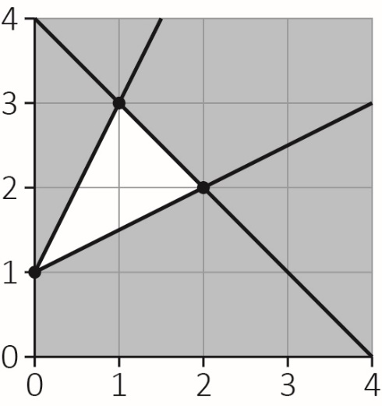  What is the maximum value of x + 4y?  [1 mark]
 |  | A | 3
 |  | B | 10
 |  | C | 13
 |  | D | 17
 |  | Answer

5 |  | Six airlines fly direct from London Heathrow to Japan.  In how many ways can four people choose their airline, so that none of them travel with the same airline?  [1 mark]
 |  | A | 720
 |  | B | 360
 |  | C | 24
 |  | D | 6
 |  | Answer

6 |  | This box plot shows the pulse rates at rest for a group of students.  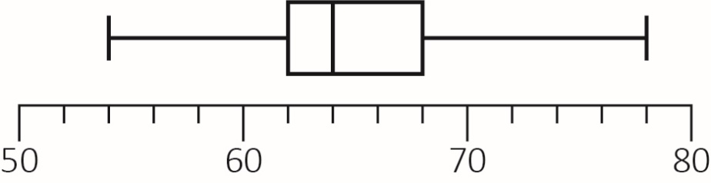  Which of these statements is definitely not true?  [1 mark]
 |  | A | There are no outliers.
 |  | B | There are no low outliers.
 |  | C | There is one outlier
 |  | D | There is at least one outlier.
 |  | Answer

Please turn over
7 |  | Cheryl puts £4200 into a savings account for 12 months.  The money earns compound interest at a rate of 1.42% every six months which is automatically added into the account at that time.  What is the correct AER (annual equivalent rate) for this investment rounded  to two decimal places?  [1 mark]
 |  | A | 2.15%
 |  | B | 2.42%
 |  | C | 2.84%
 |  | D | 2.86%
 |  | Answer

8 |  | The Gantt chart below shows the schedule for a small building project.  The duration of each activity is measured in days.  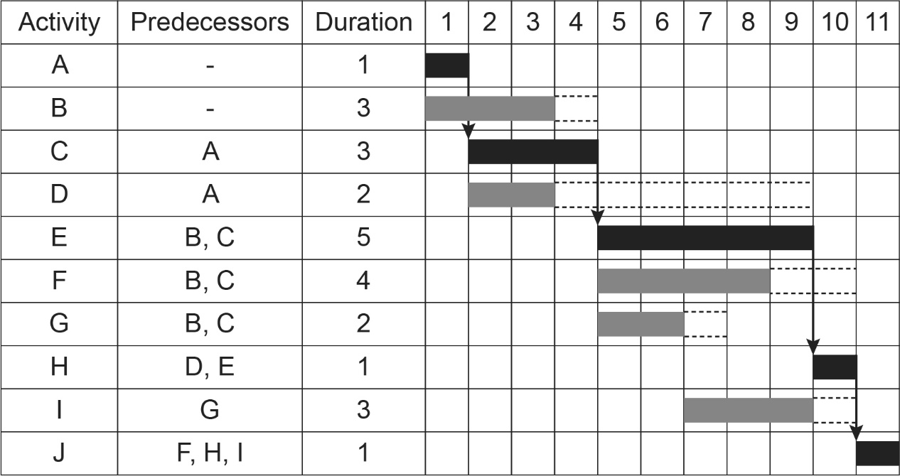  Each activity is done by one person only.  What is the fewest number of workers required to complete the project on time?  [1 mark]
 |  | A | 2
 |  | B | 3
 |  | C | 4
 |  | D | 10
 |  | Answer

Please turn over

This page is intentionally left blank.
Section 2

This section has a possible 52 marks.

We recommend that you spend 75 minutes on this section.

Answer all questions in the spaces provided.

9 | A runner is training for a race by running repetition laps of a track with a two-minute rest in between each lap.  He runs eight repetitions in all.  His times in seconds were:  53.8, 52.6, 55.5, 55.2, 55.8, 56.0, 56.1, 56.5  Find the mean and the standard deviation of these times.  Use your results to decide if any of these times could be classed as an outlier.
 | [4 marks]

Please turn over
10 | This histogram shows the amount of money spent, in pounds, at a supermarket fuelling station on a particular morning.  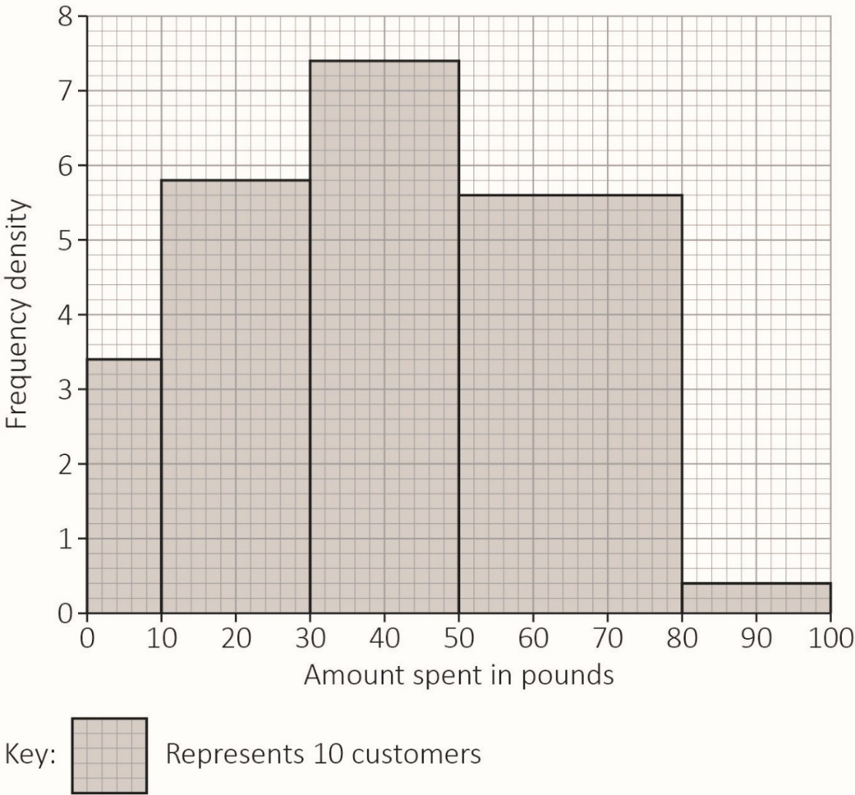
 | a) | Express the data in the form of a grouped frequency table.  [2 marks]
Amount  Spent (£) (s) | 0 ≤ s <10 |  |  |  | 80 ≤ s < 100
Frequency

 | b) | Use your table to estimate the amount of money that customers spent on that morning.
 |  |  | [2 marks]

Please turn over for the next question.
11 | A mobile phone manufacturer released its latest handset at the same time in the UK and Japan.  The price in the UK is given in pounds. The price in Japan is given in Japanese Yen.  Location Price Shipping to the UK including taxes Exchange rate  UK £795 £4.50 n/a  Japan 86800JPY 15152JPY £1 = 142.4JPY
 | a) | For a UK customer which of these would be the better price? Show your working.
 |  | [2 marks]
 | Customers who buy the handset from the UK are offered a 12-month contract costing £13 per month.
 | b) | What is the total cost of the phone including the handset, shipping and twelve monthly contract payments?
 | [1 mark]

As an alternative to buying the new handset outright, the UK customer has two other options:

- Option A is £50 up front, with a 24-month fully-inclusive contract costing £39.99 per month.
- Option B is £300 up front, with a 12-month fully-inclusive contract costing £55.99 a month.

In both cases the handset belongs to the customer at the end of the contract.
 | c) | Which of these two options costs the least over the length of the contract and explain why the cheapest option may not be the best value for money?
 |  | [3 marks]

Please turn over
12 | Records over a long period of time suggest if a particular table tennis player won her last game, the probability of her winning her next game is 0.7  If she lost her previous game the probability of her winning the next game is 0.6  Use two-digit random numbers to simulate the results of her next eight games.
 | a) | Give two efficient examples of two-digit random numbers that could be used to simulate her next result, depending on whether she won or lost her previous games:
 |  |  | [4 marks]
 |  |  | If she won her previous game.
 |  |  | If she lost her previous game.
 | b) | Given that she lost her last game, use the following two-digit random numbers to simulate the results of her next eight games.  83 05 20 72 84 58 60 12
 |  |  | [2 marks]

13 | Carla has a part-time job working 9.5 hours each weekend. She gets paid £9.40 per hour.  Her living costs are as follows:  - casual expenses: £23 per week  - college supplies: £10 per week  - cosmetics: £9 per week.  Carla wants to save up for driving lessons that will cost £400
 | a) | If Carla saves the remainder of her wages, how many weeks will it take her to save up enough money for the driving lessons?
 |  |  | [2 marks]
 | b) | Carla decides to borrow £400 from a loan company at a compound interest rate of 0.8% added daily.  The loan has to be paid back within 60 days.
 |  | i. | How much money does Carla have to pay back at the end of the 60 days?
 |  |  | [2 marks]

Please turn over
 |  | ii. | What is the total APR on Carla’s loan?
 |  |  | [3 marks]

This page is intentionally left blank.
Please turn over for the next question.
14 |  | 120 college lecturers attended a conference on the advantages of using social media in their lessons.  Before the conference began, all lecturers were asked if they used Talker (T), IntaSocial (I) or FriendZone (F) themselves.  Their results are recorded in the Venn diagram below.  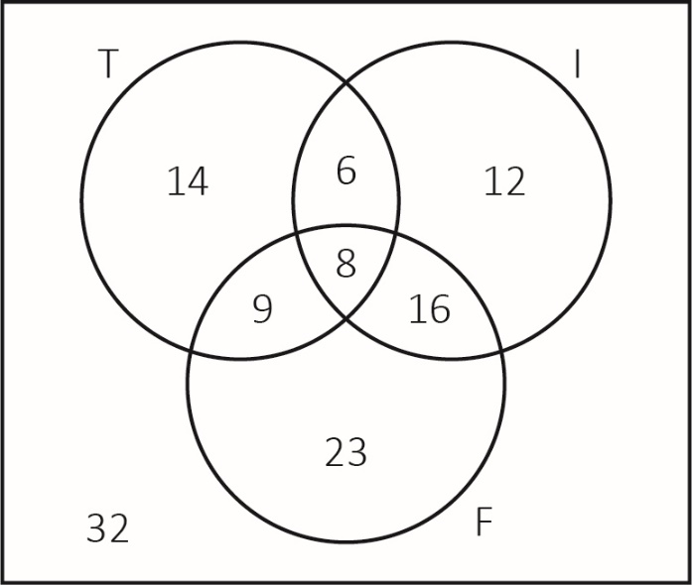  One of the lecturers is chosen at random.
 | a) |  | Find the probability to three decimal places that this lecturer:
 |  |  | i. | uses at least one of these three forms of social media.
 |  |  |  | [2 marks]

 |  | ii. | uses only one of these three forms of social media.
 |  |  | [2 marks]
 | b) | Given that the lecturer uses Talker, find the probability that they do not use FriendZone.  Round your answer to three decimal places.
 |  |  | [2 marks]

Please turn over
 | Two different lecturers are chosen at random.
 | c) | Find the probability that exactly one of them uses IntaSocial.  Round your answer to three decimal places.
 |  | [3 marks]

This page is intentionally left blank.
Please turn over for the next question.
15 | A dentist surgery’s records suggest that 20% of patients will not turn up for their appointment. In a morning session, the dentist is booked to see 15 patients.
 | a) | What is the expected number of patients who will not turn up for their appointment?
 |  |  | [1 mark]
 | b) | What is the probability that all of the patients will turn up for their appointment?
 |  |  | [2 marks]
 | c) | What is the probability that more than three patients will not turn up for their appointment?
 |  |  | [3 marks]

 | d) | If the dentist’s surgery makes 18 appointments, what is the probability that more than 15 patients will turn up?
 |  |  | [2 marks]

Please turn over for the next question.

16 | An activity network for setting up an exhibition hall is shown below.  The activity times are in hours.  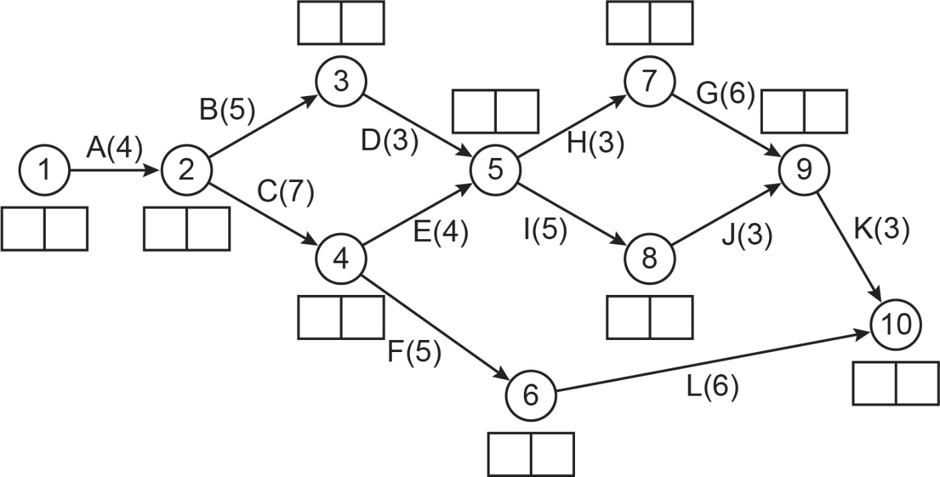  Perform a forward pass and a backward pass to find the early time and the late time for each event.  Show your working on the diagram.  From your results:  - give the project duration  - list the critical activities  - write down the float times for activities F and J.
 |  | [8 marks]

This is the end of the external assessment.

This page is intentionally left blank.

This page is intentionally left blank.

This page is intentionally left blank.

Assessment Objective Grid
Question | AO1 | AO2 | AO3 | Total
1 - 8
9
10
11
12
13
14
15
16
Total

