NCFE Level 3 Certificate in Mathematics for Everyday Life (603/3437/X)
Sample Pre-release Material

To be issued to learners four weeks prior to the exam date in preparation for the below external assessment.

Learner information
- This pre-release material is for the below external assessment ONLY.
- You must not bring this pre-release material into the external assessment.
- You will be provided with a further copy of this pre-release material at the start of the external assessment.

This is a sample assessment

Time allowed: 2 hours

A: GP appointments should be at least 15 minutes in future, leading doctors say.
Ten-minute GP appointments are letting down patients and should be made a “thing of the past” over the next decade, family doctors say.

Artificial intelligence triage systems and greater use of pharmacists and support workers for routine appointments should allow family doctors to offer face-to-face appointments of at least 15 minutes, the Royal College of GPs has said.

Britain has some of the shortest GP appointments in the developed world, with one study finding that consultations lasted an average 9.2 minutes, half the length of Sweden or the US and behind countries such as Peru and Russia.

In a vision for how the GP system should look in 2030, the college wants patients to be able to opt for longer or shorter appointments depending on their needs and to see doctors over the internet as well as in person.

Helen Stokes-Lampard, chairwoman of the college, said: “It is abundantly clear that the standard ten-minute appointment is unfit for purpose. It’s increasingly rare for a patient to present with a just single health condition, and we cannot deal with this adequately in ten minutes.”

However, GPs are seeing increasing numbers of patients as demand rises from an ageing population, while family doctor numbers are falling despite government pledges to hire thousands more.

“Without more resources and an expanded workforce, longer consultations would simply mean increased waiting times, undermining patients’ ability to access the care that they need,” Professor Stokes-Lampard conceded.

Better use of online records that incorporate data from wearables such as Fitbits and development of algorithms that assess how sick a patient is and highlight red flag symptoms are both envisioned by the college.

Such improved triage systems could help free up doctors’ time for longer appointments, while sending other patients to nurses, physiotherapists, dieticians and health coaches.

NHS England is already hiring an “army” of pharmacists, physios and other support workers to help overstretched GPs offer more appointments. Professor Stokes-Lampard said: “Much of what we envision for the future of our profession we are already embarking upon in some form or another — but we need to make sure that whatever we do is safe, evidence-based and ultimately works to make general practice and the wider NHS more sustainable. In many cases, we’re simply not there, yet.

“Ours is an ambitious vision but it is not a pipe dream. Realising it will depend on having a sufficiently resourced service to keep people well and provide them with the care they need around the clock, and we have identified several key enablers to deliver this.”

Richard Vautrey, chairman of the British Medical Association GP committee, said: “As more and more patients live with a number of complex conditions, GPs are increasingly concerned that short consultations with their patients are rarely conducive with providing the high level of care that people expect and deserve.
“This unreasonable time pressure also has a major impact on the mental wellbeing of doctors”.

“No GP wants to rush their time with patients, squeezing it into a ten-minute window when it needs far longer, but they are forced to do so by the sheer volume of workload they are faced with.”

A spokesman for the NHS said: “The NHS Long-Term Plan means an extra £4.5 billion is being invested in primary and community care, alongside the recruitment of 20,000 physios, therapists and other health experts to offer patient more access to specialist care in GP teams, building on success in the last year alone which has seen GPs across the country free up an extra half-a-million hours of time for patients.”

Source: https://www.thetimes.co.uk/article/we-need-at-least-15-minutes-totreat-patients-properly-say-gps-qt8hv3nvz

Please turn over

B: Whenever there is a general election in the UK the political parties will almost certainly focus on tax.
Their plans matter because tax underpins everything the government does. The money raised is spent on everything from schools to the NHS.

So where does the UK get most of its money? And how does it compare with other countries?

How much tax are people paying?
The amount of money the UK government collects through taxes is at a historical high.

UK tax revenues as a share of national income - the total amount of money the country earns - are at their highest sustained level since the 1940s.

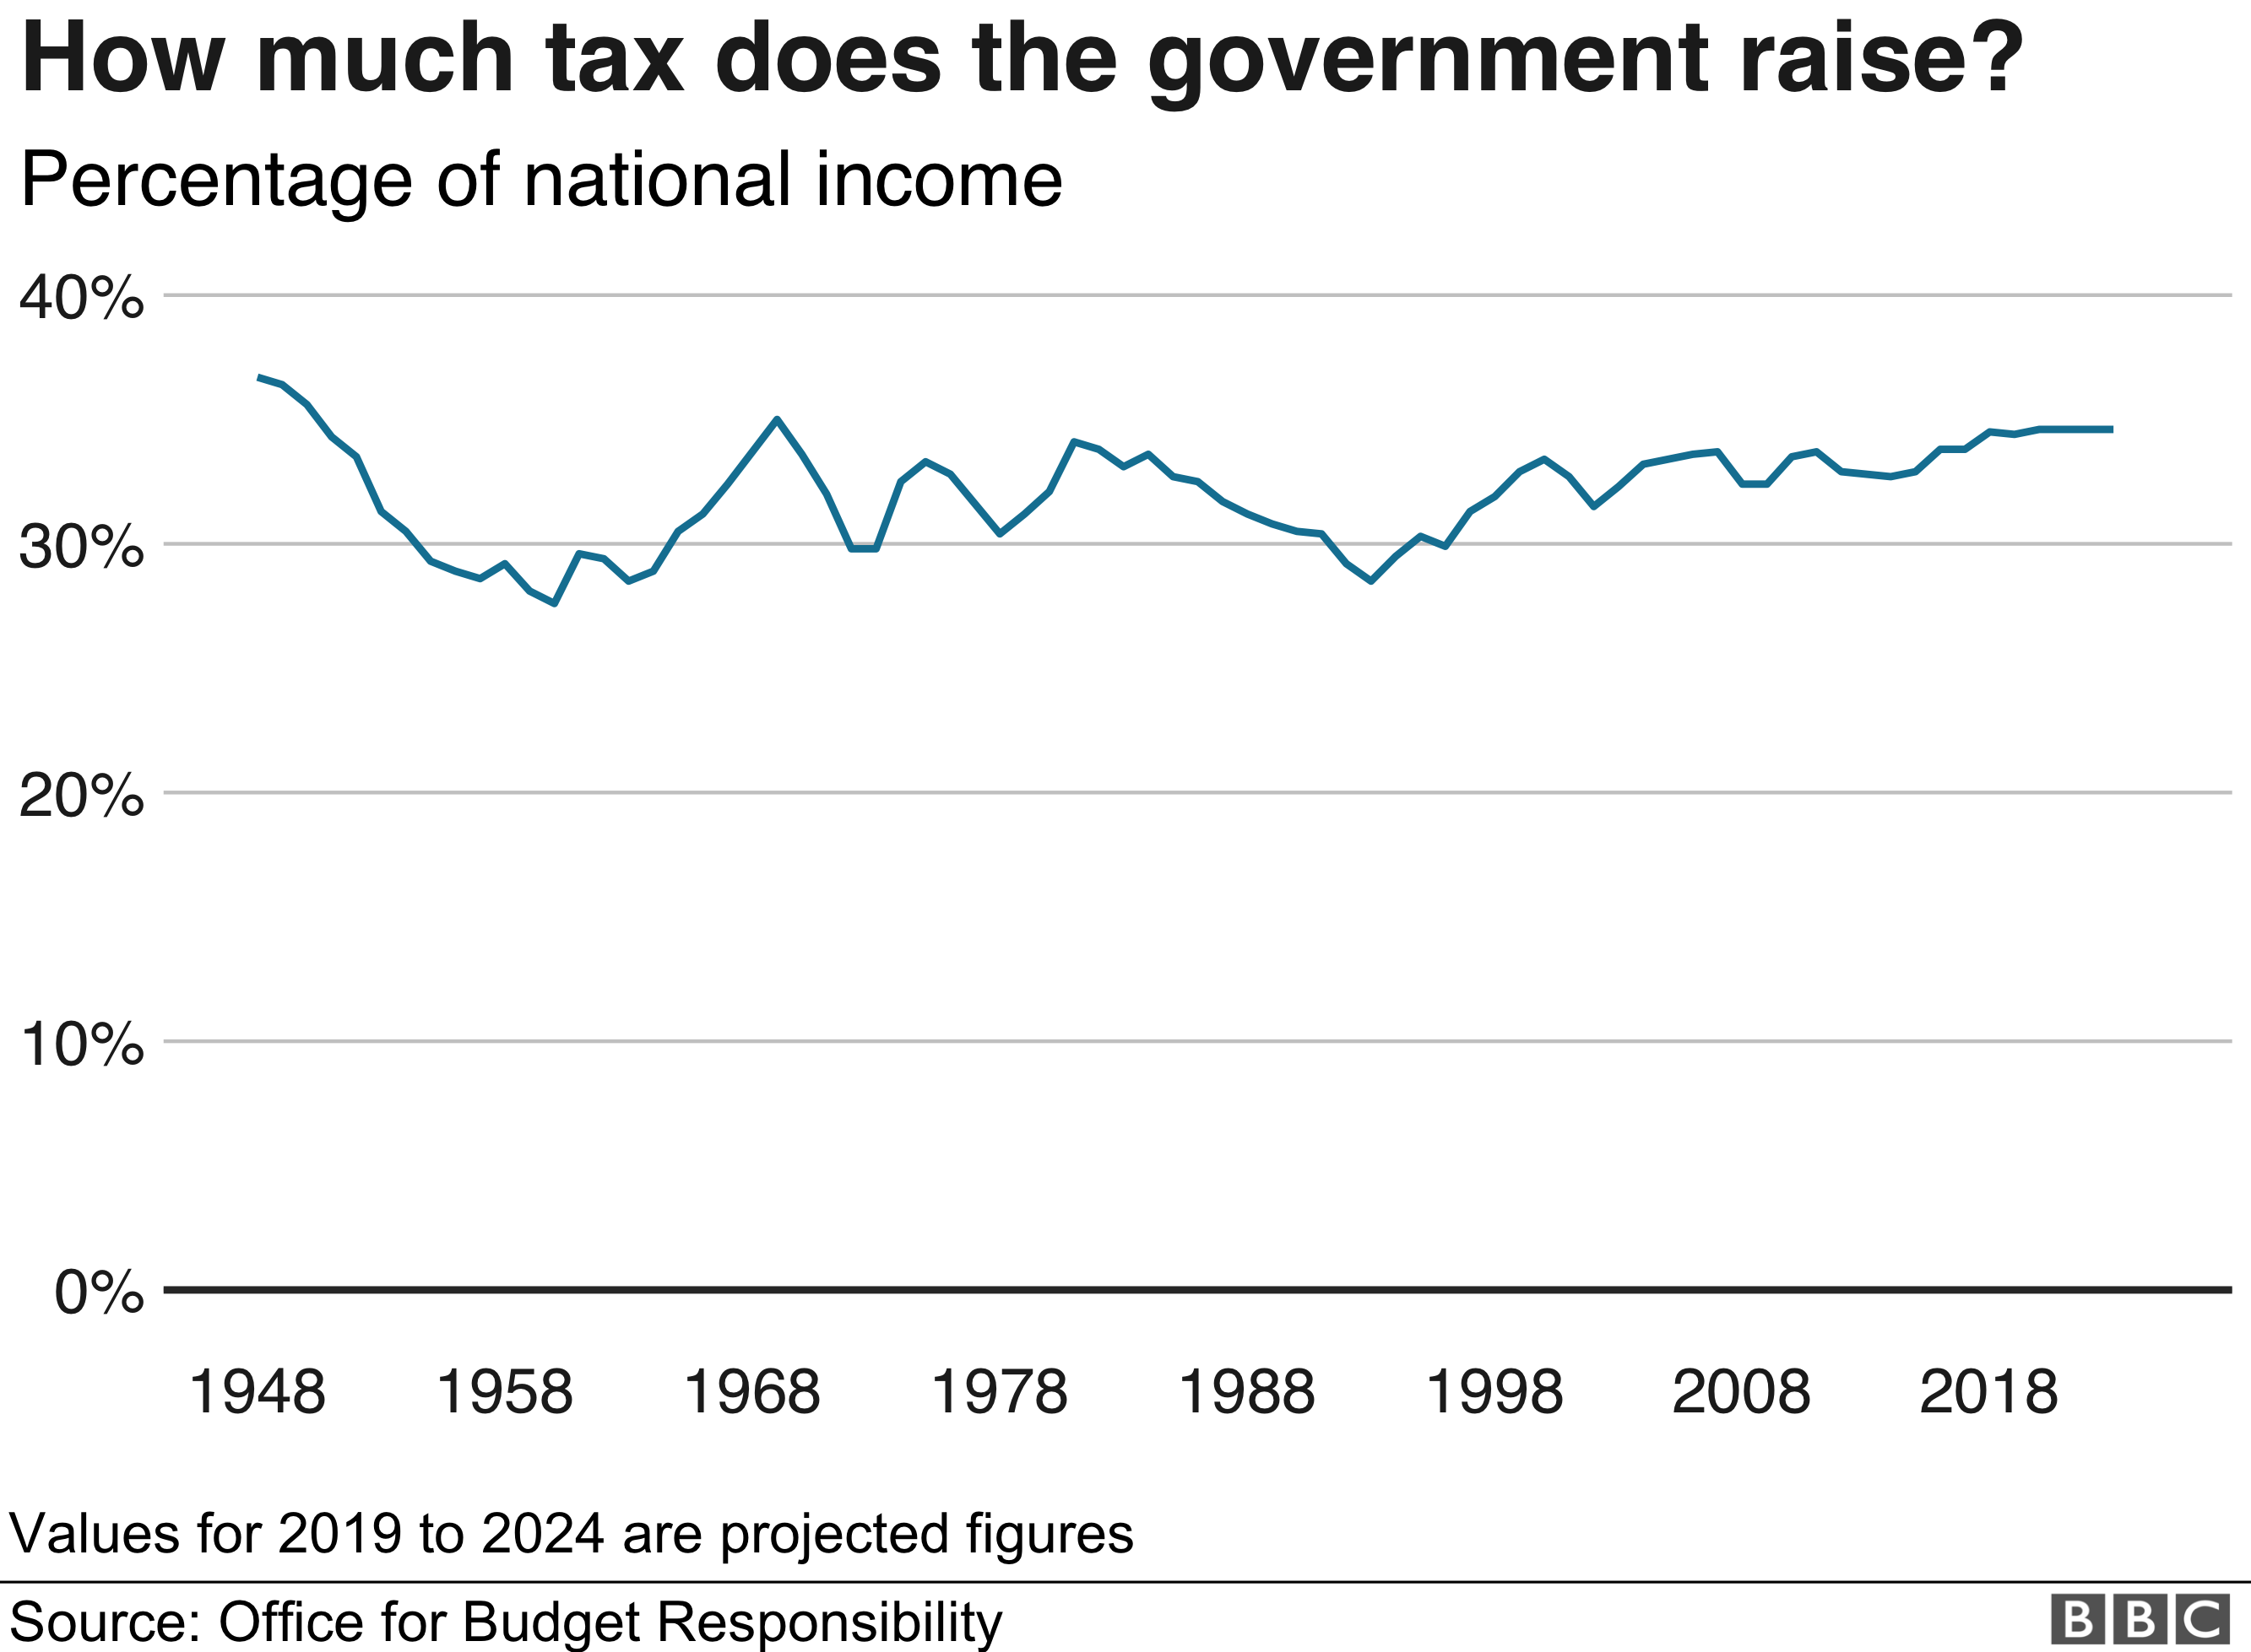

The taxes that many of us are most aware of are income tax and National Insurance contributions (NICs).

These are the sums of money on a payslip that never reach our bank account, along with pension contributions or student loan repayments.

Together, they account for the majority of revenue collected in the UK.

How much tax is deducted from your income depends on how much you earn. Those on higher salaries pay a higher share of their income in tax.

An employee earning £28,000 - a middle income earner in the UK - will pay nearly £6,000 in income tax and NICs. On top of this, their employer has to pay nearly £3,000 in employer NICs.

Overall, that means that about 28% of the cost of employing them ends up in the hands of the government.

Half of the cost of employing someone on £340,000 - 10 times higher than the average full-time UK employee - goes on tax.

What's it like in other countries?
The UK is in the middle of the pack when it comes to how much tax it raises overall.

But many other European countries have much higher taxes on workers' salaries.

For example, if the UK imported the French tax system, not 28% but 48% of the cost of employing someone on £28,000 would be paid in tax. That's a big difference - £10,000 extra for the government.

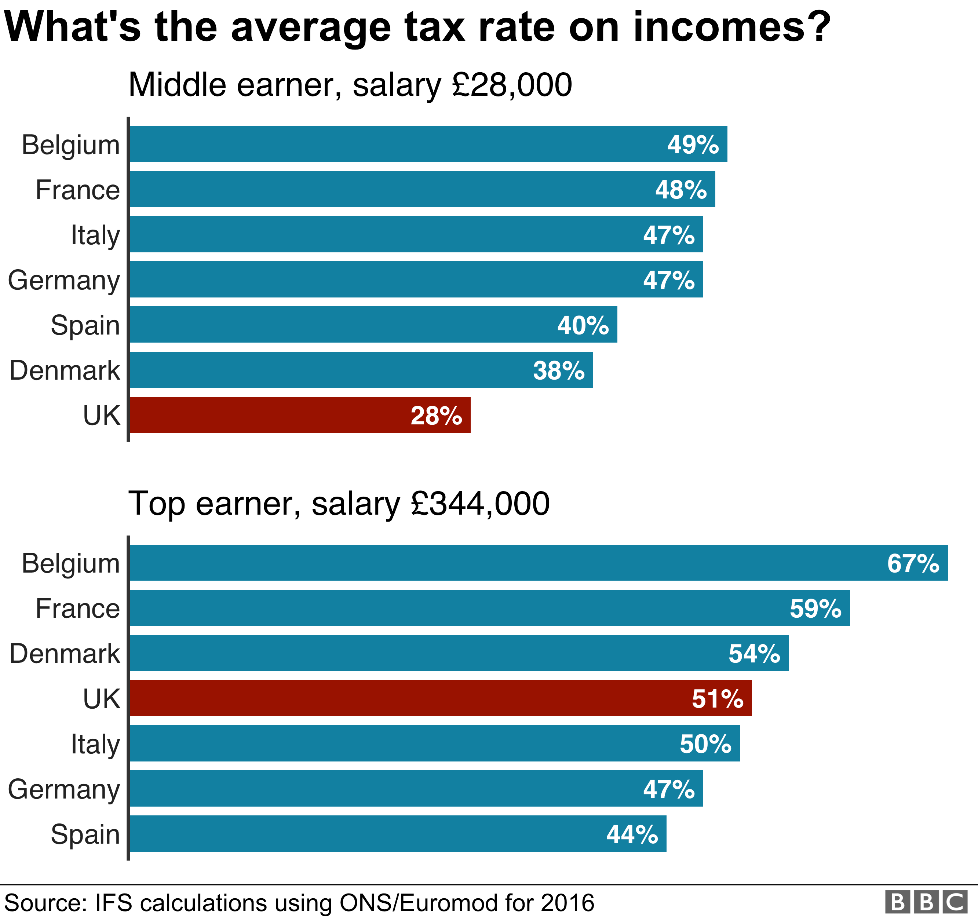

The average rate for the higher earner would increase from 51% to 67% if the UK imported the Belgian tax system. That would be an extra £91,000 in tax revenue per person.

The countries that raise more in tax than the UK almost all do this by raising more from income tax and social security contributions.

Compared with European countries, the UK stands out most in its relatively light taxation of middle earners' incomes. Rates for high earners are closer to those seen elsewhere.

If the UK imported the tax system of another European country that raises more tax, average rates would increase for high earners but middle earners would be the most affected.

Source: https://www.bbc.co.uk/news/business-48988052

Please turn over

Income Tax and National Insurance 2019 – 2020
Income tax rates and taxable bands 2019 – 2020

PAYE tax rates and thresholds | 2019 - 2020
Personal allowance | £240 per week  £1,042 per month  £12,500 per year
Basic rate | 20% on annual earnings above the PAYE tax threshold and up to £37,500.
Higher rate | 40% on annual earnings above the PAYE tax threshold from £37,501- £150,000
Additional rate | 45% on annual earnings over £150,000

To calculate your income tax if your annual income is £100,000 or less.

Find your taxable income by subtracting your personal tax allowance from your annual gross income.
You pay income tax at 20% on the first £37,500 of your taxable income.
You pay income tax at 40% on your taxable income over £37,500.

National Insurance (NI) 2019 - 2020

You only make National Insurance deductions on earnings above the Lower Earning Limit (LEL).

Class 1 National Insurance thresholds

LEL | £118 per week  £512 per month  £6,136 per year
Primary Threshold (PT) | £166 per week  £719 per month  £8,632 per year
Upper Earnings Limit (UEL) | £4,167 per month  £50,000 per year

Class 1 National Insurance rates

Earnings at or above LEL up to and including PT | 0%
Earnings above PT and up to and including UEL | 12%
Balance of earnings above UEL | 2%

Examples
A person who had a weekly income of £375 pays 12% on the amount above £166.
A person who had a monthly income of £4,250 pays 12% on the amount between £719 and £4,167 plus 2% of the amount above £4,167.
Gross pay
Your gross pay is your wage or salary, before any deductions are made.
Net pay
Your net pay (or take-home pay) is the amount of money you receive after income tax, National Insurance and other deductions have been taken off your gross pay.

National Minimum Wage (from April 1st 2019)

National Living Wage (25+) | £8.21 per hour
NMW (21 – 24) | £7.70 per hour
NMW (18 – 20) | £6.15 per hour
NMW (16 -17) | £4.35 per hour
Apprentices aged under 19 | £3.90 per hour
Apprentices aged 19 or over, but in their first year of their apprenticeship. | £3.90 per hour

Student Loans
The Student Loans Company (SLC) gives loans to students at university.
There are two types of repayment plan for student loans. If you started your course before 1 September 2012 you will be on repayment plan 1.
If you started your course on or after 1 September 2012 you will be on repayment plan 2.
Repayment plan 1
You only start making repayments when your gross income is over the threshold of £18,935 a year (£1,577.91 per month, £364.13 per week). You pay 9% of anything you earn over the threshold.
Repayment plan 2
You only start making repayments when your gross income is over the threshold of £25,725 a year (£2,143.75 per month, £494.71 per week). You pay 9% of anything you earn over the threshold. For either plan you can also make additional voluntary repayments to SLC at any time which will reduce your balance earlier.
Personal pension contributions.

In most cases, your pension contributions are deducted from your salary before income tax is paid on them and so are effectively “tax free”.
To calculate your income tax if your annual income is £100000 or less.
Find your taxable income by subtracting your personal tax allowance and your personal pension contributions from your annual gross income.

This is the end of this document.

