NCFE Level 3 Certificate in
Mathematics for Everyday Life (603/3437/X) PRACTICE

Paper 2

Engineering and Manufacturing
Paper number: P00XXXX

DATE

To be completed by the examiner | Mark
Section 1
Section 2
Section 3
Section 4
TOTAL MARK
Time allowed: 2 hours

Learner instructions
- Use black or blue ink.
- Read each question carefully.
- Answer all questions.
- Write your responses in the spaces provided.
- Use the graph paper provided where instructed.
- All of the work you submit must be your own.

Learner information
- The marks available for each question are shown in brackets.
- The maximum mark for this paper is 90.
- You may use a calculator.

Learner name
Centre name
Learner number |  |  | Centre number

Please complete the details below clearly and in BLOCK CAPITALS.

Do not turn over until the invigilator tells you to do so.

Section 1

This section has a possible 26 marks.

We recommend that you spend 35 minutes on this section.

Answer all questions in the spaces provided.

1 | Currently, family doctors allow 10 minutes for face-to-face appointments with patients. Some doctors think these need to last longer.  Dr Kunis carried out a trial where patients were allowed to spend longer with their doctor.  He recorded the time spent with each patient to the nearest minute.  Dr Kunis summarised his findings in the probability distribution below:  Minutes 10 11 12 13 14  Probability $$\frac{1}{20}$$ $$\frac{1}{10}$$ $$\frac{1}{10}$$ $$\frac{1}{2}$$ $$\frac{1}{4}$$
 | a) | i. | Calculate the mean length of the appointments over this period.
 |  |  | [2 marks]
 |  | ii. | Use this data to explain what Dr Kunis can conclude from the trial.  Give two mathematical reasons for your explanation.
 |  |  | [2 marks]

 | b) | i. | Give an efficient rule for using 2-digit random numbers from 00 to 99 in order to simulate the length of Dr Kunis’ appointments.
 |  |  | [2 marks]
 |  | ii. | Use your rule and the following random numbers to generate expected lengths of appointment for Dr Kunis’ patients:
Random number | 13 | 17 | 32 | 38 | 49 | 84 | 63 | 21 | 92 | 04
Expected length of appointments (mins)

 |  |  | [2 marks]
Please turn over
 | c) | Dr Kunis’ surgery opens at 8am and currently allows 10 minutes for each appointment.  When patients arrive, they sign in using an interactive screen. They are asked to arrive at least 5 minutes before their appointment time.  The number of minutes a patient arrives early follows the distribution given in the table below:  Number of minutes a patient arrives early 5 6 7 8 9 10 Did not attend  Probability $$\frac{1}{4}$$ $$\frac{1}{6}$$ $$\frac{1}{6}$$ $$\frac{1}{12}$$ $$\frac{1}{12}$$ $$\frac{5}{24}$$ $$\frac{1}{24}$$
 |  | i. | Give an efficient rule for using 2-digit random numbers from 00 to 99 in order to simulate the arrival times of Dr Kunis’ patients.
 |  |  | [2 marks]

 |  | ii. | Dr Kunis applies random number rules to simulate the number of minutes by which 10 patients arrive early and their appointment lengths.  Patient number 1 2 3 4 5 6 7 8 9 10  Number of minutes early 5 9 5 7 DNA 7 5 6 10 10  Appointment length (minutes) 10 14 13 11 X 13 13 12 13 14
Use the table below to simulate the arrival, waiting, and appointment time for the 10 patients.

For patients who do not attend (identified as DNA), the doctor waits for three minutes before calling for the next patient.
 |  |  | [4 marks]
Appointment time | Arrival time | Appointment start time | Appointment end time | Time spent in the waiting area
8.00am |  | 8.00am
8.10am
8.20am
8.30am
8.40am
8.50am
9.00am
9.10am
9.20am
9.30am

 |  | iii. | Comment on what you think will happen to the waiting times over a whole day.
 |  |  | [1 mark]

Please turn over
 |  | iv. | Explain how DNA patients affect the overall waiting time.
 |  |  | [1 mark]

This page is intentionally left blank.
Please turn over for the next question.
 | d) | Missed appointments put strain on time and resource within the NHS.  At Dr Karim’s surgery, 5% of patients have failed to turn up for their appointment in the past year.  To reduce this, the practice manager decided to send a text message to all registered patients reminding them of their upcoming appointment and how to cancel if no longer needed.  The practice manager was only able to contact 80% of the patients by text.  Of the patients she contacted, only 2% missed their next appointment.  The practice manager wants to summarise her results on a probability tree diagram.
 |  | i. | Complete her probability tree diagram.
 |  |  | [2 marks]
Attends
Attends

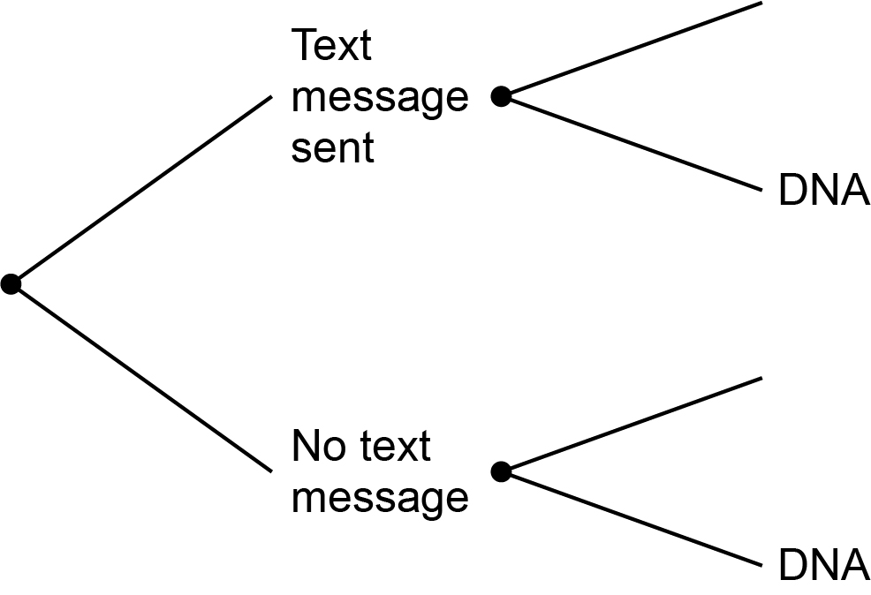

 |  | ii. | Calculate the probability that a patient does not attend their next appointment.
 |  |  | [2 marks]
 |  | iii. | Calculate the probability that a patient who does not attend their next appointment had received a text message.
 |  |  | [3 marks]
 |  | iv. | Calculate the probability that a patient who does attend their next appointment had not received a text message.
 |  |  | [3 marks]
Please turn over

Section 2

This section has a possible 19 marks.

We recommend that you spend 25 minutes on this section.

Answer all questions in the spaces provided.

2 | a) | Ellen is a 27-year-old health care assistant.  She has just got a job at a hospital.  Ellen is paid at the National Minimum Wage of £8.21 (based on 2019/20 rates) for the first 37 hours a week, and £9.50 per hour for any overtime.  She is expected to work 3.5 hours overtime per week.
 |  | i. | Calculate Ellen’s monthly gross pay assuming there are 52 working weeks in the year.
 |  |  | [2 marks]
 |  | ii. | Use the information in Article B to calculate Ellen’s monthly net pay after tax and National Insurance (NI) deductions.  Show all workings and summarise your results in the table below.
 |  |  | [3 marks]
Monthly gross pay
Less tax
Less NI
Monthly net pay

 |  | iii. | Ellen is invited to join the hospital trust pension scheme.  The contributions are 5% of her monthly income, which is deducted before NI and income tax are calculated.  Calculate her monthly net pay if she chooses to invest 5% of her wages into the pension scheme.  Include any income tax and NI adjustments.  Show all workings and summarise your results in the table below.
 |  |  | [3 marks]
Monthly gross pay
Less pension contributions
Less Tax
Less NI
Monthly net pay

Please turn over
 |  | iv. | Ellen is given a pay rise after one year. She will now be paid £1354 per month, net of tax, NI and pension.  Ellen needs to save £15 000 to access the staff help-to-buy property scheme.  She plans to save 10% of her income each month.  How long will it take her to save the required amount on her current salary?
 |  |  | [2 marks]

This page is intentionally left blank.
Please turn over for the next question.
 | b) | Ellen wants to take a degree in nursing and is interested in what she could earn.  The histogram below illustrates the salaries of 300 nurses currently working in NHS hospitals.
 |  |  | 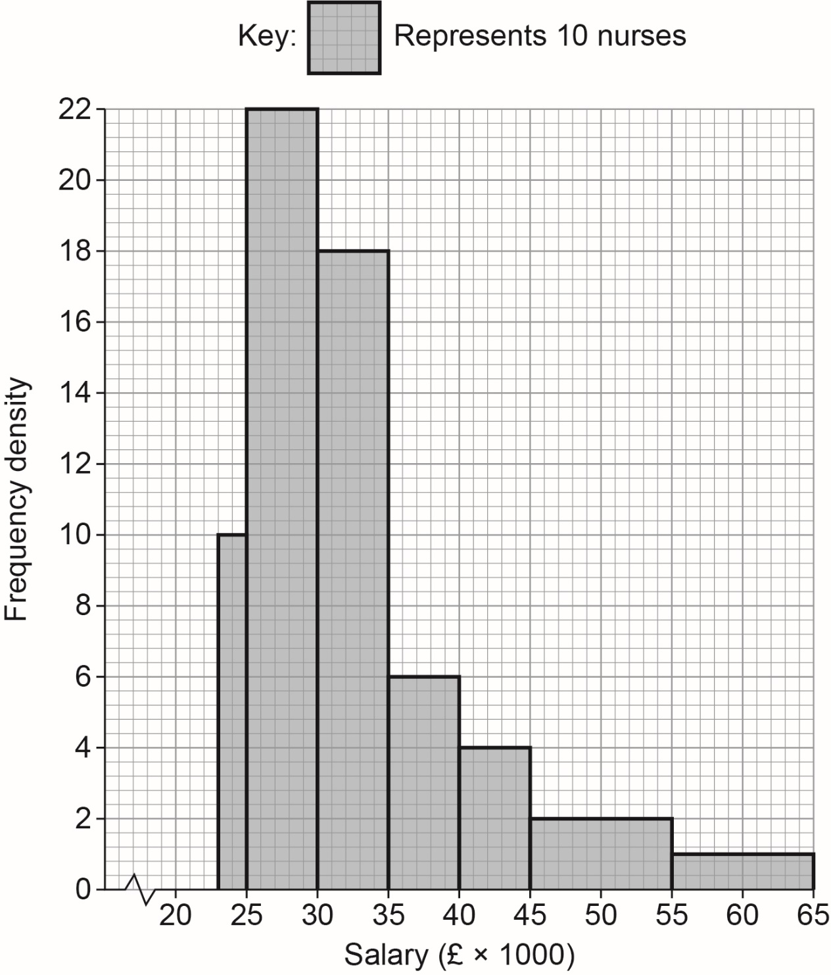
 |  | i. | State the type of skewness shown by this histogram.
 |  |  | [1 mark]

 |  | ii. | The table below shows the cumulative frequency distribution:
Salary | £23 000 -  £24 999 | £25 000 –  £29 999 | £30 000 –  £34 999 | £35 000 –  £39 999 | £40 000 –  £44 999 | £45 000 –  £54 999 | £55 000 –  £64 999
Cumulative frequency | 20 | 130 | 220 | x | 270 | 290 | 300

 |  |  | Use the histogram to find the value of x
 |  |  | [2 marks]
 |  | iii. | Use the histogram to estimate the number of nurses earning between  £27 000 and £34 000
 |  |  | [3 marks]

Please turn over
 |  | iv. | Use the table or the histogram to estimate the median salary of the nurses.
 |  |  | [3 marks]

This page is intentionally left blank.
Please turn over for the next question.
Section 3

This section has a possible 19 marks.

We recommend that you spend 25 minutes on this section.

Answer all questions in the spaces provided.

3 | Boiler Up! is a supply and service boiler company.  The company expects an increase in demand in the winter months. The two parts most in demand are the thermostatic cartridge and the standard gas valve.  There is storage for a maximum of 120 of these parts in total.  As a minimum, they must stock 40 thermostatic cartridges and 30 standard gas valves.  The Stock Manager wants to keep at least as many thermostatic cartridges as standard gas valves in stock.
 | a) | Formulate four constraints for the above scenario.  Use x to represent the number of thermostatic cartridges, and y to represent the number of standard gas valves.
 |  |  | [4 marks]

 | b) | i. | Graph the constraints on the grid below.
 |  |  | [4 marks]
 |  |  | 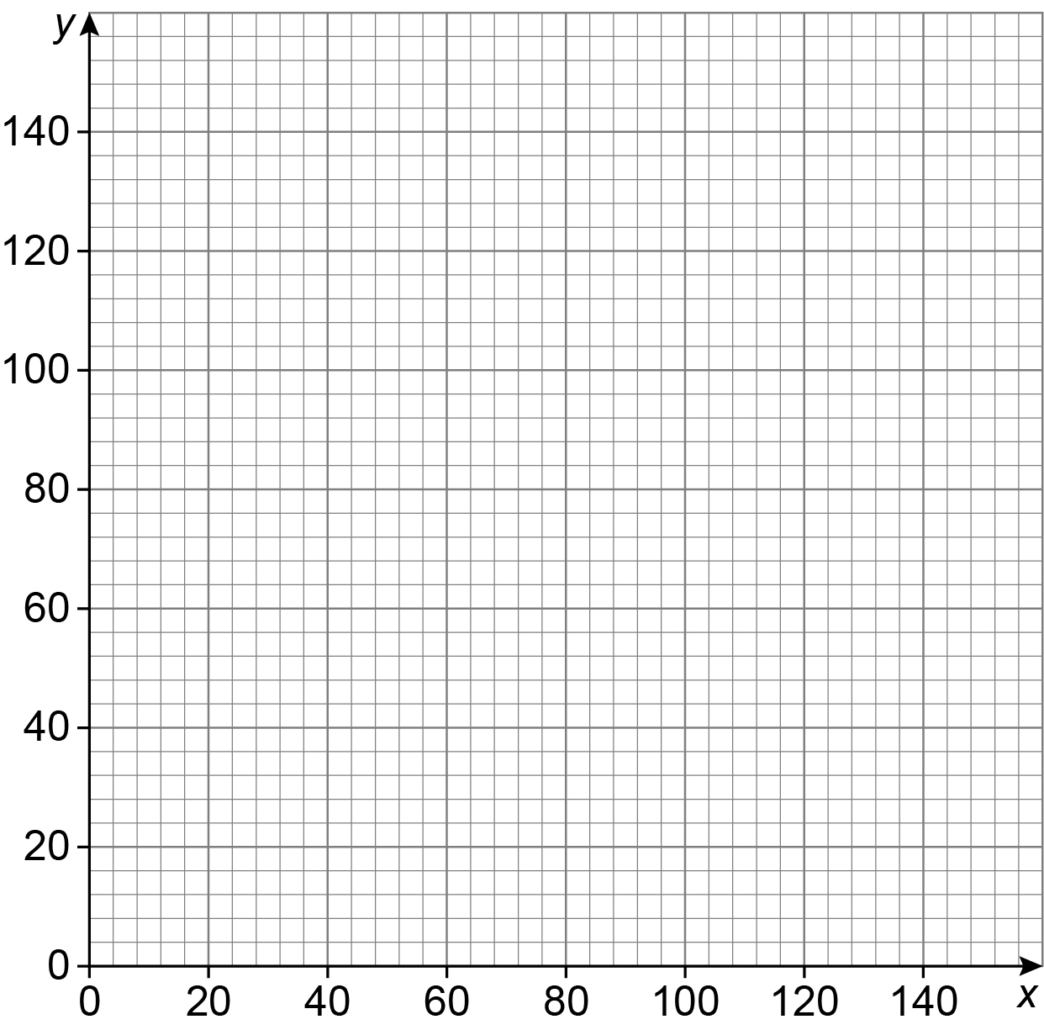
 |  | ii. | Shade the region which satisfies all of your constraints.
 |  |  | [1 mark]

Please turn over
 | c) | There is a cost to the business of sourcing, buying and storing stock.  The average cost to the business to source, buy and store one thermostatic cartridge is £50  The average cost to source, buy and store one gas valve is £100
 |  | i. | Find the vertices of your feasible region and identify the value of the stock at each vertex.  [4 marks]
 |  | Identify how many of each part could be held in each of the following situations:
 |  | ii. | There should be as many thermostatic cartridges as possible.
 |  |  | [1 mark]
 |  | iii. | There should be as many gas valves as possible.
 |  |  | [1 mark]

 | d) | Boiler Up! wants to start selling their parts to independent plumbers all over the UK.  The marketing manager investigated sales of boiler parts last year.  They found that  - 1600 out of every 5000 sales were thermostatic cartridges  - 1600 out of every 20 000 sales were gas valves.  The proportions of other sales are shown in the relative frequency table below.
 |  | Complete the table.
 |  |  | [2 marks]

Part |  |  |  |  | Thermostatic cartridges | Gas valves | Hoses | Boiler fans | Circuit boards | Control panels | Boiler pumps | Pressure release safety valves
Relative Frequency |  |  |  |  |  |  | 0.09 | 0.02 | 0.03 | 0.01 |  | 0.07
 |  | e) | What is the probability that the next three customers all require a circuit board or control panel?
 |  |  |  | [2 marks]

Please turn over
Section 4

This section has a possible 26 marks.

We recommend that you spend 35 minutes on this section.

Answer all questions in the spaces provided.

4 | Boiler Up! is reviewing the suitability of the safety equipment the company provides to its employees.  The company is focusing on the height of the hazmat suits it provides.  It is known that the height of employees is normally distributed with a mean of 162 cm and a standard deviation of 12.5 cm
 | a) | i. | Sketch the distribution of the height data.
 |  |  | [2 marks]

 |  | ii. | The company must make sure that its safety equipment is suitable for at least 99% of its employees.  What is the height of the tallest employee that the company should consider when providing hazmat suits?  Give your answer to the nearest cm
 |  |  | [4 marks]

Please turn over for the next question.
 | b) | The sales team is reviewing how often the company is called back to a property after installing or servicing a boiler.  The team decides that the gap between visits to a property is normally distributed with a mean of 265 days and a standard deviation of 14 days.  Use the 68 - 95 - 99.7 rule to estimate:
 |  | i. | the proportion of visits that fall between 251 and 279 days.
 |  |  | [1 mark]
 |  | ii. | the range of days covered by the middle 95% of customers.
 |  |  | [1 mark]
 | c) | To assess the robustness of the data, the health and safety manager decides to collect the heights of employees in the north west depot.
 |  | i. | She writes a report saying that she collected secondary data.  Is this correct?  You must give a reason for your answer.
 |  |  | [1 mark]
 |  | ii. | The Health and Safety Manager believes her data gives an unbiased representation of the heights of employees in the company depots across the country.  Do you agree?  You must give a reason for your answer.
 |  |  | [1 mark]

 |  | iii. | The health and safety manager decides to extend her study across all four depots in the business.  She decides to use a stratified sampling method to select the employees she is going to survey for the height data.  Give one advantage and one disadvantage of using stratified sampling over a census or random sampling.
 |  |  | [2 marks]
 |  | iv. | The number of employees working for Boiler Up! over the specified period is 8562  The health and safety manager decides a sample size of 706 will give her a large enough data set to represent the population of employees.  Calculate the stratified sample numbers for the information below.
 |  |  | [4 marks]
Depot | Manchester | Birmingham | Stoke on Trent | Redditch
Number of employees | 5487 | 824 | 1150 | 1101
Sample size

Please turn over
 |  | v. | The Health and Safety Manager generates the following height data from her sampling.  Use the data to draw a cumulative frequency graph on the axes on page 27.
 |  |  | [3 marks]
Height of employee (cm) | Frequency | Cumulative frequency
130<h<140 | 11
140<h<150 | 49
150<h<160 | 189
160<h<170 | 302
170<h<180 | 134
180<h<190 | 18
190<h<200 | 3

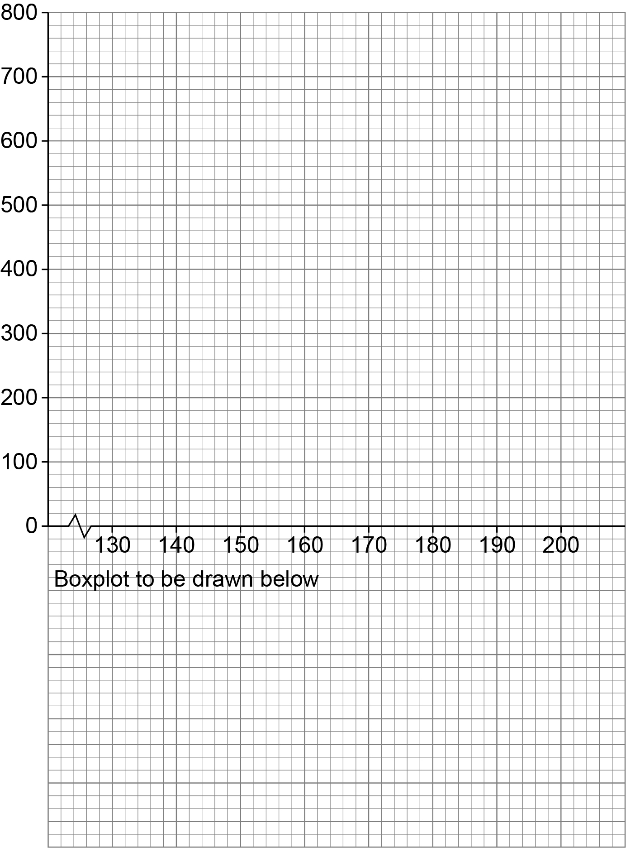

Please turn over
 |  | vi. | Use the data from your cumulative frequency graph to draw a fully labelled box plot in the space provided on page 27.  Fully label the box plot and calculate the inter quartile range for the data.  Take 130 to be your minimum value and 200 to be your maximum value.  You will need to include your minimum and maximum values, your lower quartile value, upper quartile value and your median.
 |  |  | [5 marks]
 |  | vii. | Is the data symmetrical or skewed?  Does this support the theory that the height data collected is normally distributed?
 |  |  | [2 marks]

This is the end of the external assessment.

This page is intentionally left blank.

Assessment Objective Grid
Section | AO1 | AO2 | AO3 | Total
1
2
3
4
Total

