NCFE Level 3 Certificate in
Mathematics for Everyday Life (603/3437/X) PRACTICE

Paper 2

Health and Science
Paper number: P00XXXX

DATE

To be completed by the examiner | Mark
Section 1
Section 2
Section 3
Section 4
TOTAL MARK
Time allowed: 2 hours

Learner instructions
- Use black or blue ink.
- Read each question carefully.
- Answer all questions.
- Write your responses in the spaces provided.
- Use the graph paper provided where instructed.
- All of the work you submit must be your own.

Learner information
- The marks available for each question are shown in brackets.
- The maximum mark for this paper is 90.
- You may use a calculator.

Learner name
Centre name
Learner number |  |  | Centre number

Please complete the details below clearly and in BLOCK CAPITALS.

Do not turn over until the invigilator tells you to do so.

Section 1

This section has a possible 26 marks.

We recommend that you spend 35 minutes on this section.

Answer all questions in the spaces provided.

1 | Currently, family doctors allow 10 minutes for face-to-face appointments with patients. Some doctors think these need to last longer.  Dr Kunis carried out a trial where patients were allowed to spend longer with their doctor.  He recorded the time spent with each patient to the nearest minute.  Dr Kunis summarised his findings in the probability distribution below:  Minutes 10 11 12 13 14  Probability $$\frac{1}{20}$$ $$\frac{1}{10}$$ $$\frac{1}{10}$$ $$\frac{1}{2}$$ $$\frac{1}{4}$$
 | a) | i. | Calculate the mean length of the appointments over this period.
 |  |  | [2 marks]
 |  | ii. | Use this data to explain what Dr Kunis can conclude from the trial.  Give two mathematical reasons for your explanation.
 |  |  | [2 marks]

 | b) | i. | Give an efficient rule for using 2-digit random numbers from 00 to 99 in order to simulate the length of Dr Kunis’ appointments.
 |  |  | [2 marks]
 |  | ii. | Use your rule and the following random numbers to generate expected lengths of appointment for Dr Kunis’ patients.
Random number | 13 | 17 | 32 | 38 | 49 | 84 | 63 | 21 | 92 | 04
Expected length of appointments (mins)

 |  |  | [2 marks]
Please turn over
 | c) | Dr Kunis’ surgery opens at 8am and currently allows 10 minutes for each appointment.  When patients arrive, they sign in using an interactive screen. They are asked to arrive at least 5 minutes before their appointment time.  The number of minutes a patient arrives early follows the distribution given in the table below:  Number of minutes a patient arrives early 5 6 7 8 9 10 Did not attend  Probability $$\frac{1}{4}$$ $$\frac{1}{6}$$ $$\frac{1}{6}$$ $$\frac{1}{12}$$ $$\frac{1}{12}$$ $$\frac{5}{24}$$ $$\frac{1}{24}$$
 |  | i. | Give an efficient rule for using 2-digit random numbers from 00 to 99 in order to simulate the arrival times of Dr Kunis’ patients.
 |  |  | [2 marks]

 |  | ii. | Dr Kunis applies random number rules to simulate the number of minutes by which 10 patients arrive early and their appointment lengths.  Patient number 1 2 3 4 5 6 7 8 9 10  Number of minutes early 5 9 5 7 DNA 7 5 6 10 10  Appointment length (minutes) 10 14 13 11 X 13 13 12 13 14
Use the table below to simulate the arrival, waiting, and appointment time for the 10 patients.

For patients who do not attend (identified as DNA), the doctor waits for three minutes before calling for the next patient.
 |  |  | [4 marks]
Appointment time | Arrival time | Appointment start time | Appointment end time | Time spent in the waiting area
8.00am |  | 8.00am
8.10am
8.20am
8.30am
8.40am
8.50am
9.00am
9.10am
9.20am
9.30am

 |  | iii. | Comment on what you think will happen to the waiting times over a whole day.
 |  |  | [1 mark]

Please turn over
 |  | iv. | Explain how DNA patients affect the overall waiting time.
 |  |  | [1 mark]

This page is intentionally left blank.
Please turn over for the next question.
 | d) | Missed appointments put strain on time and resource within the NHS.  At Dr Karim’s surgery, 5% of patients have failed to turn up for their appointment in the past year.  To reduce this, the practice manager decided to send a text message to all registered patients reminding them of their upcoming appointment and how to cancel if no longer needed.  The practice manager was only able to contact 80% of the patients by text.  Of the patients she contacted, only 2% missed their next appointment.  The practice manager wants to summarise her results on a probability tree diagram.
 |  | i. | Complete her probability tree diagram.
 |  |  | [2 marks]
Attends
Attends

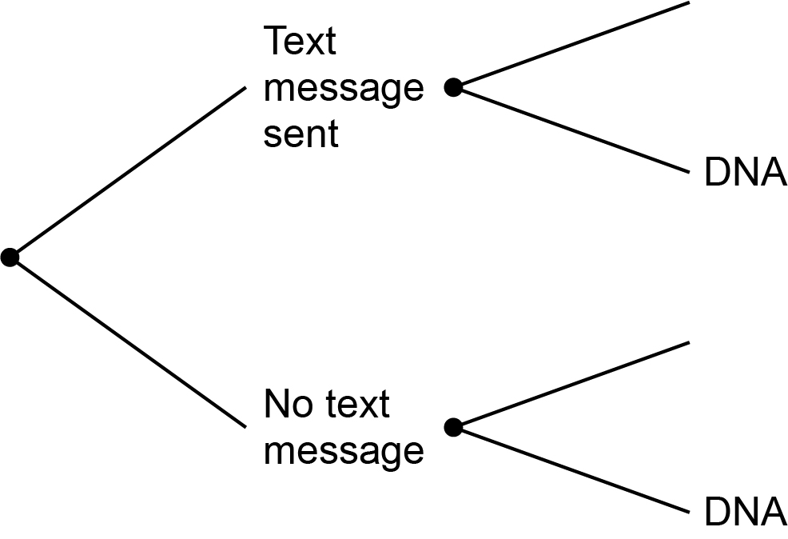

 |  | ii. | Calculate the probability that a patient does not attend their next appointment.
 |  |  | [2 marks]
 |  | iii. | Calculate the probability that a patient who does not attend their next appointment had received a text message.
 |  |  | [3 marks]
 |  | iv. | Calculate the probability that a patient who does attend their next appointment had not received a text message.
 |  |  | [3 marks]
Please turn over

Section 2

This section has a possible 19 marks.

We recommend that you spend 25 minutes on this section.

Answer all questions in the spaces provided.

2 | a) | Ellen is a 27-year-old health care assistant.  She has just got a job at a hospital.  Ellen is paid at the National Minimum Wage of £8.21 (based on 2019/20 rates) for the first 37 hours a week, and £9.50 per hour for any overtime.  She is expected to work 3.5 hours overtime per week.
 |  | i. | Calculate Ellen’s monthly gross pay assuming there are 52 working weeks in the year.
 |  |  | [2 marks]
 |  | ii. | Use the information in Article B to calculate Ellen’s monthly net pay after tax and National Insurance (NI) deductions.  Show all workings and summarise your results in the table below.
 |  |  | [3 marks]
Monthly gross pay
Less tax
Less NI
Monthly net pay

 |  | iii. | Ellen is invited to join the hospital trust pension scheme.  The contributions are 5% of her monthly income, which is deducted before NI and income tax are calculated.  Calculate her monthly net pay if she chooses to invest 5% of her wages into the pension scheme.  Include any income tax and NI adjustments.  Show all workings and summarise your results in the table below.
 |  |  | [3 marks]
Monthly gross pay
Less pension contributions
Less Tax
Less NI
Monthly net pay

Please turn over
 |  | iv. | Ellen is given a pay rise after one year. She will now be paid £1354 per month, net of tax, NI and pension.  Ellen needs to save £15 000 to access the staff help-to-buy property scheme.  She plans to save 10% of her income each month.  How long will it take her to save the required amount on her current salary?
 |  |  | [2 marks]

This page is intentionally left blank.
Please turn over for the next question.
 | b) | Ellen wants to take a degree in nursing and is interested in what she could earn.  The histogram below illustrates the salaries of 300 nurses currently working in NHS hospitals.
 |  |  | 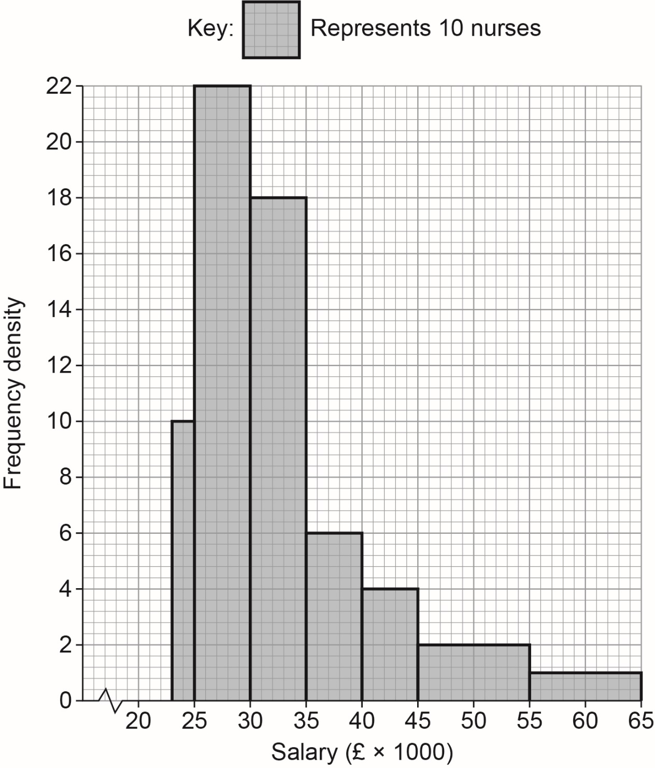
 |  | i. | State the type of skewness shown by this histogram.
 |  |  | [1 mark]

 |  | ii. | The table below shows the cumulative frequency distribution:
Salary | £23 000 -  £24 999 | £25 000 –  £29 999 | £30 000 –  £34 999 | £35 000 –  £39 999 | £40 000 –  £44 999 | £45 000 –  £54 999 | £55 000 –  £64 999
Cumulative frequency | 20 | 130 | 220 | x | 270 | 290 | 300

 |  |  | Use the histogram to find the value of x
 |  |  | [2 marks]
 |  | iii. | Use the histogram to estimate the number of nurses earning between  £27 000 and £34 000
 |  |  | [3 marks]

Please turn over
 |  | iv. | Use the table or the histogram to estimate the median salary of the nurses.
 |  |  | [3 marks]

This page is intentionally left blank.
Please turn over for the next question.
Section 3

This section has a possible 19 marks.

We recommend that you spend 25 minutes on this section.

Answer all questions in the spaces provided.

3 | Dorminster Hospital has to keep a certain amount of different blood types in stock in preparation for transfusions.  The freezers can store a maximum of 120 litres in total for their Type A+ and their Type B+ stock.  As a minimum, they must stock 40 litres of Type A+ and 30 litres of Type B+.  The Storage Manager wants to keep at least as much blood Type A+ than Type B+ in stock.
 | a) | Formulate four constraints for the above scenario.  Use x to represent Type A+, and y to represent Type B+.
 |  |  | [4 marks]

 | b) | i. | Graph the constraints on the grid below.
 |  |  | [4 marks]
 |  |  | 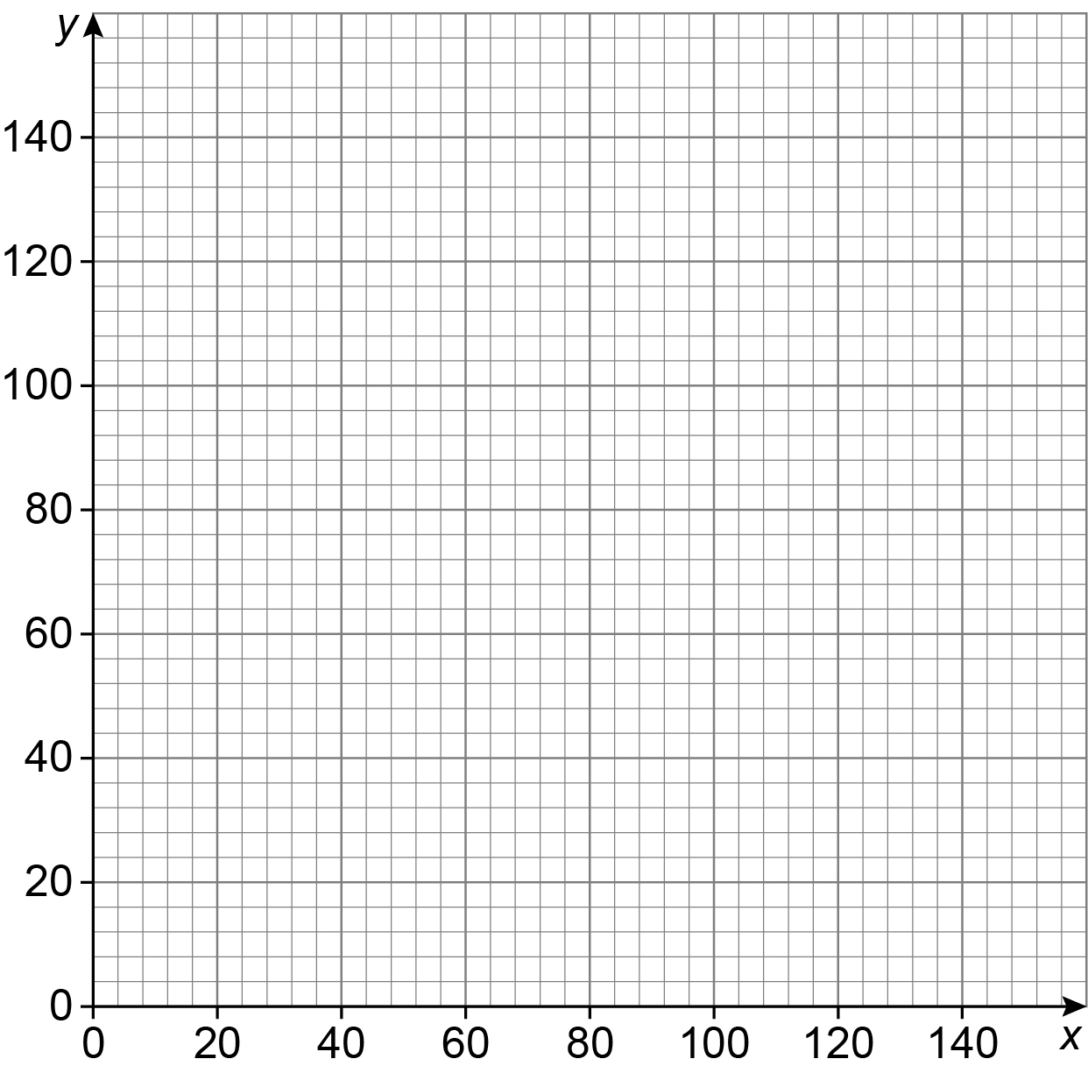
 |  | ii. | Shade the region which satisfies all of your constraints.
 |  |  | [1 mark]

Please turn over
 | c) | There is a cost to hospitals of sourcing and storing blood.  The average cost to source and store blood Type A+ is £50 per litre.  The average cost to source and store blood Type B+ is £100 per litre.
 |  | i. | Find the vertices of your feasible region and identify the value of the blood stock at each vertex.  [4 marks]
 |  | Identify how many of each blood type could be held in each of the following situations:
 |  | ii. | There should be as much of blood Type A+ as possible.
 |  |  | [1 mark]
 |  | iii. | There should be as much of blood Type B+ as possible.
 |  |  | [1 mark]

 | d) | In the UK:  - 1600 out of every 5000 people are blood Type A+  - 1600 out of every 20 000 are blood Type B+  The proportions of other blood types are shown in the relative frequency table below.
 |  | Complete the table.
 |  |  | [2 marks]

Blood Type | A+ | B+ | A- | B- | AB+ | AB- | O+ | O-
Relative Frequency |  |  | 0.09 | 0.02 | 0.03 | 0.01 |  | 0.07

 | e) | What is the probability that the next three patients who arrive all have a blood type of AB- or AB+?
 |  |  | [2 marks]

Please turn over
Section 4

This section has a possible 26 marks.

We recommend that you spend 35 minutes on this section.

Answer all questions in the spaces provided.

4 | Dorminster Hospital is reviewing the suitability of the beds and equipment on the maternity ward.  The height of women over 16 years old in the area is normally distributed with a mean of 162 cm and a standard deviation of 12.5 cm
 | a) | i. | Sketch the distribution of the height data.
 |  |  | [2 marks]

 |  | ii. | The hospital must make sure that its beds are suitable for at least 99% of the patients that use the ward.  What is the minimum length of bed the hospital should use?  Give your answer to the nearest cm
 |  |  | [4 marks]

Please turn over for the next question.
 | b) | As well as bed size, the review is also assessing the resource allocation for the maternity ward.  The length of a human pregnancy is normally distributed with a mean of 265 days and a standard deviation of 14 days.  Use the 68 - 95 - 99.7 rule to estimate:
 |  | i. | the proportion of lengths of pregnancies that fall between 251 and 279 days.
 |  |  | [1 mark]
 |  | ii. | the range of days covered by the middle 95% of pregnancies.
 |  |  | [1 mark]
 | c) | The Ward Manager wants to assess the robustness of the resourcing models she has put in place. She records the heights of women entering the ward and the number of days their pregnancy has lasted.
 |  | i. | She writes a report for her Board of Directors stating that she collected secondary data.  Is this correct?  You must give a reason for your answer.
 |  |  | [1 mark]
 |  | ii. | The ward manager believes her data gives an unbiased representation of the heights of women in labour and the length of their pregnancies.  Do you agree?  You must give a reason for your answer.
 |  |  | [1 mark]

 |  | iii. | The ward manager is asked to extend her study to the local NHS Foundation Trust.  She decides to use a stratified sampling method to select the women she is going to survey.  Give one advantage and one disadvantage of using stratified sampling over a census or random sampling.
 |  |  | [2 marks]
 |  | iv. | The population of women surveyed who give birth over the time period is 8562  The ward manager decides a sample size of 706 will give her a large enough data set to represent the population.  Calculate the stratified sample numbers for the information below.
 |  |  | [4 marks]
Location | Labour Ward | Intensive Care Unit | Home  Births | Midwife Led Maternity Unit
Births | 5487 | 824 | 1150 | 1101
Sample size

Please turn over
 |  | v. | The ward manager generates the following height data from her sampling.  Use the data to draw a cumulative frequency graph on the axes on page 27.
 |  |  | [3 marks]
Height of patient (cm) | Frequency | Cumulative frequency
130<h<140 | 11
140<h<150 | 49
150<h<160 | 189
160<h<170 | 302
170<h<180 | 134
180<h<190 | 18
190<h<200 | 3

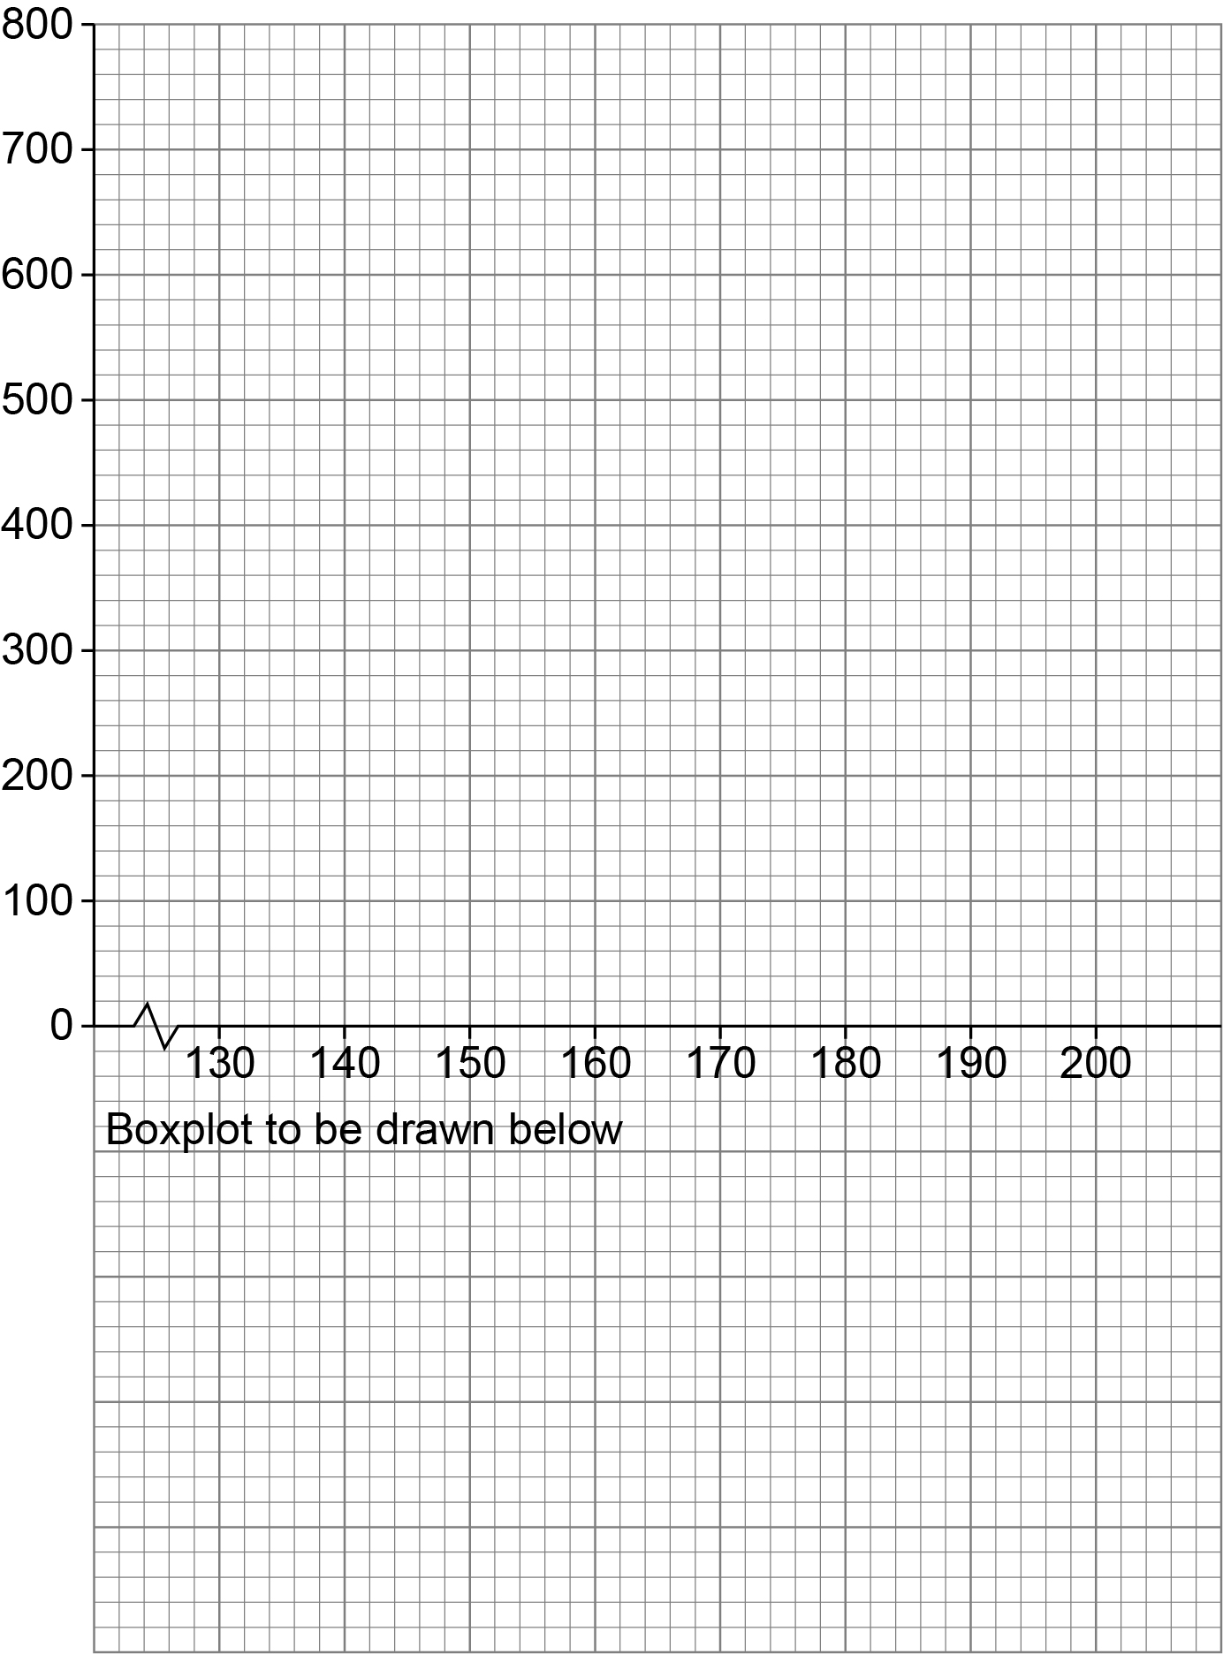

Please turn over
 |  | vi. | Use the data from your cumulative frequency graph to draw a fully labelled box plot in the space provided on page 27.  Fully label the box plot and calculate the inter quartile range for the data.  Take 130 to be your minimum value and 200 to be your maximum value.  You will need to include your minimum and maximum values, your lower quartile value, upper quartile value and your median.
 |  |  | [5 marks]
 |  | vii. | Is the data symmetrical or skewed?  Does this support the theory that the height data collected is normally distributed?
 |  |  | [2 marks]

This is the end of the external assessment.

This page is intentionally left blank.

Assessment Objective Grid
Section | AO1 | AO2 | AO3 | Total
1
2
3
4
Total

