NCFE Level 2 Functional Skills Qualification in English (603/5054/4)

Paper Title: Level 2 Functional Skills Qualification in English: Reading

Paper number: P001244

To be completed by the examiner | Mark
Section 1 | / 6
Section 2 | / 9
Section 3 | / 8
Section 4 | / 7
TOTAL MARK | / 30
Time allowed: 1 hour

Learner instructions
- Use black or blue ink.
- Answer all questions.
- Read each question carefully.
- Write your responses in the spaces provided.
- All of the work you submit must be your own.

Learner information
- The marks available for each question are shown in brackets.
- The maximum mark for this paper is 30.
- The use of a dictionary is permitted.

Learner name
Centre name
Learner number |  |  | Centre number

Please complete the details below clearly and in BLOCK CAPITALS.

Do not turn over until the invigilator tells you to do so.

Document 1

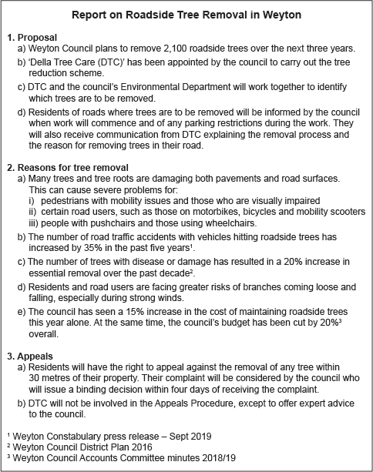

Section 1

The questions in this section refer to Document 1.

This section has a possible 6 marks available.

Answer all questions in the spaces provided.

1 |  | Which word best describes the style of Document 1?  [1 mark]
 |  | A | Descriptive
 |  | B | Instructive
 |  | C | Informative
 |  | D | Persuasive
 |  | Answer

2 |  |  | Give one reason why this writer has used each of the following organisational features:  - Subheadings  [1 mark]

- Lettered list
[1 mark]

Please turn over
3 |  |  | Section 2 states that there has been a 20% increase in tree removal over the past decade. Where has the writer taken this information from?  [1 mark]

4 |  |  | Identify a group of people Weyton Council suggests would benefit from its plan to remove tree roots.  [1 mark]

5 |  |  | What is the meaning of the word ‘binding’ as used in Section 3a)?  You may use a dictionary to help you answer this question.  [1 mark]

Please turn over for the next section.
Document 2
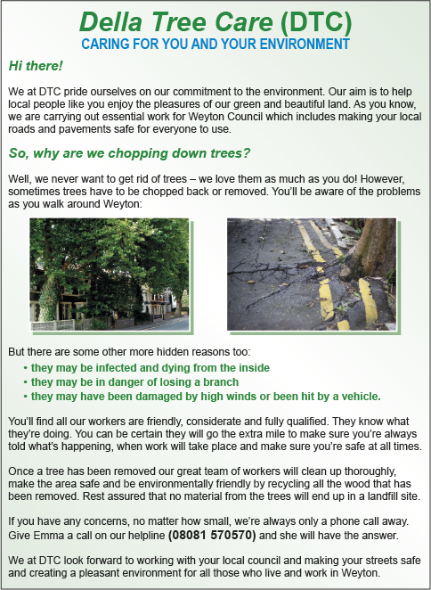
Please turn over

Section 2

The questions in this section refer to Document 2.

This section has a possible 9 marks available.

Answer all questions in the spaces provided.

6 |  |  | Della Tree Care (DTC) entitles their leaflet ‘Caring for You and Your Environment’. Give two examples from the document that demonstrates DTC’s care for the environment.  [2 marks]

7 |  |  | Identify one example of each of the following in Document 2:  a) Fact  [1 mark]

b) Opinion
[1 mark]

8 |  |  | The writer of Document 2 has included two images. What problems relating to trees are illustrated by each of these images?  [2 marks]

9 |  |  | Document 2 gives a very positive image of DTC. Give two examples of how the writer of the document has done this.  [2 marks]

10 |  |  | What organisational feature has the writer of Document 2 used to give examples of why trees need to be removed?  [1 mark]

Please turn over
Document 3

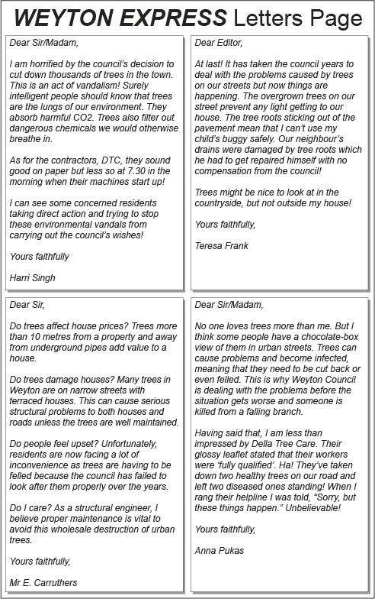

Section 3

The questions in this section refer to Document 3.

This section has a possible 8 marks available.

Answer all questions in the spaces provided.

11 |  |  | Give two words that best describe the tone of Teresa Frank’s letter.  [2 marks]

12 |  |  | What does Harri Singh imply by writing that DTC ‘sound good on paper’?  [2 marks]

13 |  |  | Anna Pukas likes trees and understands the council’s policy, but has some concerns. Identify two of these concerns.  [2 marks]

Please turn over

14 |  |  | The letter from Mr E. Carruthers contains a number of rhetorical questions. Give two reasons why he has used these.  [2 marks]

Section 4

The questions in this section refer to multiple documents.

This section has a possible 7 marks available.

Answer all questions in the spaces provided.

15 |  |  | Compare the views expressed by Teresa Frank in Document 3 with the information given in Document 1, and how these are conveyed.  [3 marks]

Please turn over

16 |  |  | Analyse all three documents and explain which is the most biased. Provide examples from all three documents to support your decision.  [4 marks]

[Total: 30 marks]

This is the end of the assessment.

