NCFE Level 2 Functional Skills Qualification in English (603/5054/4)

Paper Title: Level 2 Functional Skills Qualification in English: Reading

Paper number: P001243

To be completed by the examiner | Mark
Section 1 | / 8
Section 2 | / 9
Section 3 | / 6
Section 4 | / 7
TOTAL MARK | / 30
Time allowed: 1 hour

Learner instructions
- Use black or blue ink.
- Answer all questions.
- Read each question carefully.
- Write your responses in the spaces provided.
- All of the work you submit must be your own.

Learner information
- The marks available for each question are shown in brackets.
- The maximum mark for this paper is 30.
- The use of a dictionary is permitted.

Learner name
Centre name
Learner number |  |  | Centre number

Please complete the details below clearly and in BLOCK CAPITALS.

Do not turn over until the invigilator tells you to do so.

Document 1
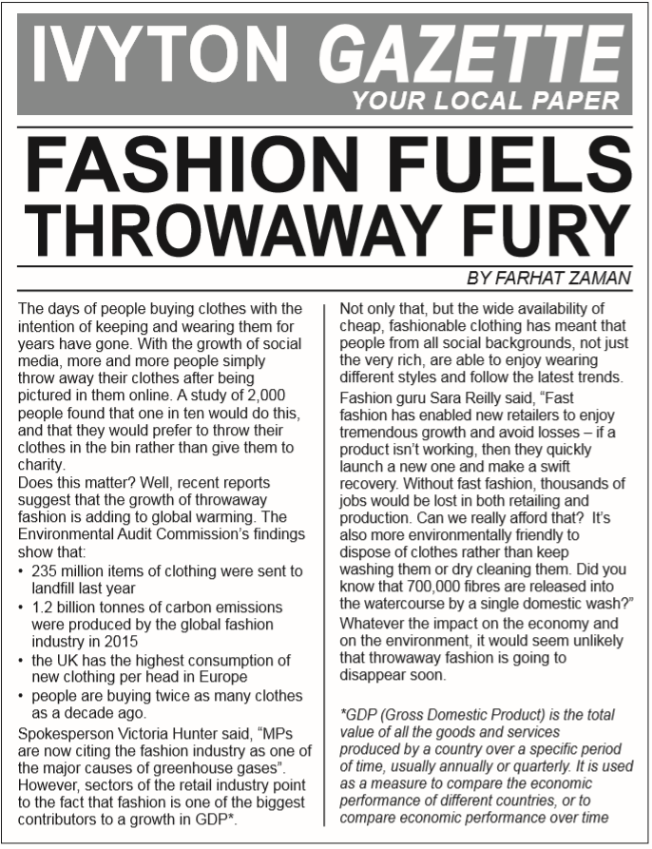

Section 1

The questions in this section refer to Document 1.

This section has a possible 8 marks available.

Answer all questions in the spaces provided.

1 |  | What best describes the tone of Document 1?  [1 mark]
 |  | A | Amusing
 |  | B | Balanced
 |  | C | Sarcastic
 |  | D | Righteous
 |  | Answer

2 |  |  | State two meanings that Sara Reilly could be implying by using the term ‘fast’ fashion instead of ‘throwaway’ fashion?  [2 marks]

3 |  |  | Give one reason why the writer has used each of the following organisational features.  a) Bullet points  [1 mark]

b) Footnote
[1 mark]

4 |  |  | a) What is the main point made by Document 1?  [1 mark]

b) The writer believes that throwaway fashion is here to stay. Give two examples from the document that support this opinion.
[2 marks]

This page is intentionally left blank.
Please turn over for the next section.

Document 2

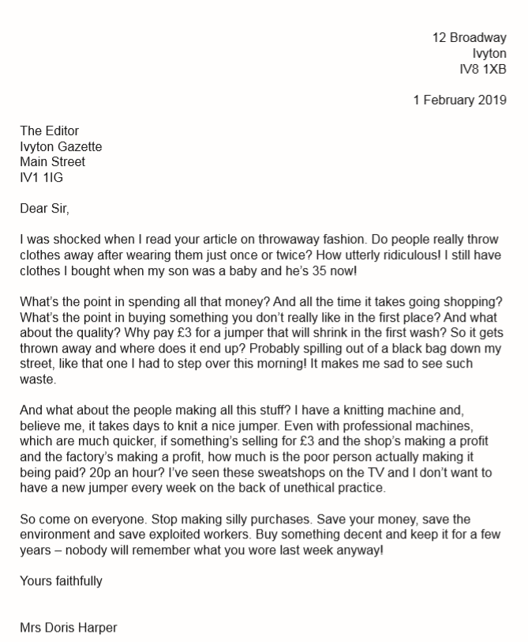

Section 2

The questions in this section refer to Document 2.

This section has a possible 9 marks available.

Answer all questions in the spaces provided.

5 |  |  | Give two words that identify the style of writing used in Document 2.  [2 marks]

6 |  |  | In paragraphs 2 and 3, the writer repeats questions beginning with ‘what?’ and ‘why?’ several times. Give two reasons why she has done this.  [2 marks]

7 |  |  | Give one example of each of the following features being used to present a negative image of throwaway fashion.  a) Emotive language  [1 mark]

b) Personal experience
[1 mark]

8 |  |  | What is the meaning of the word ‘spilling’ as used in Document 2?  [1 mark]

9 |  |  | Identify one example of each of the following in Document 2.  a) Fact  [1 mark]

b) Opinion
[1 mark]

This page is intentionally left blank.
Please turn over for the next section.

Document 3
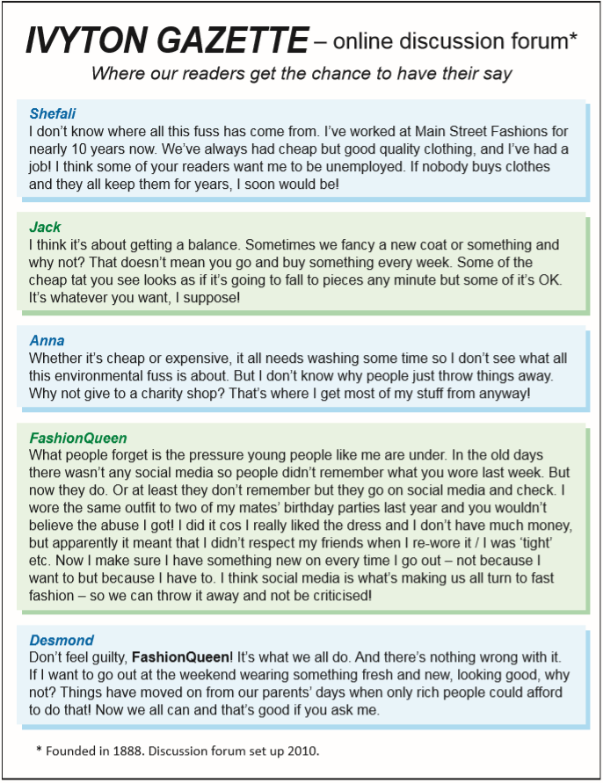

Section 3

The questions in this section refer to Document 3.

This section has a possible 6 marks available.

Answer all questions in the spaces provided.

10 |  |  | When was the discussion forum started?  [1 mark]

11 |  |  | Why does Shefali feel hurt by some of the comments which have been made?  [2 marks]

12 |  |  | What can be inferred from ‘FashionQueen’ about how she feels from her contribution to the discussion forum?  [2 marks]

13 |  |  | Give one example of information that bold text helps the reader to find.  [1 mark]

Section 4

The questions in this section refer to multiple documents.

This section has a possible 7 marks available.

Answer all questions in the spaces provided.

14 |  |  | Compare the views expressed in Document 3 with those of Document 1, and how these views are conveyed.  [3 marks]

Please turn over

15 |  |  | Analyse all three documents and explain which document is the least biased.  [4 marks]

[Total: 30 marks]

This is the end of the assessment.

