NCFE Level 1 Functional Skills Qualification in English
(603/5058/1)

Paper Title: Level 1 Functional Skills Qualification in English: Writing

Paper number: P001238
To be completed by the examiner | Mark
Activity 1 | / 20
Activity 2 | / 20
TOTAL MARK | / 40

Time allowed: 1 hour

Learner instructions
- Use black or blue ink.
- Answer all questions.
- Read each question carefully.
- Write your responses in the spaces provided.
- All of the work you submit must be your own.

Learner information
- The marks available for each question are shown in brackets.
- The maximum mark for this paper is 40.
- The use of a dictionary is not permitted.

Learner name
Centre name
Learner number |  |  | Centre number

Please complete the details below clearly and in BLOCK CAPITALS.

Do not turn over until the invigilator tells you to do so.

This page is intentionally left blank.

This assessment is about:
- Noisy neighbours
- Theme park development.
Read the information provided and complete the two writing activities:
Activity 1: Write a letter (20 marks)
Activity 2: Write a review (20 marks)

45% of the marks are available for evidence of accurate spelling, punctuation and grammar.
Suggested Timings:
- Allow 10 minutes overall for reading, planning and proofreading
- Allow approximately 25 minutes for Activity 1
- Allow approximately 25 minutes for Activity 2.

Activity 1: Write a letter

This activity has a possible 20 marks available.

Answer the question in the space provided.

Some new neighbours have moved in next door and they are very noisy. You have asked them to keep the noise down, but they won’t listen to you.

Write a letter to your local council making a complaint outlining what you want the council to do. You should:
- give details of the noise
- outline any actions you have taken
- explain how you have been affected.

Your local council’s address is:

Complaints Department
South Middleshire District Council
Torchester
SN1 5TC
[20 marks]

You may use the space below for planning and drafting your letter.

Write your letter here:

Activity 2: Write a review for a newsletter

This activity has a possible 20 marks available.

Answer the question in the space provided.

The construction of a theme park has been proposed within a mile of your town, Stiven.

Information from the company’s website is given in Document 1 which you may find useful for your review.

Write a review for your local town newspaper telling readers about how the proposed plans may impact on the area, as well as giving your opinion.

The newspaper’s editor has said your review should be between 150-250 words.
[20 marks]

Document 1:

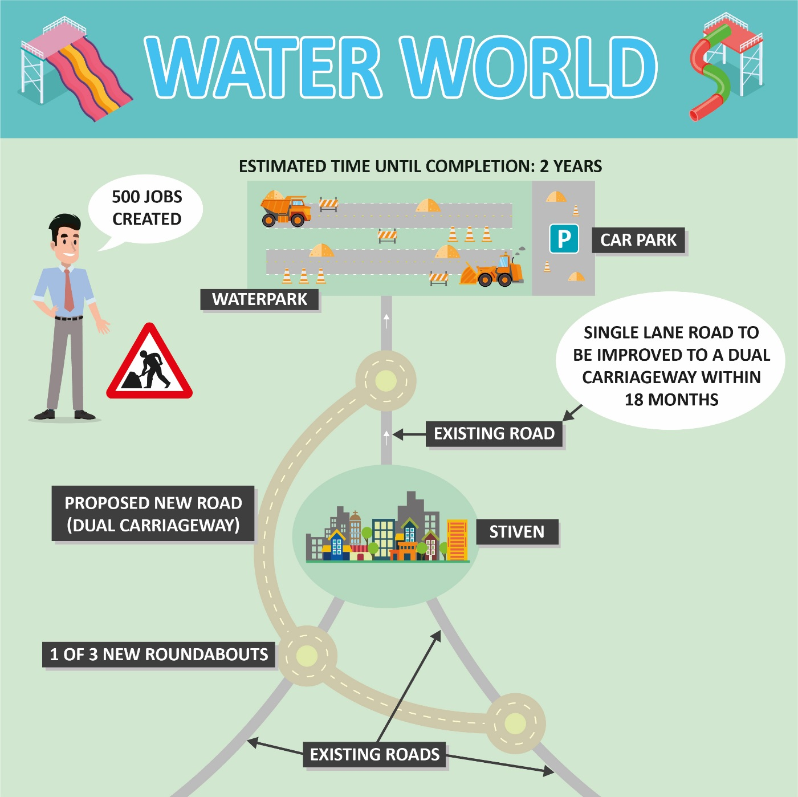

You may use the space below for planning and drafting your review.

Write your review here:

This is the end of the assessment

