NCFE Level 2 Functional Skills Qualification in Mathematics (603/5060/X)
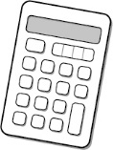
Paper number: P001259
Section B: Calculator Test

Assessment window: Monday 9 December 2019 – Friday 13 December 2019
Time allowed: 1 hour 30 minutes

Learner instructions
- Answer all questions.
- Read each question carefully.
- Write your answers in the spaces provided.
- Show your working, as marks may be awarded for working.
- State units in your answers, where appropriate.
- Check your work.
- Use $π$ = 3.14

Learner information
- Section B contains Activities 2, 3 and 4.
- The maximum mark for this section is 45.
- The marks available for each question are shown in brackets.

Resources
You will need a:
- pen, with black or blue ink
- pencil and eraser
- 30 cm ruler
- protractor
- calculator.

If extra pages are used, please make sure your name and centre name are on them
and they are securely fastened to this booklet.

Please complete the details below clearly and in BLOCK CAPITALS.
Learner name
Centre name
Learner number |  | Centre number

Do not turn over until the invigilator tells you to do so.
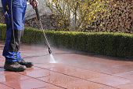
Activity 2: Running a business

2 (a) |  | Dan has set up a patio cleaning business.  He charges £4.25 per m² of the patio to  be cleaned.  Mrs Jones has asked Dan how much he will charge for cleaning her patio.  This diagram shows her patio:  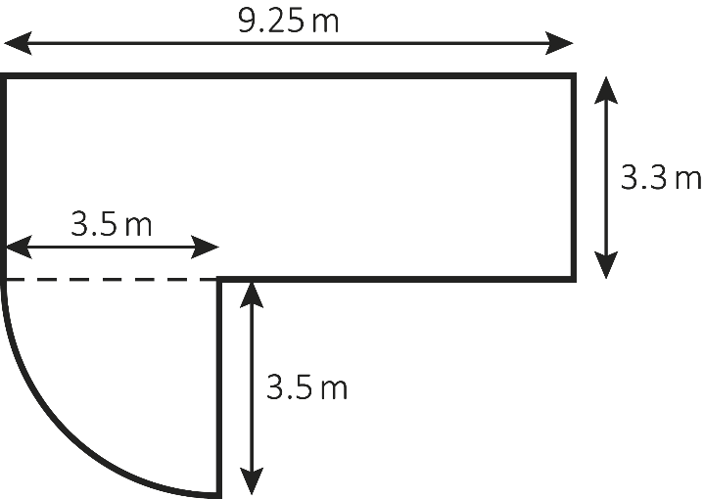  Not drawn accurately

How much will Dan charge Mrs Jones for cleaning her patio?

Use $π$ = 3.14
[4 marks]

 |  |  | Your answer: | £

Please turn over
2 (b) |  |  | Mr Patel pays Dan £250 to clean his patio.  The £250 includes VAT at 20%  How much was the bill before the VAT was added?  [2 marks]
 |  |  | Your answer: | £

2 (c) |  |  | Dan needs to make a mixture of weed killer and water to clean Mr Patel’s patio.  The area of the patio to be sprayed is 63.2 m²  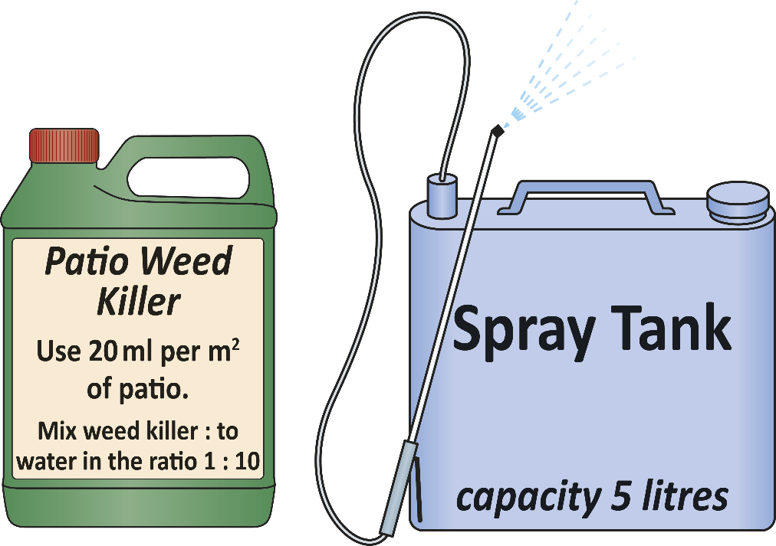  He fills the spray tank with the weed killer and water mixture.  How many times does Dan need to fill the spray tank to cover the whole patio?  [3 marks]
 |  |  | Your answer:

Please turn over
2 (d) |  |  | Dan wants to expand his business.  Next year he plans to clean patios from 8.30am to 3.30pm, Monday to Friday  for 26 weeks during the spring and summer.  This table shows how long each job took Dan this year.  The times include travel time.  Time per cleaning job Number of jobs  30 < time ≤ 60 minutes 25  60 < time ≤ 90 minutes 36  90 < time ≤ 120 minutes 45  120 < time ≤ 150 minutes 21  Total 127  Use the data to estimate how many patios Dan can clean next year  if he works the hours planned.  [5 marks]
 |  |  | Your answer: | patios

2 (e) |  |  | This table shows how long each job took Dan last year.  Time per cleaning job Number of jobs  30 < time ≤ 60 minutes 14  60 < time ≤ 90 minutes 22  90 < time ≤ 120 minutes 30  120 < time ≤ 150 minutes 16  Total 82  Dan’s accounts are checked by the tax office.  They pick one of last year’s jobs at random to check.  What is the probability that the job would have taken more than 90 minutes?  [1 mark]
 |  |  | Your answer:

[Total marks: 15]

Please turn over

This page is intentionally left blank.

Activity 3: Cycling

3 (a) |  |  | There are 51 million adults in the UK.  20.5 million do not do any regular exercise.  What fraction of adults in the UK do not do any regular exercise?  [1 mark]
 |  |  | Your answer:

3 (b) |  |  | The proportion of commuters who cycle to work in the UK is 0.06  Write 0.06 as:  - a fraction  - a percentage.  [2 marks]
 |  |  | Your answer: | Fraction
 |  |  |  | Percentage

Please turn over
3 (c) |  | Jackie is training for a cycle race.  She reads a cycling blog.  It says that cyclists should aim to keep their heart rate above 72% of their maximum heart rate.  Jackie uses this formula to work out her maximum heart rate:  M = 191.5 – 0.007A²  Where: M is the maximum heart rate in beats per minute  A is age in years.  Jackie is 25 years old.  This scatter diagram shows the relationship between power (in Watts)  and heart rate (beats per minute).

Relationship between power (in Watts)
and heart rate (in beats per minute)
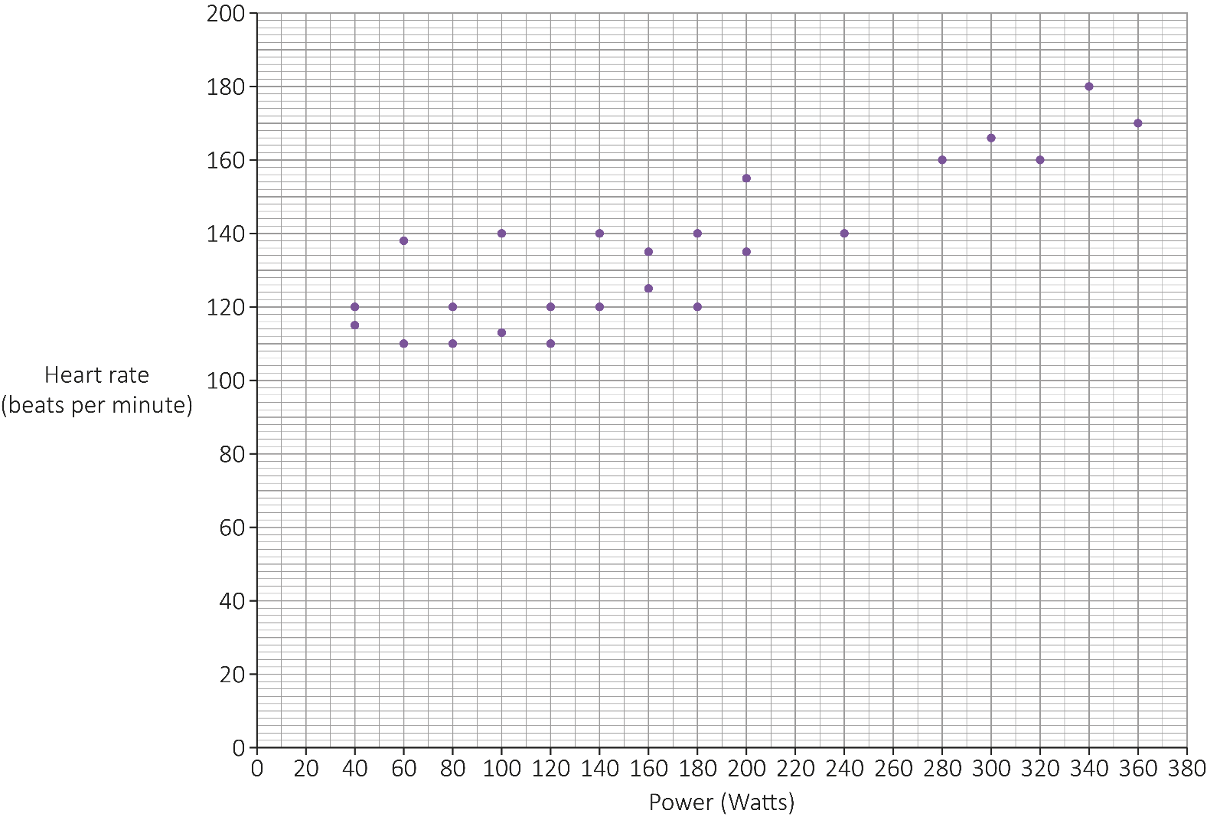

To produce 100 Watts of power, a cyclist uses about 350 kilocalories per hour.

Estimate the number of kilocalories Jackie uses per hour if she cycles at 72%
of her maximum heart rate.
[6 marks]

 |  |  | Your answer: | kilocalories

Please turn over
3 (d) |  |  | Rafa and his friends cycle to keep fit.  They want to reduce the mean time it takes them to cycle 10 km  Their target is to reduce the time by 11% within 12 weeks.  This table shows their times in Week 1 and Week 12.  Time (minutes) to cycle 10 km  Week 1 Week 12  Ann 26.3 23.9  Mike 22.0 20.2  Rafa 28.1 25.7  Ali 24.9 20.4  Maria 18.4 18.1  Luke 21.7 20.7  Becky 20.3 17.3  Has the group achieved its target?  Show how you decide.  [4 marks]
 |  |  | Your answer:
3 (e) |  |  | Peta cycles around this route:  Not drawn accurately  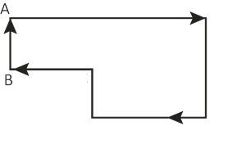  She starts at A.  When she reaches B she has cycled 12.5 miles.  - What is 12.5 miles in km?  Use this conversion: 1.6 km = 1 mile  [1 mark]
 |  |  | Your answer:

The total route is 23 km

- What fraction of the total route has she cycled when she reaches B?
[1 mark]

Your answer:

[Total marks: 15]

Please turn over
Activity 4: Packaging

4 (a) |  |  | Beth is on a work placement.  The company makes biscuits.  In 2018 it reduced the number of biscuits in each packet.  The weight of each biscuit stayed the same.  The weight of a packet went from 135 g to 108 g  The 135 g packet contained 25 biscuits.  How many fewer biscuits did the 108 g packet contain?  [2 marks]
 |  |  | Your answer: | biscuits

4 (b) |  |  | The company also makes pizza.  This table shows information about the two sizes it sells:  Pizza Diameter Depth  Large 38 cm 2 cm  Small 19 cm 1.5 cm  Beth says that the large size gives over 5 times as much pizza as the small size.  Is Beth correct?  Show how you decide.  Use π = 3.14  [4 marks]
 |  |  | Your answer:

Please turn over
4 (c) |  | The large pizzas are sold in cardboard boxes.  When closed, the boxes measure 40 cm by 40 cm by 2.5 cm and are cuboid.  This is the net of the pizza box.  Not drawn accurately  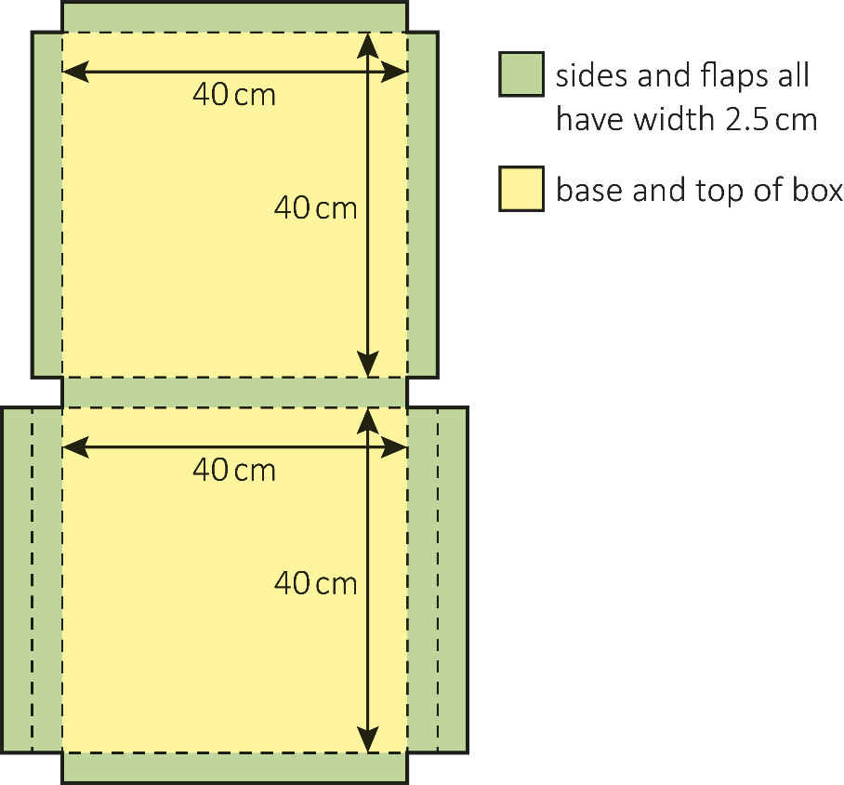

The company thinks it could use the same net but reduce the dimensions
to 38 cm by 38 cm by 2 cm

Beth is asked to calculate the percentage reduction in cardboard if the smaller boxes are used.

What answer should Beth get?
[5 marks]

 |  |  | Your answer: | %

Please turn over
4 (d) |  | The company also makes a chocolate bar.  It is divided into 10 identical triangle-shaped pieces.  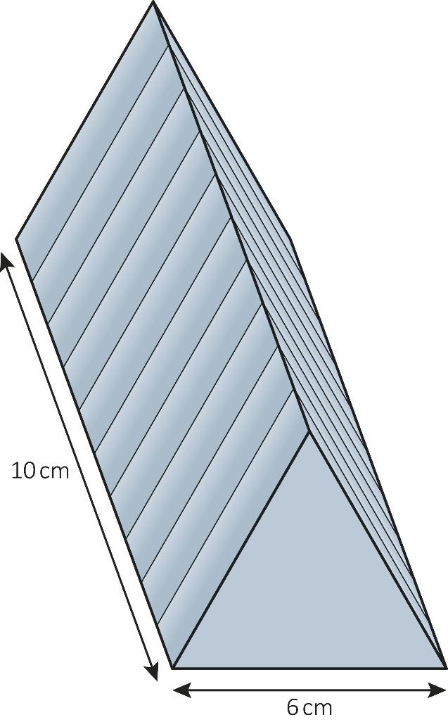  Not drawn accurately  Draw a plan view of the bar in the space below.  Label the dimensions.  [3 marks]

4 (e) |  |  | One triangular face of the chocolate bar is shown in the diagram.  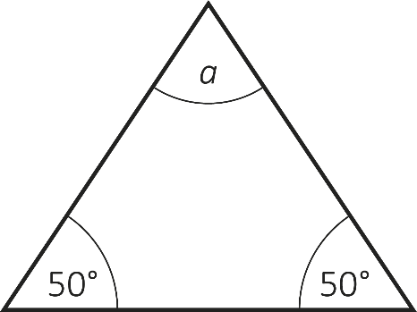  Not drawn accurately  Calculate the size of the angle labelled a  [1 mark]
 |  |  | Your answer: | º

[Total marks: 15]

This is the end of the assessment.

This page is intentionally left blank.

