NCFE Level 2 Functional Skills Qualification in Mathematics (603/5060/X)
Paper number: P001259
Section A: Non-calculator Test

Assessment window: Monday 9 December 2019 – Friday 13 December 2019
Time allowed: 30 minutes

Learner instructions
- Answer all questions.
- Read each question carefully.
- Write your answers in the spaces provided.
- Show your working, as marks may be awarded for working.
- State units in your answers, where appropriate.
- Check your work.

To be completed by the examiner |  | Mark
A | Activity 1 | / 15
B | Activity 2 | / 15
 | Activity 3 | / 15
 | Activity 4 | / 15
TOTAL MARK |  | / 60
Learner information
- Section A contains Activity 1 only.
- The maximum mark for this section is 15.
- The marks available for each question are shown in brackets.

Resources
You will need a:
- pen, with black or blue ink
- pencil and eraser
- 30 cm ruler
- protractor.

If extra pages are used, please make sure your name and centre name are on them
and they are securely fastened to this booklet.

Please complete the details below clearly and in BLOCK CAPITALS.
Learner name
Centre name
Learner number |  | Centre number

Do not turn over until the invigilator tells you to do so.

This page is intentionally left blank.
Activity 1: Weather

1 (a) |  |  | Zak is a journalist.  He is writing an article about the local weather.  This table shows the highest and lowest temperatures in Zak’s town for two different years.  Year Lowest Highest  2014 -3.4ºC 20.3ºC  2018 -0.2ºC 23.4ºC  Which year had the greater difference between highest and lowest temperatures?  Show how you decide.  [1 mark]
 |  |  | Your answer:

1 (b) |  |  | Zak works out the percentage of days last year that the temperature  fell below 0°C  His calculator gives the answer 8.219178082  Write this percentage to 2 decimal places.  [1 mark]
 |  |  | Your answer: | %

Please turn over
1 (c) |  |  | The highest temperature recorded in Zak’s town this year was 32.9ºC  Zak writes the headline,  “Temperature reaches 95ºF!”  A formula to convert between ºC and ºF is:  ºC = 5 × (ºF – 32) ÷ 9  Is Zak’s headline correct?  Show how you decide.  [2 marks]
 |  |  | Your answer:

1 (d) |  |  | Zak looks at the weather forecast.  This table shows the highest daily temperatures forecast for the next eight days.  Day 1 2 3 4 5 6 7 8 9 10  Temperature °C 15 19 17 15 15 20 19 16  - The median of the ten temperatures is 17.5ºC and  - the ten temperatures have two modes.  Use this information to find the forecast temperatures for Day 9 and Day 10.  [2 marks]
 |  |  | Your answer: | Day 9:
 |  |  |  | Day 10:

Please turn over
1 (e) |  |  | Zak wants to find out how accurate the weather forecast is.  This table shows the last 6 months’ forecasts for rain.  It also shows the number of days that it actually rained or stayed dry.  Actual weather (days)  Rain Dry  Forecast weather (days) Rain 70 60  Dry 36 16  Was the forecast more likely to be right when it was for rain or when it  was for dry weather?  Explain how you decide.  [3 marks]
 |  |  | Your answer:

This page is intentionally left blank.
Please turn over for the next question.
1 (f) |  | This scatter diagram shows the relationship between forecast temperatures and actual temperatures for the town over nine days.  The line represents the points at which the forecast and actual temperatures are the same.

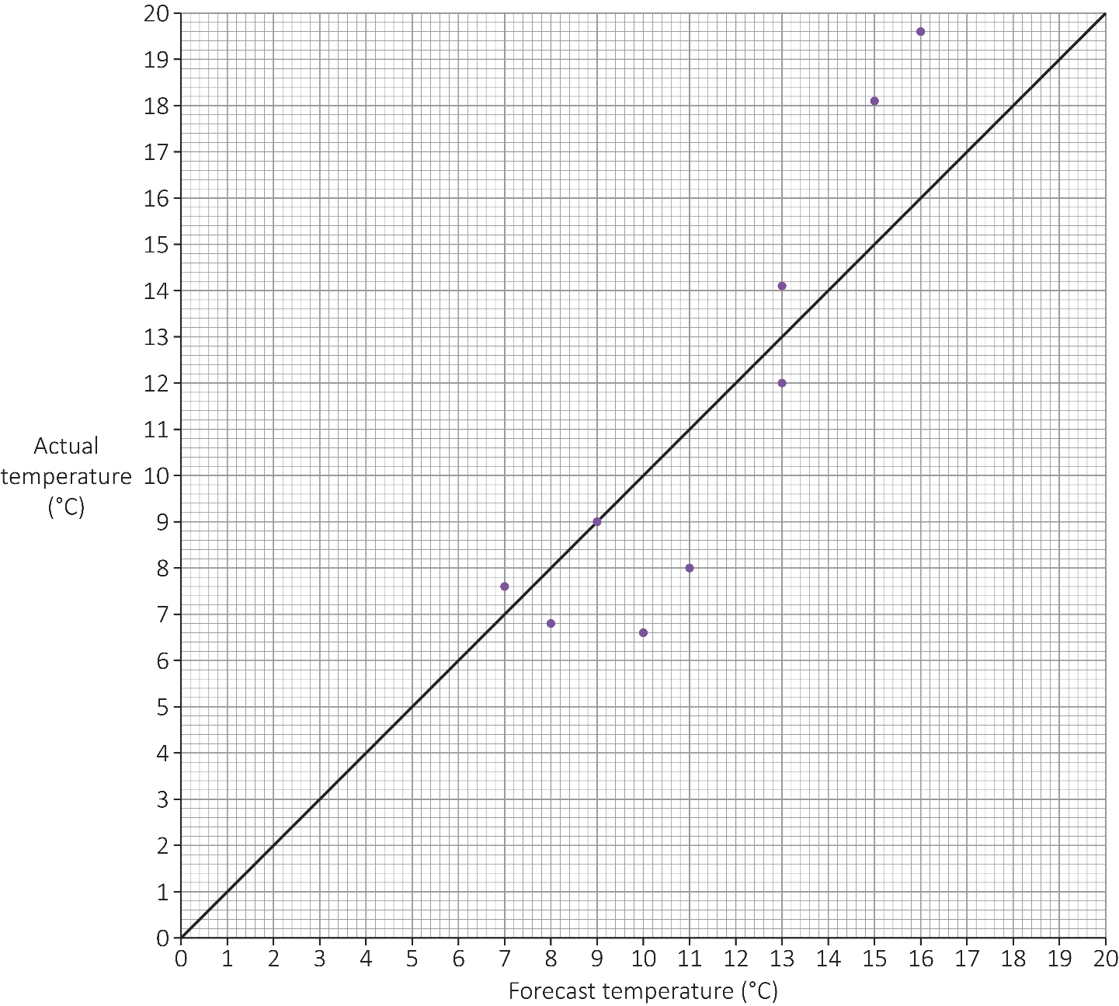
Relationship between forecast temperatures and
actual temperatures over nine days

A forecast is recorded as “accurate” if the actual temperature is within 2ºC
of the forecast temperature.

Zak writes that,
“The temperature forecast was accurate for less than 70% of the time”.

Is Zak correct?

Show how you decide.
[3 marks]
Your answer:

Please turn over
1 (g) |  |  | Zak wants to include a map in his article.  The map must be to scale.  The map shows a part of the country that is 30 km wide and 48 km long.  It must fit into a space that is no more than 12 cm wide and 16 cm long.  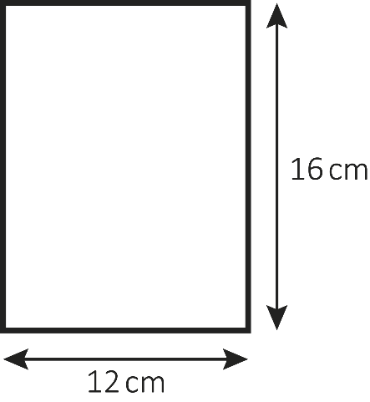  Not drawn accurately  The map is scaled down to fit into the space.  In the article, what distance, in km, will 1 cm on the map represent?  [3 marks]
 |  |  | Your answer: | km

[Total marks: 15]

This is the end of Section A.

This page is intentionally left blank.

