NCFE Level 1 Functional Skills Qualification in Mathematics (603/5055/6)
Paper number: P001253
Section A: Non-calculator Test

Assessment window: Monday 14 October 2019 – Friday 18 October 2019
Time allowed: 30 minutes

Learner instructions
- Answer all questions.
- Read each question carefully.
- Write your answers in the spaces provided.
- Show your working, as marks may be awarded for working.
- State units in your answers, where appropriate.
- Check your work.

To be completed by the examiner |  | Mark
A | Activity 1 | / 15
B | Activity 2 | / 15
 | Activity 3 | / 15
 | Activity 4 | / 15
TOTAL MARK |  | / 60
Learner information
- Section A contains Activity 1 only.
- The maximum mark for this section is 15.
- The marks available for each question are shown in brackets.

Resources
You will need a:
- pen, with black or blue ink
- pencil and eraser
- 30 cm ruler
- protractor.

If extra pages are used, please make sure your name and centre name are on them
and they are securely fastened to this booklet.

Please complete the details below clearly and in BLOCK CAPITALS.
Learner name
Centre name
Learner number |  | Centre number

Do not turn over until the invigilator tells you to do so.

This page is intentionally left blank.
Activity 1: Climbing mountains

1 (a) |  |  | 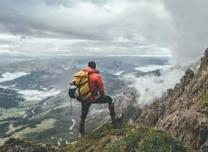  Don spends his holidays climbing mountains.  The twenty highest mountains in the UK are  all in Scotland.  Don began climbing these mountains in 2011.  He climbed 4 of these mountains each year.  In which year did he finish climbing the twenty highest mountains?  [2 marks]
 |  |  | Your answer:

Please turn over
1 (b) |  |  | Don lives in London.  He wants to travel to Fort William in Scotland.  Don finds this information about travel times.  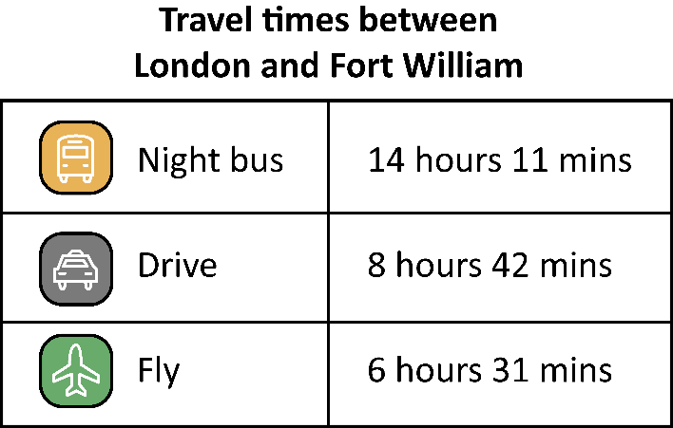  How much longer does it take to travel by the night bus than to fly?  [1 mark]
 |  |  | Your answer:

1 (c) |  |  | The cost of a return train ticket from London to Fort William is £176  Don sees an offer which gives him a 15% discount.  How much money will Don save if he has the discount?  [2 marks]
 |  |  | Your answer: | £

Please turn over
1 (d) |  |  | Don is going to climb a mountain called Ben Nevis.  To estimate how long this will take he uses this rule:  - 12 minutes for every 1 kilometre (km) of distance forward  plus  - 10 minutes for every 100 metres (m) of height gained.  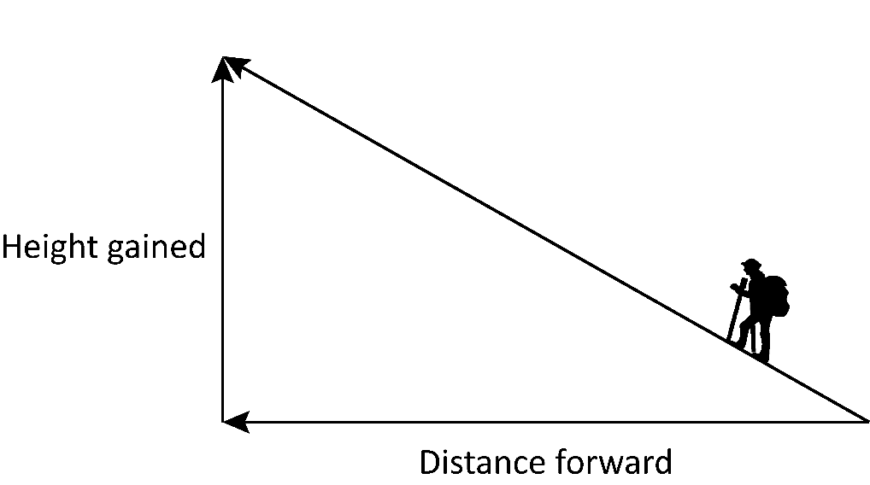  The height of Ben Nevis is 1345 m  The distance forward is 17 km  Estimate how long it will take Don to climb Ben Nevis.  Give your answer to the nearest hour.  [5 marks]
 |  |  | Your answer: | hours

1 (e) |  | The time taken to come down a mountain depends on the angle of the slope.  Estimate the angle of this slope and tick the correct statement.  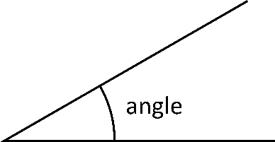  The angle is less than 5º  The angle is between 5º and 12º  The angle is more than 12º but less than 90º  The angle is more than 90º  [1 mark]

1 (f) |  |  | When Don arrives in Fort William  - the temperature at the bottom of Ben Nevis is 3 ºC  - the temperature at the top of Ben Nevis is –6 ºC  Calculate the difference in temperature between the top and bottom  of Ben Nevis.  [2 marks]
 |  |  | Your answer: | degrees

Please turn over
1 (g) |  |  | The weather forecast says that, at the top of Ben Nevis at 2pm there is  - a 20% chance of snow  - a chance of rain.  Is it more likely to snow or rain?  Show your working.  [2 marks]
 |  |  | Your answer:

[Total marks: 15]

This is the end of Section A.

