NCFE Level 1 Functional Skills Qualification in Mathematics (603/5055/6)
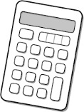
Paper number: P001254
Section B: Calculator Test

Assessment window: Monday 9 December 2019 – Friday 13 December 2019
Time allowed: 1 hour 30 minutes

Learner instructions
- Answer all questions.
- Read each question carefully.
- Write your answers in the spaces provided.
- Show your working, as marks may be awarded for working.
- State units in your answers, where appropriate.
- Check your work.

Learner information
- Section B contains Activities 2, 3 and 4.
- The maximum mark for this section is 45.
- The marks available for each question are shown in brackets.

Resources
You will need a:
- pen, with black or blue ink
- pencil and eraser
- 30 cm ruler
- protractor
- calculator.

If extra pages are used, please make sure your name and centre name are on them
and they are securely fastened to this booklet.

Please complete the details below clearly and in BLOCK CAPITALS.
Learner name
Centre name
Learner number |  | Centre number

Do not turn over until the invigilator tells you to do so.

This page is intentionally left blank.
Activity 2: Healthy-eating café

2 (a) |  |  | John is opening a healthy-eating café.  He looks for a property with a seating area for 20 customers.  This is a scale plan of the seating area in one property he finds.  The drawing has a scale of 1 centimetre (cm) : 150 cm  4 cm  3 cm  The recommended maximum number of customers in a café is the  seating area (m²) divided by 1.5  Is this property suitable for 20 customers?  Show how you decide.  [5 marks]
 |  |  | Your answer:

Please turn over
2 (b) |  |  | Another property has a kitchen that has an area of 7 metres squared.  What is 7²?  [1 mark]
 |  |  | Your answer:

2 (c) |  |  | John wants his menu to offer healthy food.  He reads that six hundred and seventeen thousand people went to hospital last year with illnesses caused by a poor diet.  What is six hundred and seventeen thousand in numbers?  [1 mark]
 |  |  | Your answer:

2 (d) |  |  | John buys food in preparation for his opening day.  Ingredients Price per item Number of items Total price per ingredient  Cabbage 64p 5  Pack of carrots 30p 20  Pack of tomatoes £1.25 11  Cucumbers 50p 9  Pack of onions £1 15  Total (£)  Complete the table to show how much has John spent.  [2 marks]

Please turn over
2 (e) |  |  | John fills a fruit bowl with 6 apples, 4 plums, 5 oranges and 3 pears.  The first customer chooses a piece of fruit at random.  What is the probability that they choose a pear?  [2 marks]
 |  |  | Your answer:

2 (f) |  |  | John looks at the bills from all the customers.  The range of amounts spent is £22.46  The largest bill was £24.56  What was the smallest bill?  [2 marks]
 |  |  | Your answer: | £

2 (g) |  |  | John asks his customers to rate the café.  - The customers give four times as many good ratings as excellent ratings.  - The customers also give three times as many excellent ratings as satisfactory ratings.  60 customers rated the café as good.  How many customers rated the café as satisfactory?  [2 marks]
 |  |  | Your answer: | customers

[Total marks: 15]

Please turn over
Activity 3: Go-karting

3 (a) |  |  | Hamid organises a go-karting party for himself and five friends.  The cost is £29.95 per person.  He uses rounding to estimate the cost for the whole group.  How much is the estimated cost?  [2 marks]
 |  |  | Your answer: | £

3 (b) |  |  | Hamid needs to book transport.  A small minibus will cost £45  He has a voucher for 5% off.  How much will the minibus cost Hamid?  [2 marks]
 |  |  | Your answer: | £
3 (c) |  |  | The safety instructions show a plan view of the go-kart.  2 m  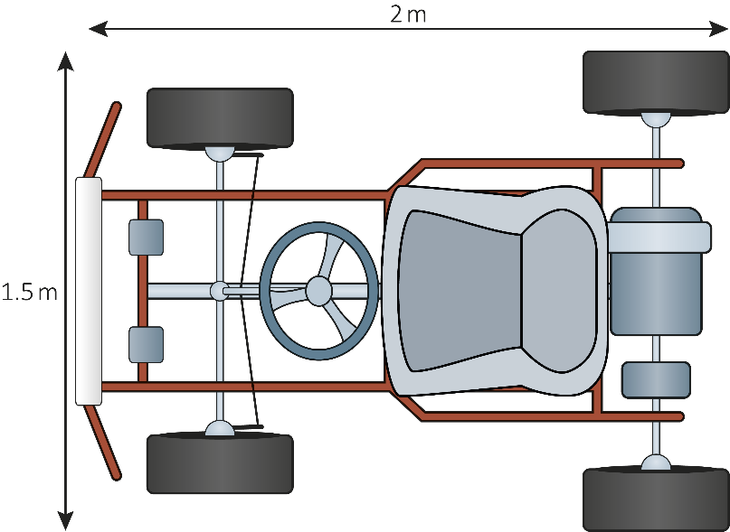  1.5 m  Hamid says that the go-kart is 1.5 m high, 2 m long and 0.6 m wide.  Is Hamid correct?  Explain your answer.  [1 mark]

Please turn over
3 (d) |  | This table shows the times Hamid and two of his friends take to complete their first lap.  Person Time in seconds  Hamid 39.041  Jane 39.3  Ikrah 39.12  Write these times in order of fastest to slowest.  [1 mark]  Fastest _________ _________ _________ Slowest

3 (e) |  |  | Which person had the fastest lap?  [1 mark]
 |  |  | Your answer:

3 (f) |  |  | Hamid looks at the times on the leader board for that day.  The times are in seconds.  Leader board  1st 26.52  2nd 27.5  3rd 28.9  4th 29.82  5th 30.18  6th 31.2  7th 31.4  Calculate the mean time.  [2 marks]
 |  |  | Your answer: | seconds

Please turn over
3 (g) |  | Here are people’s lap times in seconds over the last week:  21 34 27 36 27 38 22 30 40 21  29 32 20 26 37 31 22 33 27  Using the lap times complete this frequency table:  Lap time in seconds Frequency of people  20 – 25  26 – 30  31 – 35  36 – 40  Plot your results on this bar chart.  [4 marks]  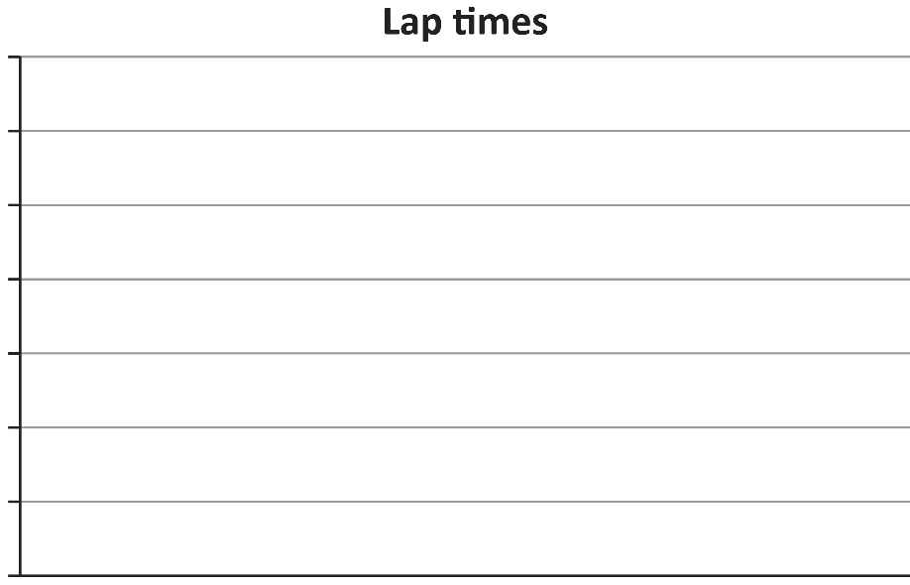

3 (h) |  |  | The friends go to lunch after they have raced.  Bethany has a voucher giving her 35% off.  Ikrah has a voucher for off.  Who has the better discount?  Show how you decide.  [2 marks]
 |  |  | Your answer:

[Total marks: 15]

Please turn over
Activity 4: Childcare course

4 (a) |  |  | Natalie teaches a childcare course.  She is planning a trip with 16 students.  They have volunteered to work for two weeks abroad.  They need to raise £2000 per student to pay for the trip.  They have already raised of the money needed.  How much money have they raised so far?  [3 marks]
 |  |  | Your answer: | £

4 (b) |  |  | They have one eighth left to raise.  Write one eighth in figures.  [1 mark]
 |  |  | Your answer:

4 (c) |  |  | 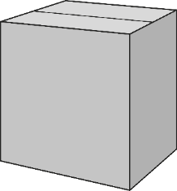  Natalie packs children’s clothes into boxes.  Each box is a cube with side lengths of 50 cm  The clothes weigh 350 grams (g) per 500 cm³  Calculate the weight of the clothes in each box when the box is full.  Give your answer in kg  [4 marks]
 |  |  | Your answer: | kg

Please turn over
4 (d) |  |  | When the group get on the plane the pilot announces that the temperature is 10°C at their destination.  It is -2°C in the UK.  What is the difference in temperature from the UK to their destination?  [1 mark]
 |  |  | Your answer: | °C

4 (e) |  |  | The volunteers are going to help children in a home.  The ratio of boys to girls in the home is 1 : 3  There are 80 children in total.  75% of the boys and 40% of the girls are under 10.  How many boys and how many girls are under 10?  [4 marks]
 |  |  | Your answer: | Boys:
 |  |  |  | Girls:

Please turn over
4 (f) |  | Natalie knows that only 60% of the children can write their name.  She chooses one of the children at random to work with.  On the scale, mark the probability that this child can write their name.  [1 mark]

4 (g) |  |  | Write 60% as a decimal.  [1 mark]
 |  |  | Your answer:

[Total marks: 15]

This is the end of the assessment.

This page is intentionally left blank.

