NCFE Level 1 Functional Skills Qualification in Mathematics (603/5055/6)
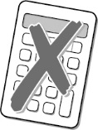
Paper number: P001254
Section A: Non-calculator Test

Assessment window: Monday 9 December 2019 – Friday 13 December 2019
Time allowed: 30 minutes

Learner instructions
- Answer all questions.
- Read each question carefully.
- Write your answers in the spaces provided.
- Show your working, as marks may be awarded for working.
- State units in your answers, where appropriate.
- Check your work.

To be completed by the examiner |  | Mark
A | Activity 1 | / 15
B | Activity 2 | / 15
 | Activity 3 | / 15
 | Activity 4 | / 15
TOTAL MARK |  | / 60
Learner information
- Section A contains Activity 1 only.
- The maximum mark for this section is 15.
- The marks available for each question are shown in brackets.

Resources
You will need a:
- pen, with black or blue ink
- pencil and eraser
- 30 cm ruler
- protractor.

If extra pages are used, please make sure your name and centre name are on them
and they are securely fastened to this booklet.

Please complete the details below clearly and in BLOCK CAPITALS.
Learner name
Centre name
Learner number |  | Centre number

Do not turn over until the invigilator tells you to do so.

This page is intentionally left blank.
Activity 1: Starting a business

1 (a) |  |  | Denise starts up a business making candles.  She borrows £2500 for one year.  The interest on the loan is 5% per year.  How much will Denise pay back in total?  [2 marks]
 |  |  | Your answer: | £

Please turn over
1 (b) |  |  | Denise needs wax to make candles.  She wants to know how much wax, in kilograms (kg), she needs to buy.  She uses this calculation:  870 × 1.5  10²  How much wax will Denise need to buy?  [3 marks]
 |  |  | Your answer: | kg

1 (c) |  |  | Denise decides to buy 10 kg of wax.  She finds these deals:  Deal A  Wax £34.99  per 10 kg  Deal B  Wax 75p  per 200 g  Which is the better deal?  Show your working.  [3 marks]
 |  |  | Your answer:

Please turn over
1 (d) |  |  | Denise needs 30000 millimetres (mm) of ribbon to decorate the candles.  Write 30000 mm in metres (m).  [2 marks]
 |  |  | Your answer: | m

1 (e) |  |  | Denise needs to buy some boxes for the candles.  This is the net of the box she chose:  The net is made up of six squares.  What shape will the box be?  [1 mark]
 |  |  | Your answer:

Please turn over
1 (f) |  | Denise sells candles for two weeks.  She wants to compare the number and type of candles she sold in Week 1  with the number and type of candles she sold in Week 2.  After the second week of selling candles, Denise wants to produce a pie chart  to compare sales of candles from Week 1 and Week 2.  This is the pie chart for candles she sold in Week 1.  Candles sold in Week 1 Type  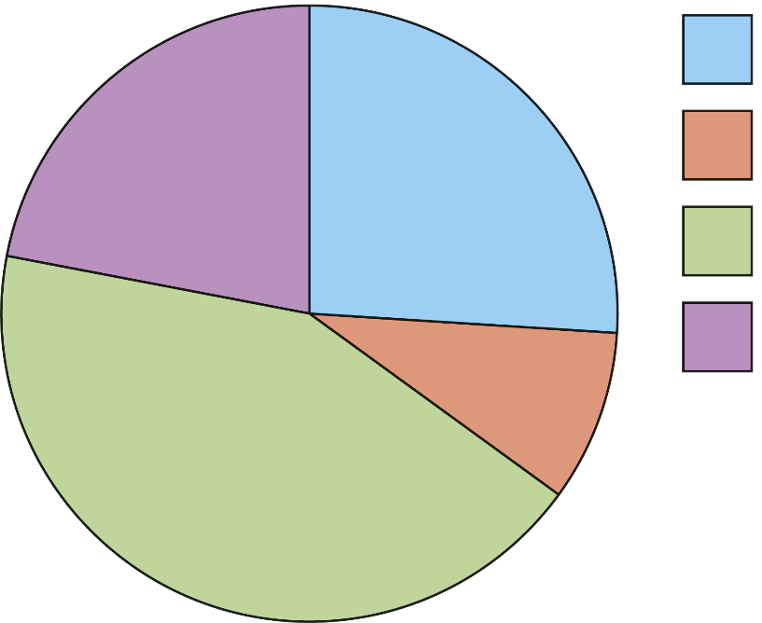  Cherry  Linen  Lavender  Vanilla

This table shows the number and type of candles sold in Week 2.

Type of the candle | Number of candles sold in Week 2
Vanilla | 85
Lavender | 123
Cherry | 100
Linen | 52

Draw and label the pie chart below for Week 2.

Candles sold in Week 2 Type

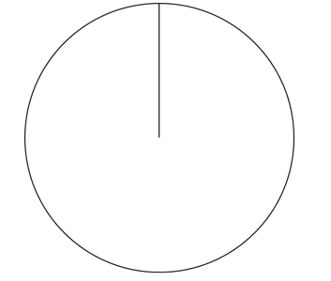

Make one comparison between Week 1 and Week 2.
[4 marks]

[Total marks: 15]
This is the end of Section A.

This page is intentionally left blank.

