NCFE Level 1 Functional Skills Qualification in Mathematics (603/5055/6)
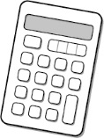
Paper number: P001253
Section B: Calculator Test

Assessment window: Monday 14 October 2019 – Friday 18 October 2019
Time allowed: 1 hour 30 minutes

Learner instructions
- Answer all questions.
- Read each question carefully.
- Write your answers in the spaces provided.
- Show your working, as marks may be awarded for working.
- State units in your answers, where appropriate.
- Check your work.

Learner information
- Section B contains Activities 2, 3 and 4.
- The maximum mark for this section is 45.
- The marks available for each question are shown in brackets.

Resources
You will need a:
- pen, with black or blue ink
- pencil and eraser
- 30 cm ruler
- protractor
- calculator.

If extra pages are used, please make sure your name and centre name are on them
and they are securely fastened to this booklet.

Please complete the details below clearly and in BLOCK CAPITALS.
Learner name
Centre name
Learner number |  | Centre number

Do not turn over until the invigilator tells you to do so.

This page is intentionally left blank.
Activity 2: Community nurse

2 (a) |  | Asmita is a community nurse.  Each week she runs a drop-in clinic where people can have a check-up.  People arrive at the clinic and wait until it is their turn to be seen.  At one clinic Asmita asks each person to estimate how many minutes they  have had to wait.  The results are shown below:  2 15 18 32 37 8 25 13  31 32 3 5 6 7 4 12  12 14 11 35 28 11 8 12  Use this template to create a grouped frequency table for this data.  [4 marks]

Please turn over
2 (b) |  | At the next clinic, the time that each person arrives is recorded.  Asmita also writes down the times that each person’s check up begins and ends.  She uses this information to draw a graph.

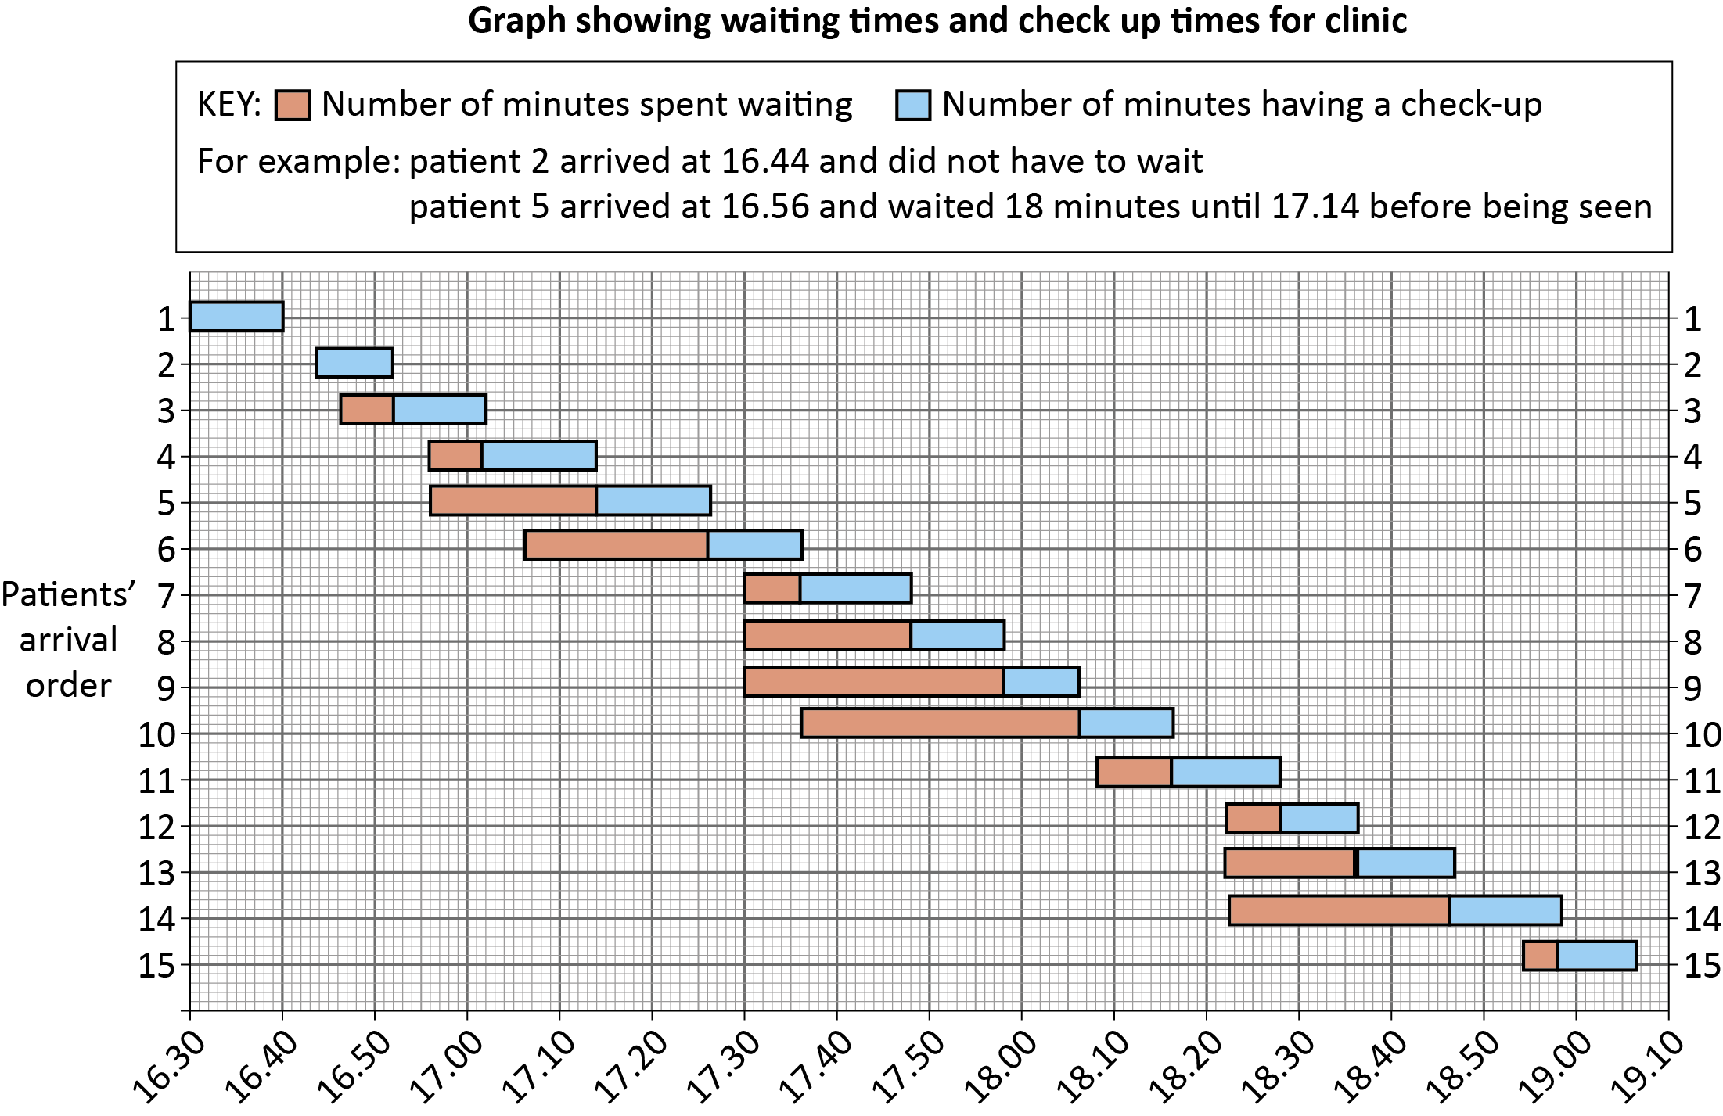

Asmita says,
“40% of people either waited no time or waited less than 10 minutes before the start of their check-up”.

Is Asmita correct?

Show your working.
[3 marks]

Your answer:

Please turn over
2 (c) |  | Asmita does home visits.  She drives from Skegness to Candlesby to visit one of her patients.  Asmita has a map with scale 1 cm : 2 km  The distance on the map between Skegness and Candlesby is 6.5 cm  Asmita can claim 28p per kilometre for fuel.  Complete the travel expense form below for Asmita’s one-way journey from Skegness to Candlesby.  [3 marks]  Your answer:
 |  | Journey | Distance (km) | Pence per km | Total (£)
 |  | Skegness to Candlesby |  | 28

2 (d) |  |  | Asmita parks her car on the road in Candlesby.  The car is facing North West.  When she has finished the visit, Asmita turns her car round ready to drive  South East.  Through how many degrees has the car turned?  [1 mark]
 |  |  | Your answer: | degrees

2 (e) |  |  | Asmita is concerned about how much fuel she is using.  The manufacturer says that the car has:  - a 52-litre fuel tank  - fuel consumption of 17 km per litre.  Asmita finds that she uses one full tank of fuel to drive 800 km  Is Asmita’s fuel consumption as good as the manufacturer claims?  Show how you decide.  [2 marks]
 |  |  | Your answer:

Please turn over
2 (f) |  |  | Asmita puts 40.2 litres of fuel in her car.  The fuel costs 130.1 pence per litre.  She is charged £52.70 for the fuel.  By rounding litres of fuel and cost per litre to the nearest whole numbers, show how Asmita could check that she has been charged about the right amount.  [2 marks]
 |  |  | Your answer:

[Total marks: 15]

Activity 3: French flag

3 (a) |  |  | Tomas is an apprentice gardener. He is asked to make a flowerbed to look like the French flag.  The flowerbed is a rectangle 225 cm long and 150 cm wide.  Tomas is going to put paving round the perimeter of the flowerbed.  Calculate the perimeter of the flowerbed in metres.  [2 marks]
 |  |  | Your answer: | m

3 (b) |  | Draw in all the lines of symmetry on the flowerbed.  [1 mark]

Please turn over
3 (c) |  |  | Tomas will use red, white and blue flowers to make the flowerbed look like the French flag.  - The flowerbed is a 225 cm by 150 cm rectangle.  - The 3 stripes need to be of equal width.  - Tomas needs one plant for every 12 cm² of flowerbed.  How many red plants will Tomas need?  [4 marks]
 |  |  | Your answer:

3 (d) |  |  | Tomas’s manager is ordering plants for a different project.  The table shows the costs per tray for different colours.  Flower colour Cost per tray  Blue £42.98  Red £31.56  White £33.98  Yellow £42.99  Pink £35.75  Purple £28.50  Calculate the mean cost per tray.  [2 marks]
 |  |  | Your answer: | £

Please turn over
3 (e) |  |  | The order is for one tray of each colour.  There are 310 plants in each tray.  Tomas says,  “The mean cost per plant is over 10 pence.”  Is Tomas correct?  Explain your answer.  [2 marks]
 |  |  | Your answer:

3 (f) |  |  | Each plant tray is cuboid and measures 30 cm by 50 cm by 4 cm.  How many litres of compost would be required to fill one tray?  Use the conversion 1 cm³ = 1 ml  [2 marks]
 |  |  | Your answer:

Please turn over
3 (g) |  |  | Tomas needs to mix grit and compost in the ratio 1 : 4  He mixes litres of grit with litres of compost.  Are these numbers in the correct ratio?  Show how you decide.  [2 marks]
 |  |  | Your answer:

[Total marks: 15]

Activity 4: World hunger

4 (a) |  |  | The world population is about 7726.5 million.  About one in nine people in the world experience extreme hunger.  Use this information to estimate how many millions of people in the world experience extreme hunger.  Give your answer to the nearest million.  [2 marks]
 |  |  | Your answer: | million

Please turn over
4 (b) |  |  | When people are starving, aid organisations have to decide quickly who to help first.  One method they use is to measure, in mm, the distance round each person’s mid upper arm.  These are the mid upper arm measurements of 20 people.  170 172 158 175 156  154 162 151 172 186  158 173 190 174 169  178 175 157 188 189  What is the range of the measurements?  [1 mark]
 |  |  | Your answer:

4 (c) |  |  | What is the probability that one of these people chosen at random has a  mid upper arm measurement of less than 160 mm?  Give your answer as a decimal.  [2 marks]
 |  |  | Your answer:

4 (d) |  |  | Another method aid organisations use is to calculate Body Mass Index (BMI).  To find the BMI:  Step 1: calculate height × height  Step 2: divide weight by your answer to Step1.  Height must be in metres and weight in kilograms.  Calculate the BMI for a person who has:  - weight 64 kg  - height 1.60 m  [3 marks]
 |  |  | Your answer:

Please turn over
4 (e) |  |  | An aid charity finds that:  20% of the people in village A are malnourished.  15% of the people in village B are malnourished.  Village A has a population of 300  Village B has a population of 440  Which village has the higher number of people who are malnourished?  Show how you decide.  [2 marks]
 |  |  | Your answer:

4 (f) |  |  | A newspaper reports that the UK wastes one million tons of food each year which could be used to feed hungry people.  Write one million in figures.  [1 mark]
 |  |  | Your answer:

4 (g) |  |  | This information appeared on a website about food wastage.  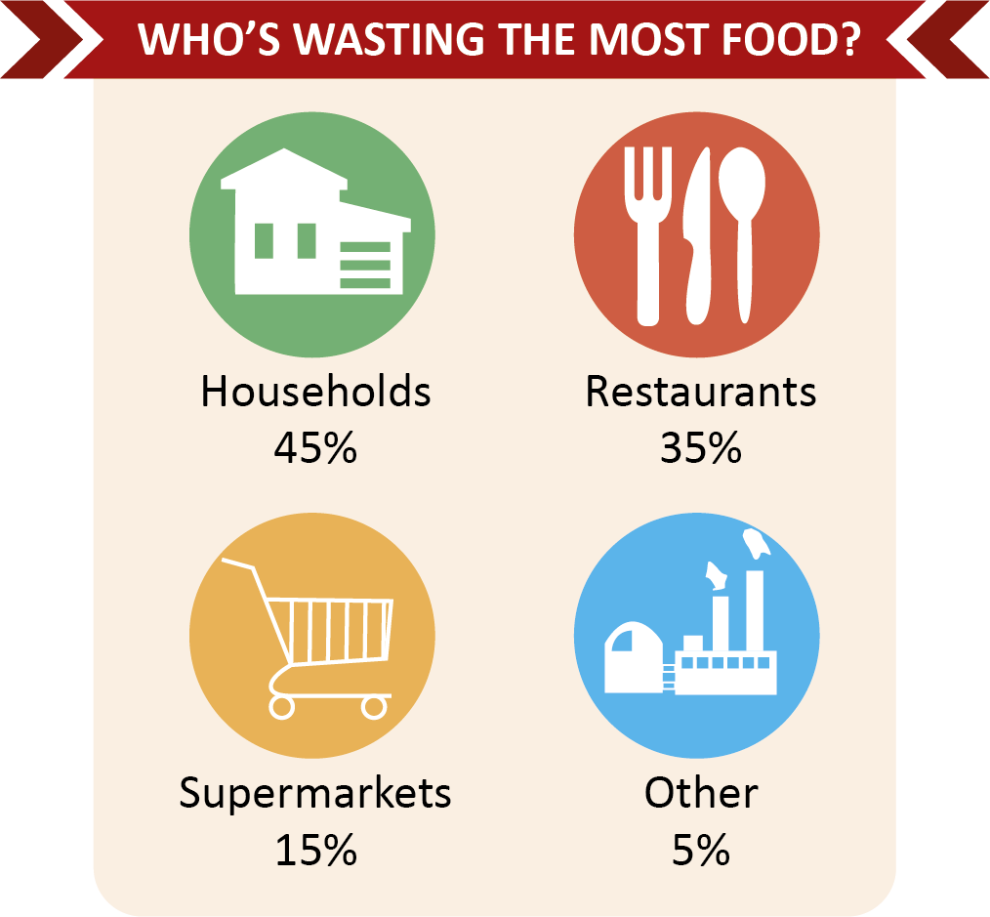  What fraction of food wastage came from supermarkets?  Give your answer in its lowest terms.  [2 marks]
 |  |  | Your answer:

Please turn over
4 (h) |  | Use the information about food wastage given in 4 (g) to complete the pie chart below.  [2 marks]  Who’s wasting the most food?  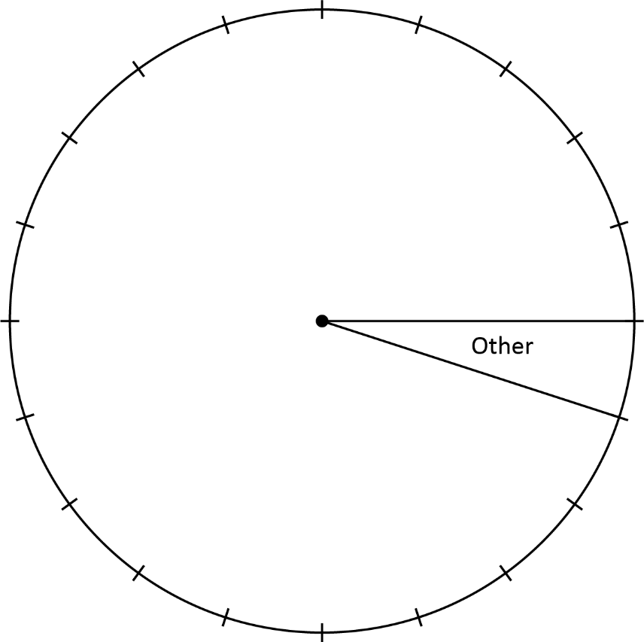

[Total marks: 15]

This is the end of the external assessment.

